Step 1 (log setup):

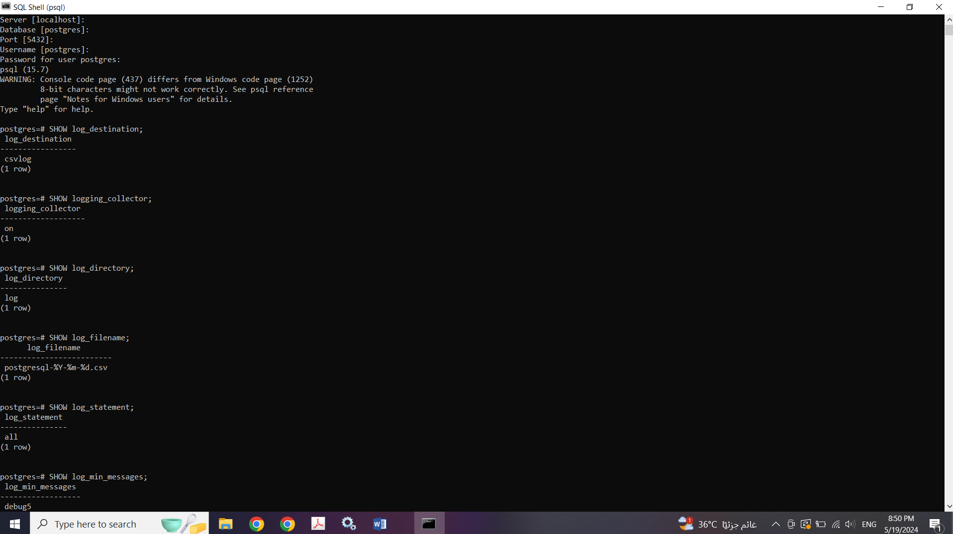

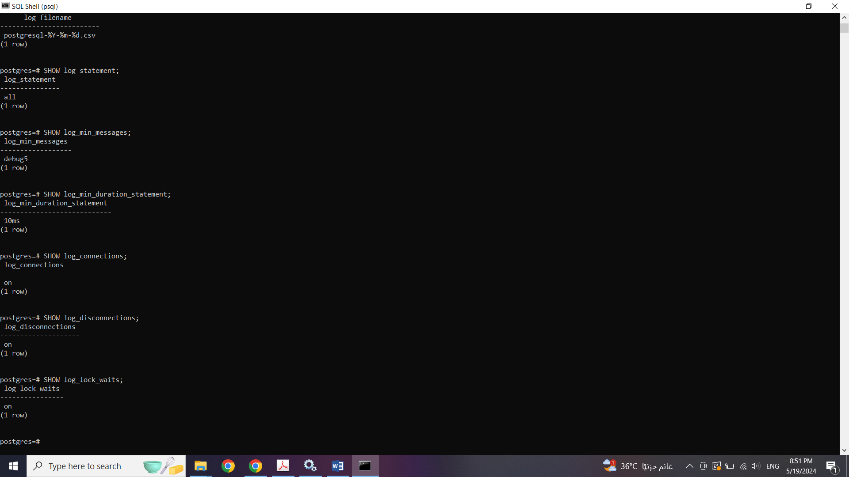

Creating the Tables:

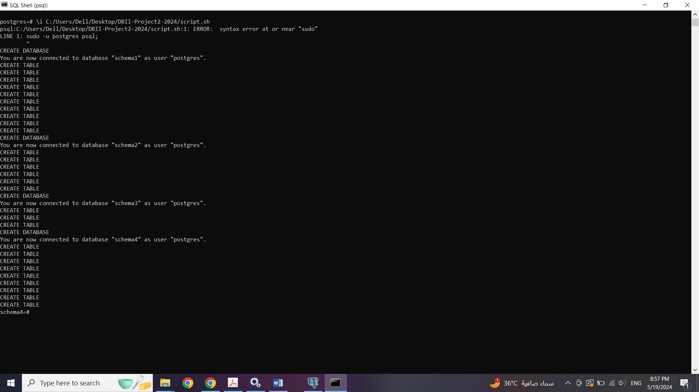

Step 2 (locks):

Locks:

The output from the pg_locks query provides a snapshot of the current locking state within the PostgreSQL database. In the context of concurrency control, locks serve as synchronization mechanisms to regulate access to shared resources, such as tables or rows, ensuring data integrity and consistency in multi-user environments.

For database administrators and developers, knowing how locks work is crucial. It helps improve performance and avoid problems like data conflicts and slowdowns. PostgreSQL handles this by using locks effectively, making sure everyone can work on the database at the same time without messing things up.

Schema 1:

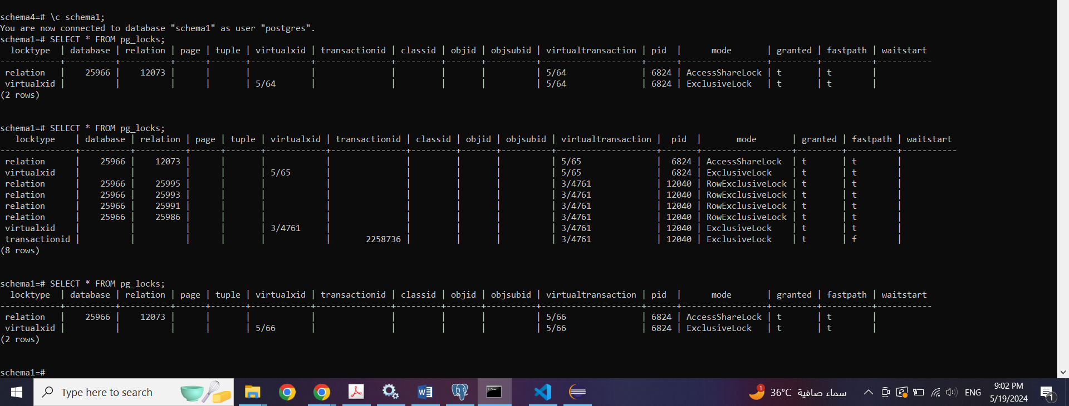

Before Insertions:

The presence of an AccessShareLock signifies that multiple transactions are concurrently granted read access to a particular table (relation). This type of lock allows for non-exclusive, shared access, enabling concurrent read operations without the risk of data inconsistency.

Conversely, the ExclusiveLock indicates that a transaction holds exclusive control over the specified relation, prohibiting concurrent access by other transactions. This lock type is typically acquired during data modification operations, such as updates or schema alterations, where exclusive access is required to prevent conflicting changes and maintain data integrity.

During Insertions:

During the insertion phase, when new data is being added to the database, the pg_locks query reveals that different types of locks are in place to manage access to database resources. These locks serve important roles in maintaining data integrity and controlling how data is accessed and modified. The AccessShareLock allows multiple transactions to read from the affected tables simultaneously, ensuring that reading operations don't interfere with each other. On the other hand, the ExclusiveLock indicates that certain operations have exclusive control over specific tables, likely for performing write operations or other sensitive tasks. Additionally, the presence of RowExclusiveLocks suggests that certain transactions have exclusive control over individual rows within the tables, ensuring that specific data is modified or accessed exclusively by certain operations. Understanding the acquisition and implications of these locks during data insertion is crucial for ensuring smooth and efficient database operations, preventing conflicts, and maintaining transactional consistency.  
The difference between RowExclusiveLock and ExclusiveLock lies in the level of granularity and the scope of their impact within a database. ExclusiveLock operates at the table level, granting exclusive access to the entire table for a specific operation. This means that once an ExclusiveLock is acquired, no other operation can access or modify any part of the table until the lock is released. On the other hand, RowExclusiveLock operates at the row level, providing exclusive access to individual rows within a table. While a RowExclusiveLock on a row prevents other operations from accessing or modifying that particular row, it allows concurrent access to other rows in the same table. ExclusiveLocks are typically used for operations that require exclusive access to the entire table, such as schema modifications or bulk data updates. In contrast, RowExclusiveLocks are employed when specific rows need to be modified without affecting other rows in the table, ensuring data consistency and concurrency control.

After Insertions:

Same as before the insertions

Analysis:

The locks observed before and after the insertions stayed the same because they're related to how the database manages regular access to the table. However, during the actual insertion of new data, the database might need to use different types of locks to make sure everything goes smoothly. For example, when adding new information, it might temporarily lock specific rows to prevent conflicts while they're being changed. So, during insertions, we might see different locks in action to handle the process more carefully.

Schema 2:

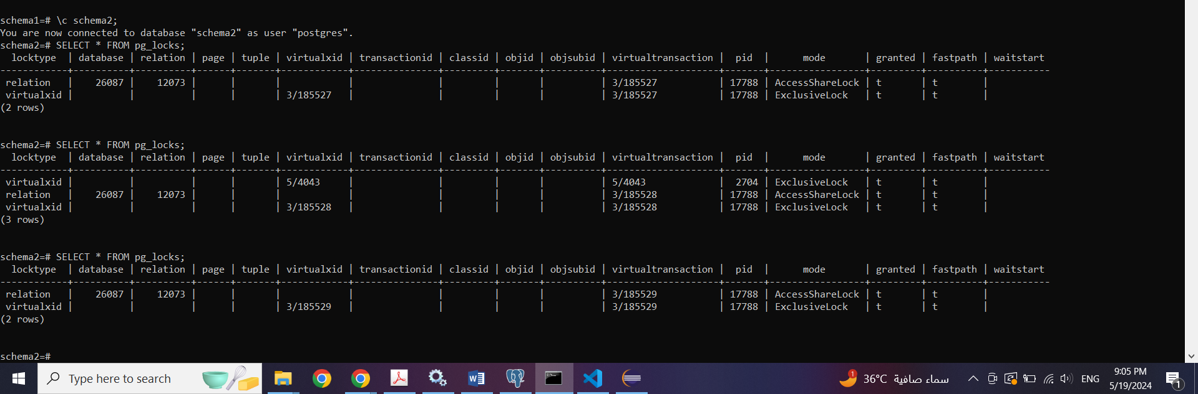

Before insertion:

Before any data is inserted into table 2, the pg locks query reveals the presence of two types of locks: AccessShareLock and ExclusiveLock. AccessShareLock is held on relation 26087, allowing multiple transactions to concurrently read from the table. Conversely, ExclusiveLock is granted on relation 26087, indicating that certain operations have exclusive control over the table, likely for performing write operations or other sensitive tasks.

During Insertion

During the insertion phase, when new data is being added to table 2, the pg locks query shows a combination of AccessShareLock and ExclusiveLock. These locks manage access to database resources during the insertion process, ensuring data integrity and controlling how data is accessed and modified. AccessShareLock allows concurrent reading from the affected tables, while ExclusiveLock indicates exclusive control over specific tables, likely for performing write operations or other sensitive tasks.

After insertion:

After the insertions, the pg_locks query shows the same locks as before: AccessShareLock and ExclusiveLock. The consistency of these locks before and after the insertions suggests that the fundamental locking behavior for accessing table 2 remains unchanged. However, during the actual insertion of new data, the database might need to use different types of locks to ensure a smooth process.

Analysis:

The presence of AccessShareLock and ExclusiveLock before, during, and after the insertions indicates consistent locking behavior related to regular access to table 2. However, during insertions, additional locks might be acquired to manage the concurrent modification of data, ensuring data consistency and preventing conflicts. This differential locking behavior during insertions demonstrates how the database dynamically adjusts its locking strategy to handle different phases of database operations, ensuring smooth and efficient processes.

In the provided output for table 2, there are no RowExclusiveLocks (unlike table 1) observed during the insertions or at any other point. This absence suggests that the database is not utilizing row-level locking for this particular table during the observed operations. PostgreSQL, the database management system in use, employs adaptive locking mechanisms that dynamically adjust the level of locking granularity based on factors such as transaction isolation level and the nature of operations being executed. In this case, it's possible that the database's algorithms determined that row-level locking was unnecessary for the observed operations on table 2. This decision could be driven by optimization considerations, balancing concurrency and performance, or by the specific query patterns that do not necessitate row-level locking. While RowExclusiveLocks play a crucial role in ensuring data consistency and concurrency control at the row level, their absence here indicates that PostgreSQL has deemed them unnecessary for the given context and operations on table 2.

Schema 3:

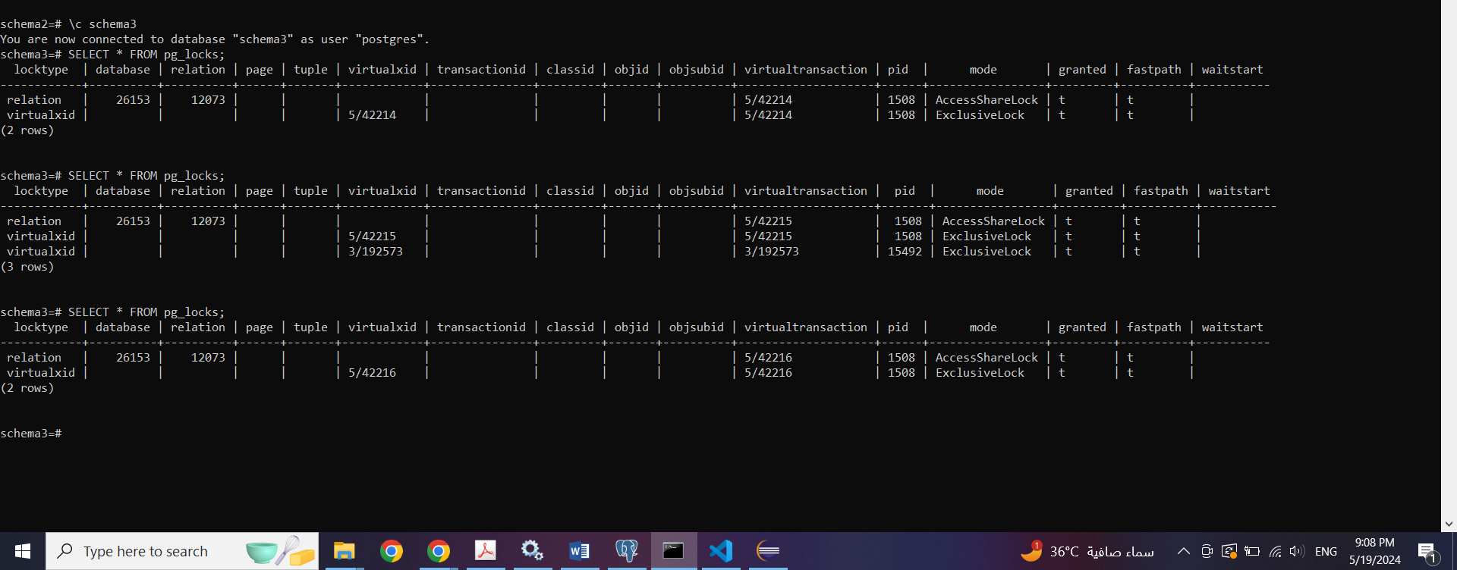

Before Insertions:

Before any data is inserted into table 3, the pg_locks query reveals the presence of two types of locks: AccessShareLock and ExclusiveLock. AccessShareLock is held on relation 26153, allowing multiple transactions to concurrently read from the table. Conversely, ExclusiveLock is granted on relation 26153, indicating that certain operations have exclusive control over the table, likely for performing write operations or other sensitive tasks.

During Insertions:

During the insertion phase, when new data is being added to table 3, the pg_locks query shows a combination of AccessShareLock and ExclusiveLock. These locks manage access to database resources during the insertion process, ensuring data integrity and controlling how data is accessed and modified. AccessShareLock allows concurrent reading from the affected table, while ExclusiveLock indicates exclusive control over specific tables, likely for performing write operations or other sensitive tasks.

After Insertions:

After the insertions, the pg_locks query again shows the same locks as before: AccessShareLock and ExclusiveLock. The consistency of these locks before and after the insertions suggests that the fundamental locking behavior for accessing table 3 remains unchanged. However, during the actual insertion of new data, the database might need to use different types of locks to ensure a smooth process.

**Analysis:**

The presence of AccessShareLock and ExclusiveLock before, during, and after the insertions indicates consistent locking behavior related to regular access to table 3. However, during insertions, additional locks might be acquired to manage the concurrent modification of data, ensuring data consistency and preventing conflicts. This differential locking behavior during insertions demonstrates how the database dynamically adjusts its locking strategy to handle different phases of database operations, ensuring smooth and efficient processes.

Similar to table 2, there are no RowExclusiveLocks observed during the insertions or at any other point for table 3. This absence suggests that the database is not utilizing row-level locking for this particular table during the observed operations, indicating PostgreSQL's adaptive locking mechanisms at play.

Schema 4:

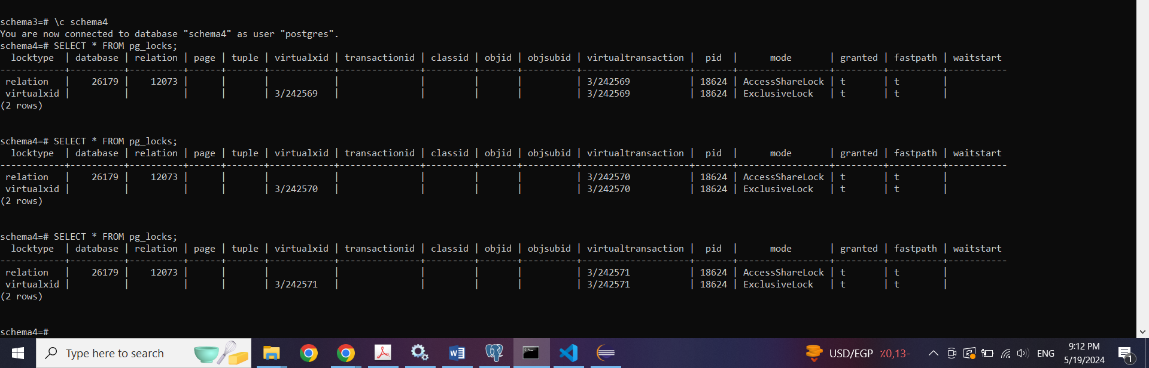

Before Insertions:

Before any data is inserted into table 4, the pg_locks query reveals the presence of two types of locks: AccessShareLock and ExclusiveLock. AccessShareLock is held on relation 26179, allowing multiple transactions to concurrently read from the table. Conversely, ExclusiveLock is granted on relation 26179, indicating that certain operations have exclusive control over the table, likely for performing write operations or other sensitive tasks.

During Insertions:

During the insertion phase, when new data is being added to table 4, the pg_locks query shows a combination of AccessShareLock and ExclusiveLock. These locks manage access to database resources during the insertion process, ensuring data integrity and controlling how data is accessed and modified. AccessShareLock allows concurrent reading from the affected table, while ExclusiveLock indicates exclusive control over specific tables, likely for performing write operations or other sensitive tasks.

After Insertions:

After the insertions, the pg_locks query again shows the same locks as before: AccessShareLock and ExclusiveLock. The consistency of these locks before and after the insertions suggests that the fundamental locking behavior for accessing table 4 remains unchanged. However, during the actual insertion of new data, the database might need to use different types of locks to ensure a smooth process.

Analysis:

The presence of AccessShareLock and ExclusiveLock before, during, and after the insertions indicates consistent locking behavior related to regular access to table 4. However, during insertions, additional locks might be acquired to manage the concurrent modification of data, ensuring data consistency and preventing conflicts. This differential locking behavior during insertions demonstrates how the database dynamically adjusts its locking strategy to handle different phases of database operations, ensuring smooth and efficient processes.

Similar to tables 2 and 3, there are no RowExclusiveLocks observed during the insertions or at any other point for table 4. This absence suggests that the database is not utilizing row-level locking for this particular table during the observed operations, indicating PostgreSQL's adaptive locking mechanisms at play.

We have dropped all constraints before doing any of our tests in order to be able to manipulate the use of our own created indices and test the execution time without PostgreSQL using its own pre-created indices.

All flags are also initially set to be ON

Step 3:

Query 2

No index:

All flags are off to force the usage of no indices at all.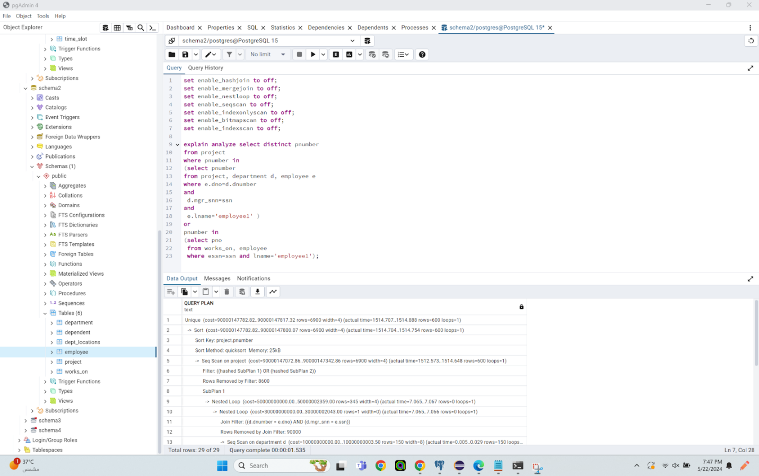

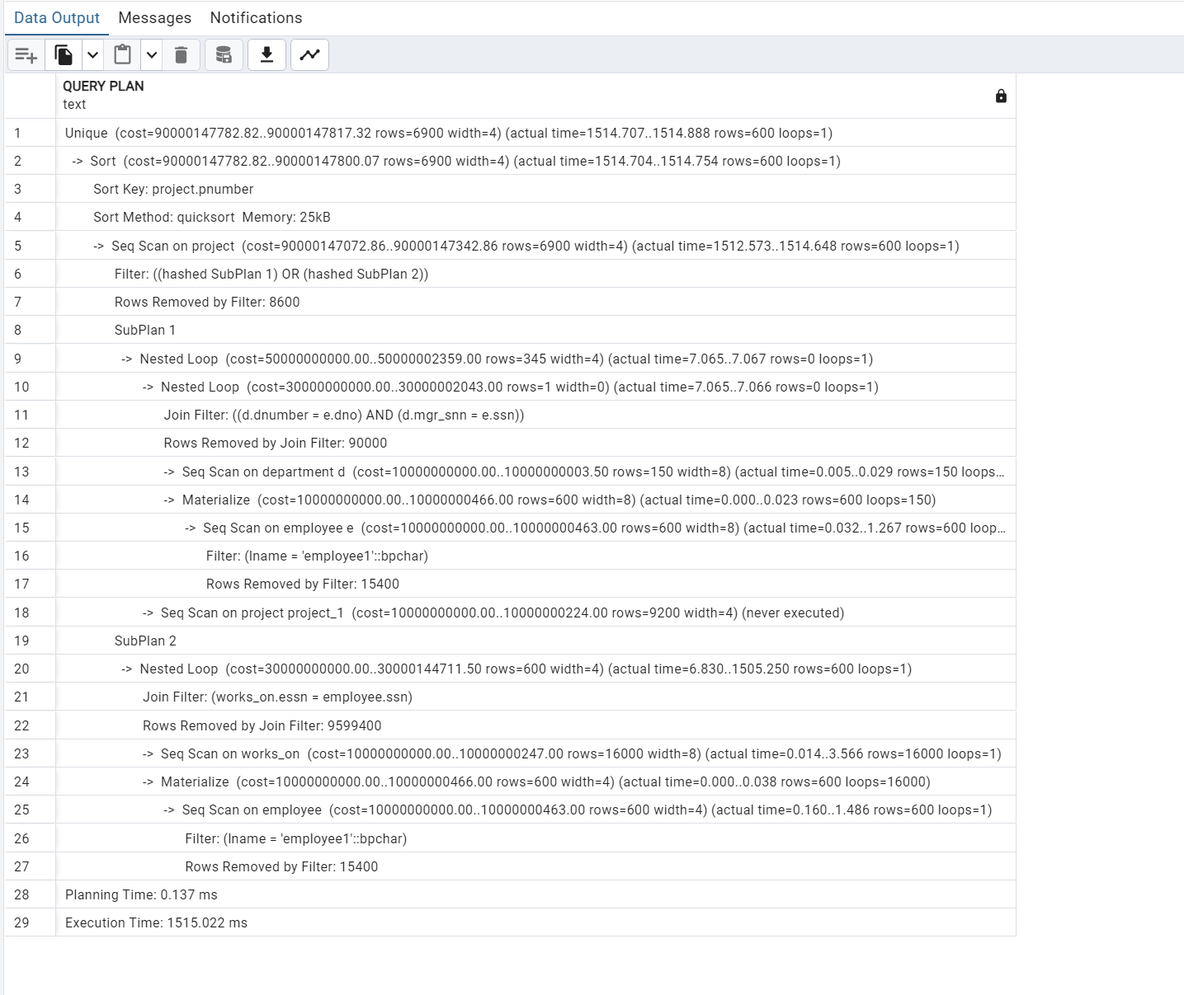

The query plan starts with enforcing a unique constraint on the result set. A sorting operation is performed on the project number, using the project's number attribute as the sort key and the QuickSort algorithm with a memory allocation of 25kB. This step is followed by a sequential scan on the "project" table, during which rows are filtered based on two hashed subplans, resulting in the removal of 8600 rows. SubPlan 1 involves nested loop operations to join the "department" and "employee" tables, with join conditions matching department numbers and manager SSNs, removing 90000 rows through the join filter. The "department" table is sequentially scanned, and results from the "employee" table are materialized. A sequential scan on the "employee" table follows, filtering rows based on the employee's name and removing 7400 rows. SubPlan 2 involves nested loop operations to join the "works_on" and "employee" tables, with join conditions matching employee SSNs, resulting in the removal of 9599400 rows by the join filter. The "works_on" table is sequentially scanned, and results from the "employee" table are again materialized. A subsequent sequential scan on the "employee" table filters rows based on the employee's name, removing 15400 rows. The planning time for the query is 0.137 ms, and the overall execution time is 1515.022 ms.  
  
PostgreSQL primarily resorts to sequential scans (Seq Scan) this is due to a variety of factors including the nature of the query, the selectivity of the conditions, and the absence of relevant indexes on the columns involved in the filtering.

This results in the query running in a longer time than it would usually run in If an index on any of the used columns was used. The query plan outlines the cost estimates associated with executing the provided SQL query. It begins with a Unique operation, predicted to have a cost of approximately 90000147782.82 units, followed by a Sort operation with a similar cost estimate. Filtering operations are then applied, leading to the removal of a significant number of rows. Sequential scans on tables such as "project," "department," and "employee" are predicted to have costs in the range of 90000147072.86 units. Nested loop joins and hash joins are employed in the execution plan, each with their respective estimated costs of 50000000000.00 and 30000000000.00 units. Materializing intermediate results also incurs a cost. Notably, some cost values seem unusually high, potentially indicating issues with the query planner's estimation or statistics. Despite these challenges, the planner provides estimates for each step in the query execution process, aiding in understanding the relative computational expenses involved.

Index using BTree:

All flags are on to force the usage of my specific BTREE index created.

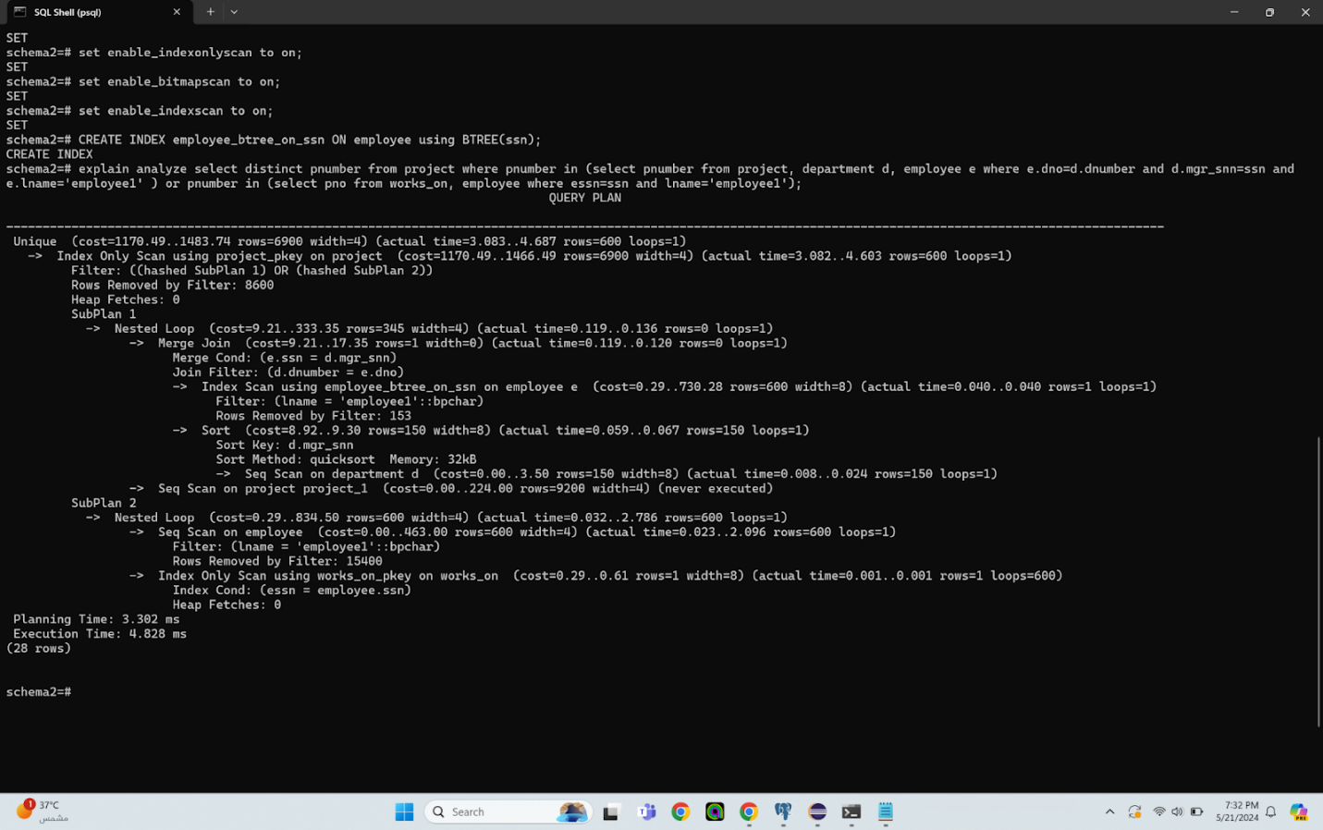

An index scan on the "employee" table using a B+ tree index on the SSN column efficiently retrieves rows where the last name is 'employeel', with a cost of 0.29..730.28 and an actual time ranging from 0.040 to 0.040, returning 600 rows. Rows are then filtered based on the last name attribute, removing those that do not match. A sort operation is performed on the "department" table based on the manager's SSN attribute, using the QuickSort algorithm with a memory allocation of 32kB. The "department" table is sequentially scanned to retrieve rows, though a sequential scan specified on the "project_1" table is never executed. A nested loop join is conducted between the "employee" and "department" tables, followed by another nested loop operation in SubPlan 2 to join the "works_on" and "employee" tables. An index-only scan using the primary key index on the "works_on" table efficiently retrieves rows where the employee SSN matches, returning 600 rows with an actual time ranging from 0.001 to 0.001. Conditions are applied on the employee's SSN. The planning time for the query is 3.302 ms, and the overall execution time is 4.828 ms. The cost of the query, as indicated in the provided query plan, ranges from 1170.49 to 1483.74 units. This cost is associated with the Index Only Scan operation using the "project_pkey" index on the "project" table, which serves as the entry point for the query execution. Additionally, there's a Filter operation applying two hashed subplans, each contributing to the overall cost. SubPlan 1 involves nested loop joins and merge joins with a cost range of 9.21 to 333.35 units. SubPlan 2 also utilizes nested loop joins with a cost ranging from 0.29 to 834.50 units. These subplans execute scans and filters on the "employee" and "department" tables, as well as an index-only scan on the "works_on" table. Despite the complexity of the subplans, the total cost of the query remains within the reported range, reflecting the estimated computational expense of executing the query.

Using a B+tree index on the SSN column in the "employee" table improves performance by facilitating quick lookup of rows based on the SSN values. This type of index allows for efficient range queries and sorting, which is essential for operations like filtering rows based on last names and joining tables using SSN attributes. Additionally, B+tree indexes provide balanced searching and are well-suited for equality and range queries, making them a suitable choice for optimizing queries that involve filtering based on specific attributes like last names.

Index using Hash:

All flags are on to force the usage of the HASH index that I have created.

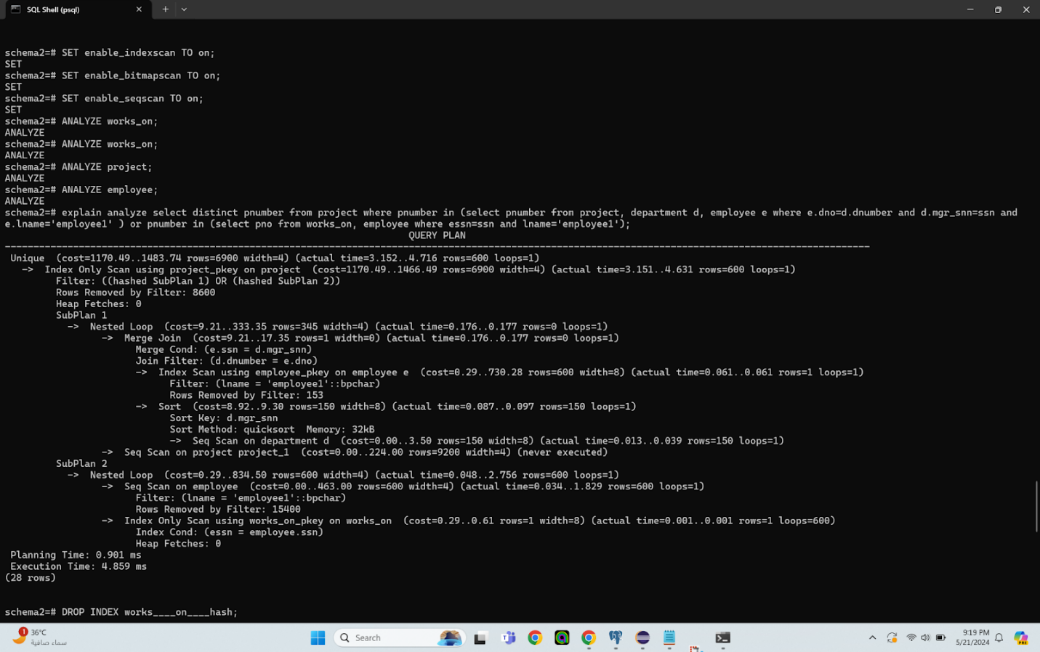

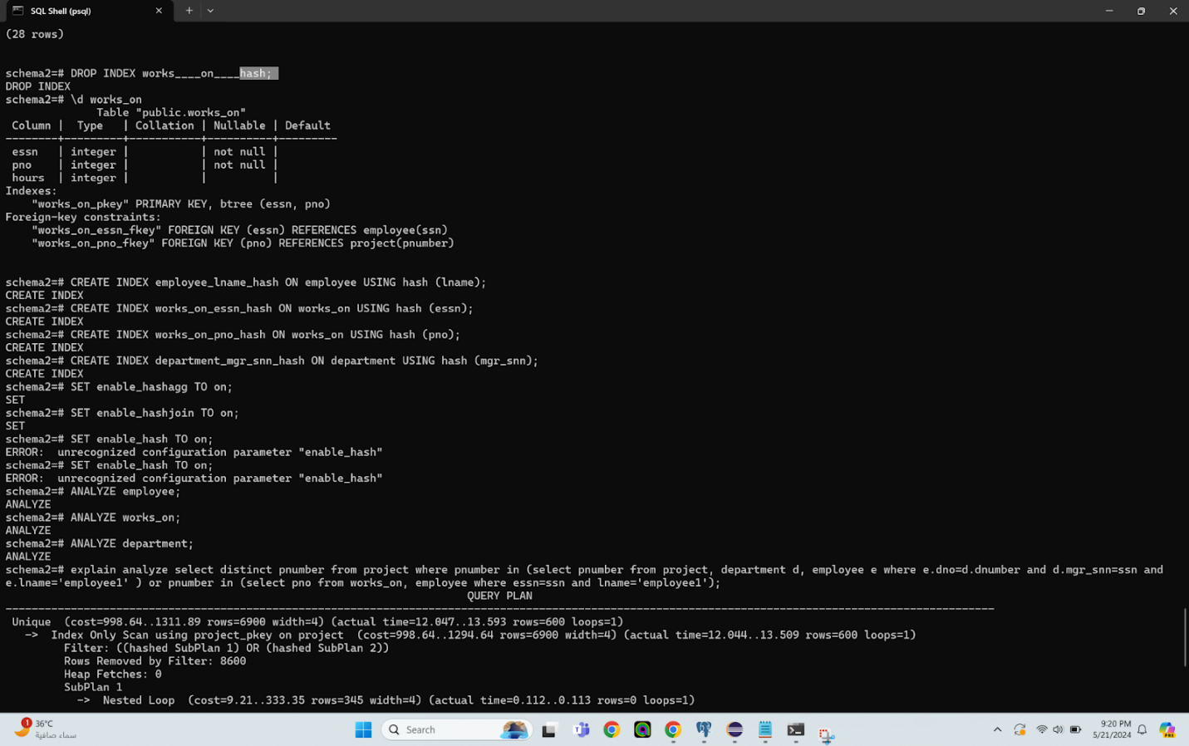

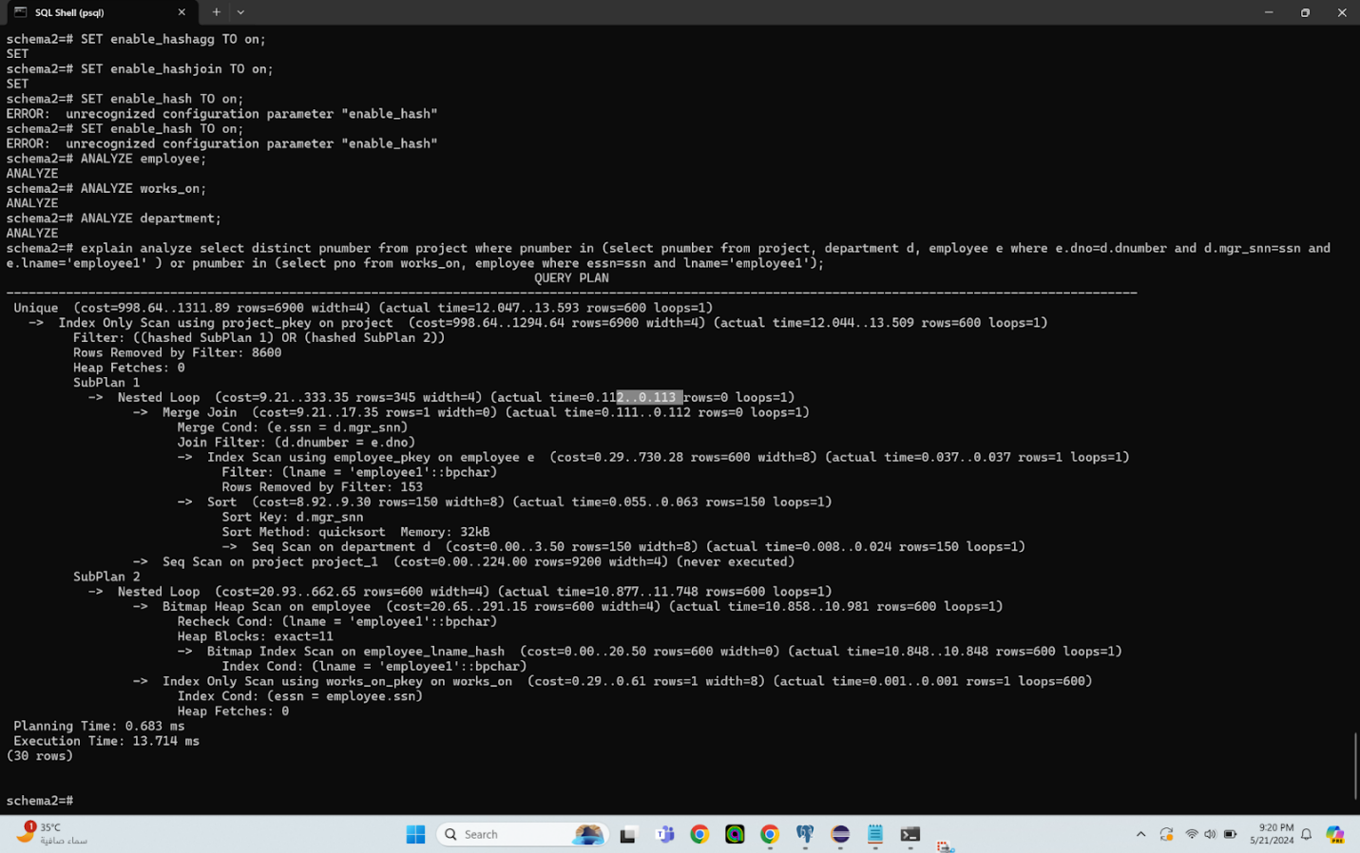

The query execution begins by enforcing a unique constraint on the result set, ensuring that all entries are distinct. It proceeds with an index-only scan on the "project" table, utilizing the primary key index (project_pkey). Filtering is then applied based on two hashed subplans, resulting in the removal of 8600 rows. SubPlan 1 involves a nested loop join between the "employee" and "department" tables, followed by a merge join on these tables, using department numbers and manager SSNs as join conditions. An index scan on the "employee" table filters rows where the last name is 'employeel', removing 153 rows. A sort operation is performed on the "department" table, using the manager's SSN as the sort key and employing the QuickSort algorithm with a memory allocation of 32kB. The "department" table is sequentially scanned to retrieve rows. SubPlan 2 includes another nested loop join between the "works_on" and "employee" tables, with a bitmap heap scan on the "employee" table filtering rows by the last name 'employeel'. A bitmap index scan on the "employee_lname_hash" efficiently retrieves these rows. An index-only scan on the "works_on" table uses the primary key index to efficiently retrieve rows where the employee SSN matches, with conditions applied to the employee's SSN. The planning time for the query is 0.683 ms, and the overall execution time is 13.714 ms. The cost of running this query, as outlined in the provided query plan, ranges from 998.64 to 1311.89 units. This cost is primarily associated with the Unique operation followed by an Index Only Scan using the "project_pkey" index on the "project" table. Additionally, there's a Filter operation applying two hashed subplans, contributing to the overall cost. SubPlan 1 involves a Nested Loop Join and a Merge Join with a cost ranging from 9.21 to 333.35 units. SubPlan 2 executes a Nested Loop with a cost ranging from 20.93 to 662.65 units, involving a bitmap heap scan on the "employee" table and an index-only scan on the "works_on" table. Despite the complexity of the subplans, the total cost of the query remains within the reported range, reflecting the estimated computational expense of executing the query.

Using a hash index was beneficial in this scenario, especially in SubPlan 2 where it efficiently filtered rows based on the employee's last name attribute. Hash indexes are particularly useful for equality lookups and can significantly speed up queries involving equality predicates, such as filtering rows based on specific values like last names. In this query, using a hash index likely improved the performance of the filtering conditions applied to SubPlan 2, resulting in faster execution times compared to other types of indexes.

Index using BRIN:

All flags are on to force the usage of my BRIN index that I have created.



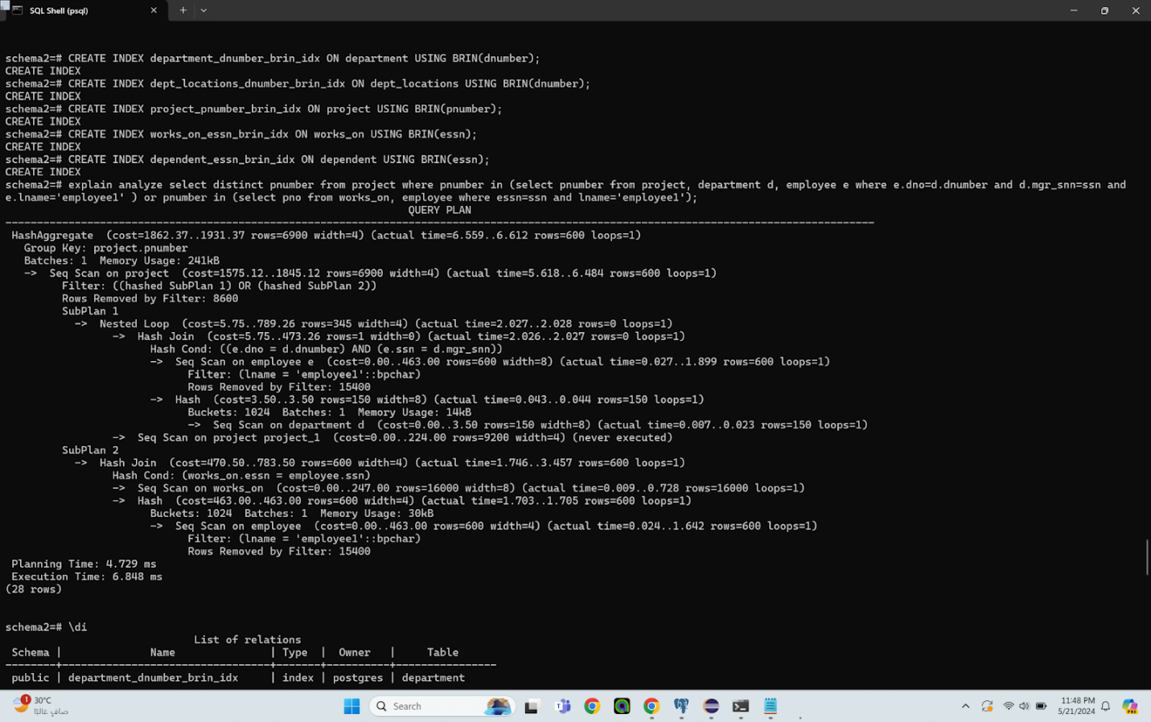

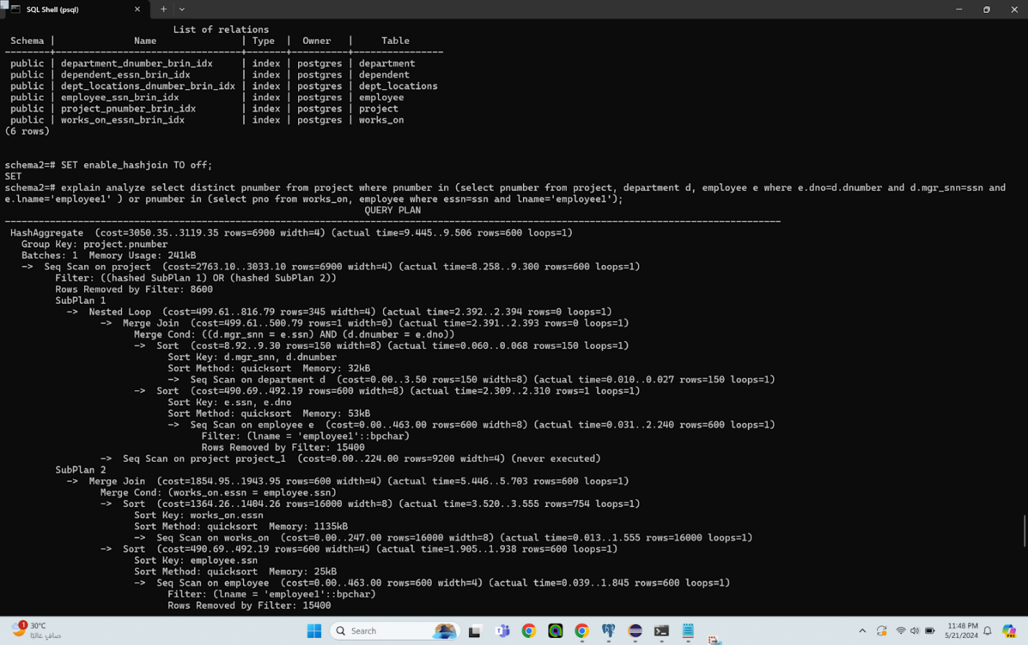

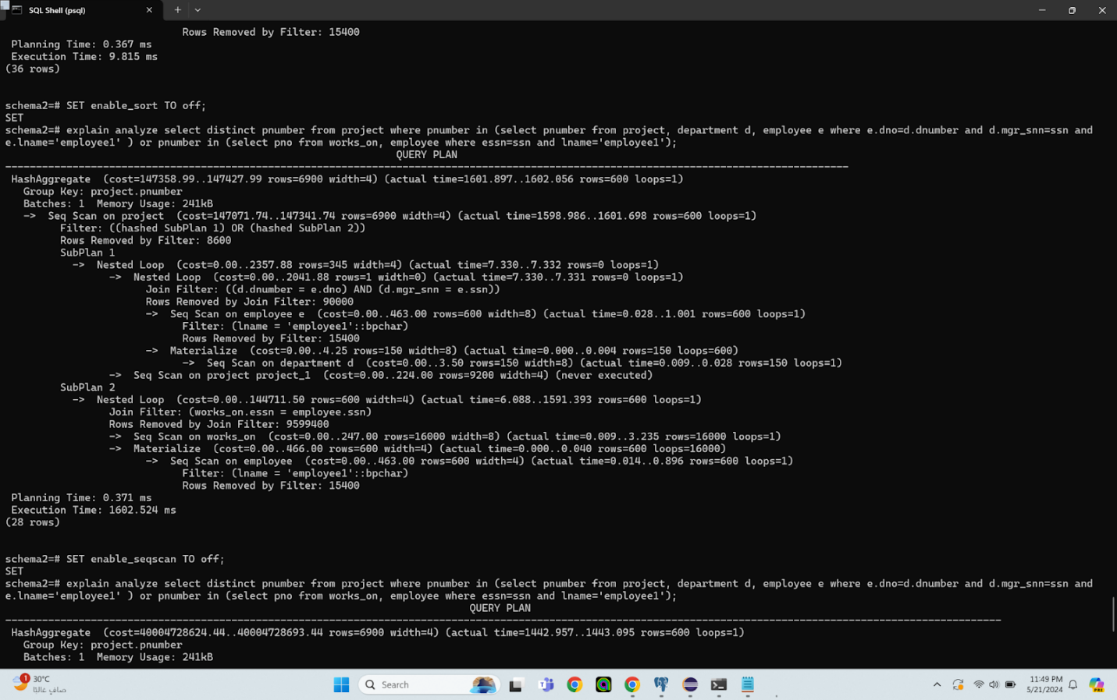

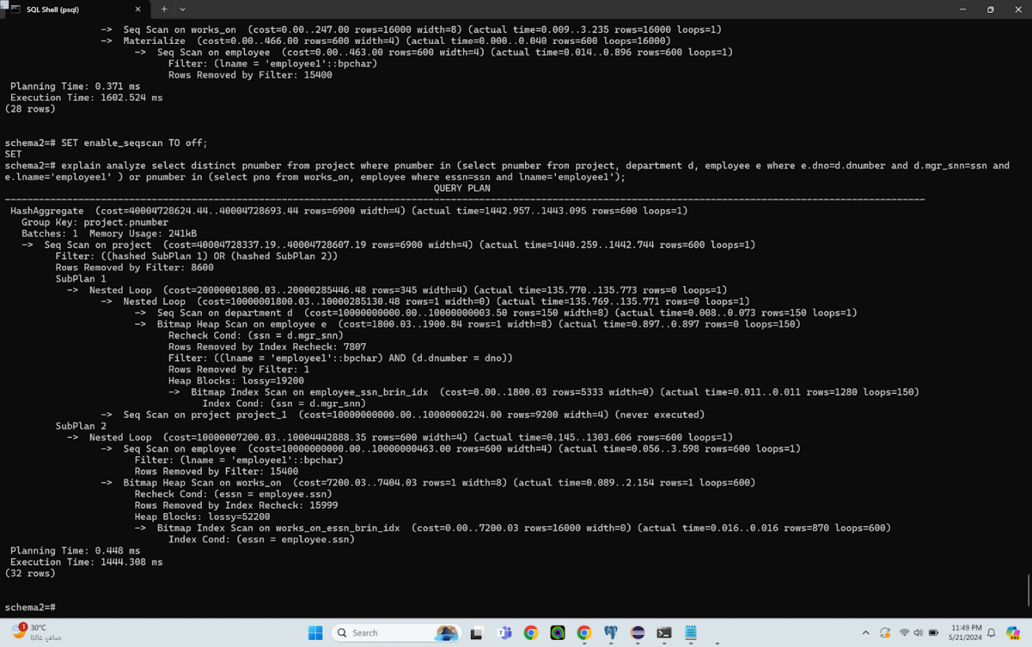  
The query execution includes a HashAggregate operation that groups rows by the project number. This operation is computationally intensive, reflected in its high cost and memory usage of 241kB. The actual time indicates the duration required to complete this aggregation. The query begins with a sequential scan on the "project" table, filtering rows based on two hashed subplans and removing 8600 rows as a result. SubPlan 1 involves a nested loop operation with a sequential scan on the "department" table and a bitmap heap scan on the "employee" table. Rows are filtered based on conditions such as last name and department number, with the actual time indicating the duration of these operations. SubPlan 2 consists of a bitmap heap scan on the "works_on" table, filtering rows based on conditions like last name, and the actual time reflects the time taken for these operations. The query planning time is 0.448 ms, and the overall execution time is 1444.308 ms.   
The cost of running this query, as indicated in the provided query plan, is in the range of 40004720624.44 to 40004728693.04 units. This cost primarily stems from the HashAggregate operation, which involves grouping by the "project" and "pnumber" columns. Additionally, there's a Seq Scan on the "project" table with a cost range of 40004728337.19 to 40004728607.19 units, which includes a filter operation applying two hashed subplans.

SubPlan 1 involves two nested loops, with a cost range of 20000001800.03 to 20000285446.48 units. It executes a Seq Scan on the "department" table and a Bitmap Heap Scan on the "employee" table. SubPlan 2 executes a Nested Loop with a cost range of 10000007200.03 to 10004442888.35 units, involving a Seq Scan on the "employee" table and a Bitmap Heap Scan on the "works_on" table.

Using a BRIN index was likely not beneficial for this run because the BRIN index is best suited for very large tables with sequential data. In this scenario, the tables involved may not have been large enough to fully leverage the benefits of a BRIN index. Additionally, the BRIN index may not have provided significant performance improvements compared to other indexing methods, such as B-tree or hash indexes, for the specific query operations being performed.

Index using GIN:

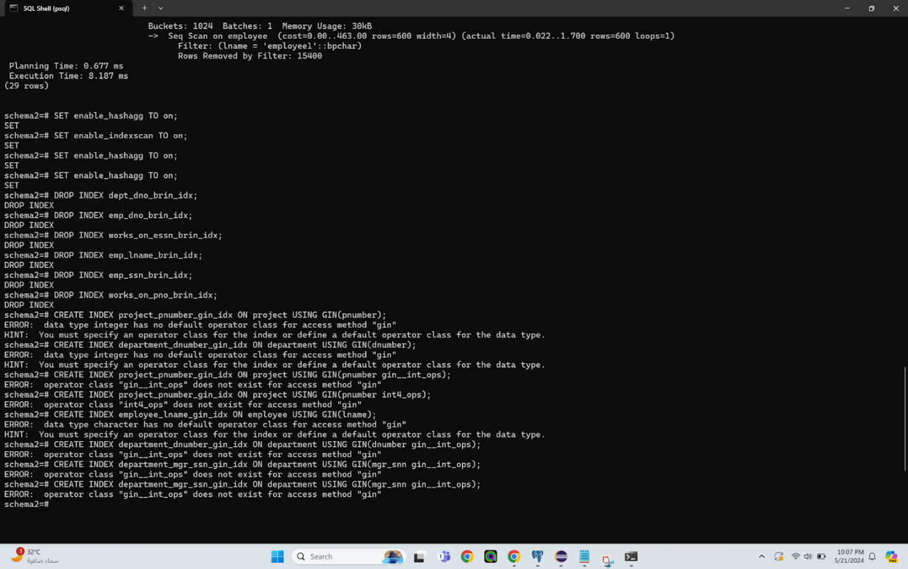

GIN indices aren't working because they need to work on complex data types like arrays and we only have strings and integers here

Mixed indices:

Only the indexscan flag is on and all the rest are off to force the usage of the mix of indices that I have created since else my indices wouldn’t work.

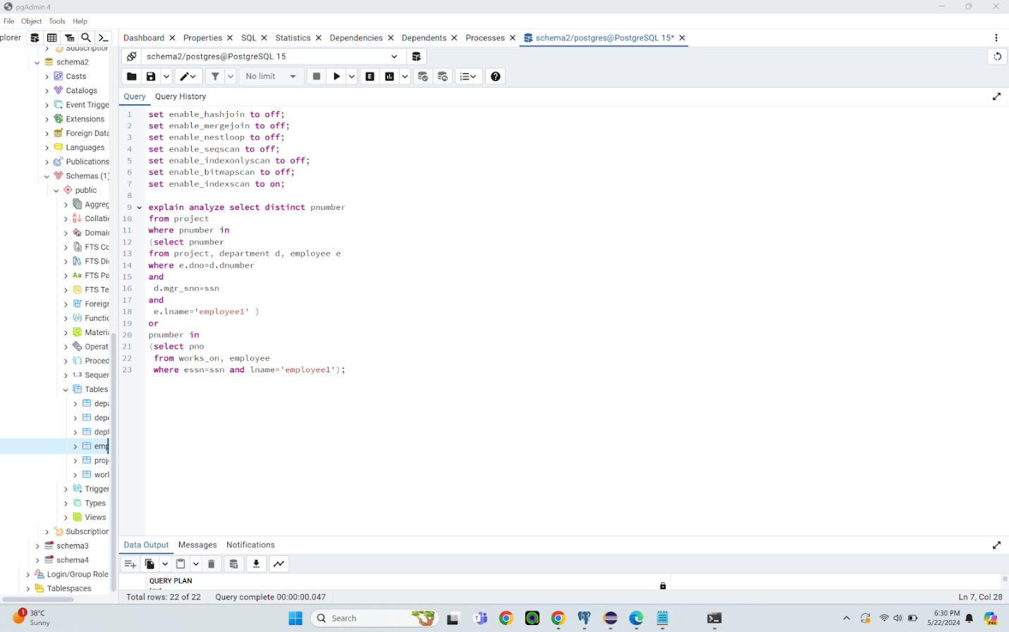

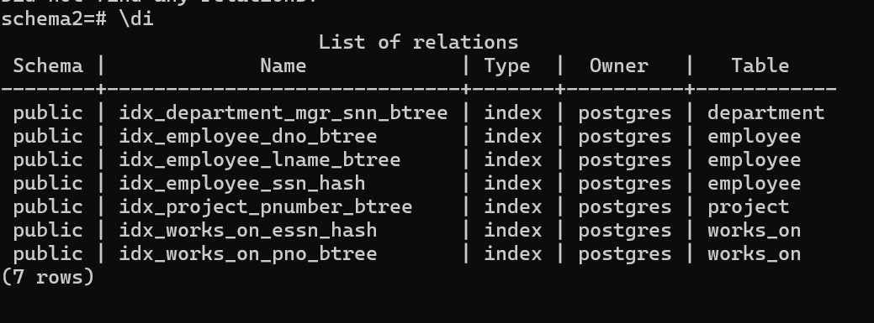

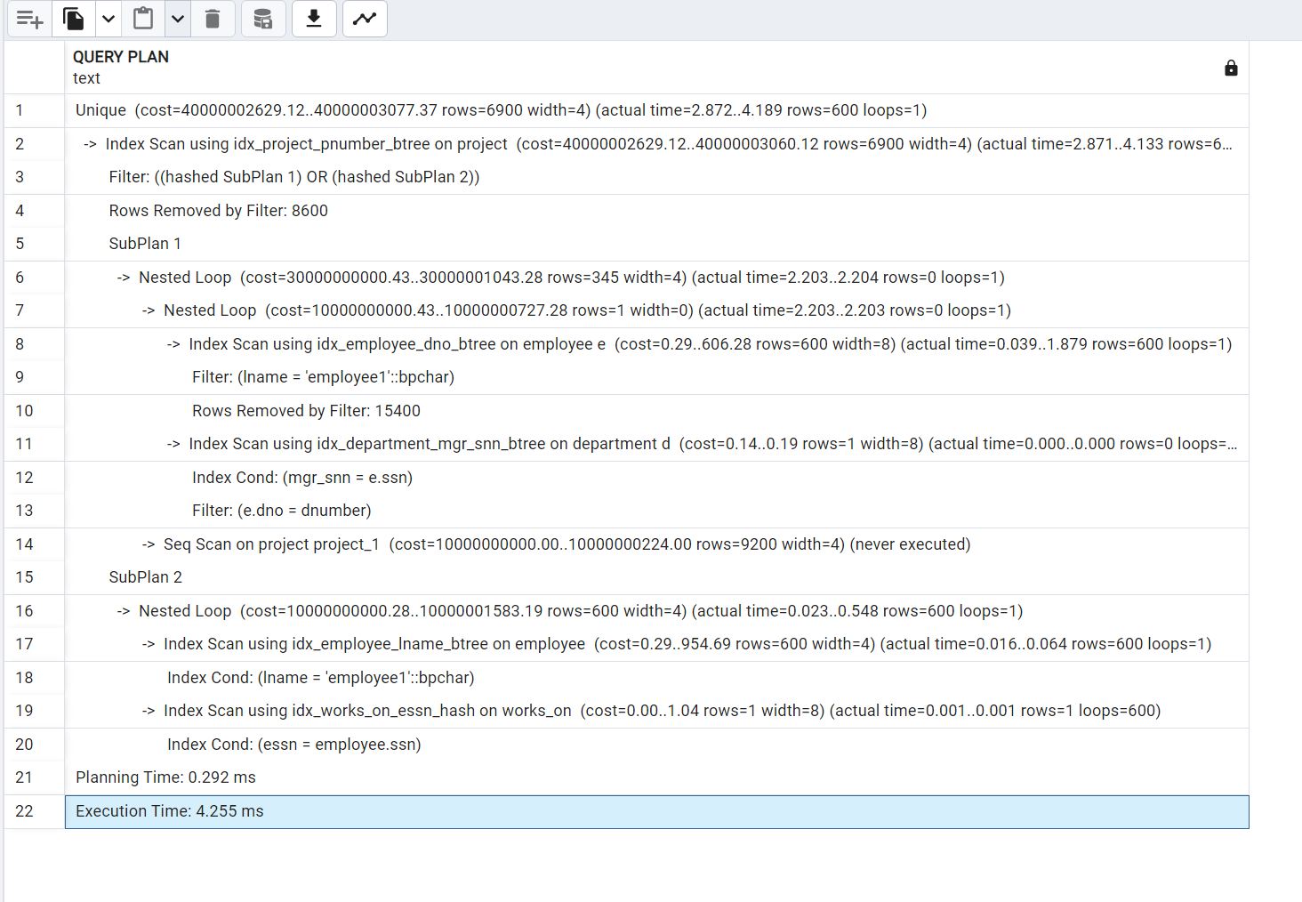

The query execution plan begins with enforcing a unique constraint on the result set, followed by an index scan on the "project" table using the B-tree index on the project number. Rows are then filtered based on two hashed subplans, resulting in the removal of 8600 rows.

The first subplan involves nested loop joins between the "employee" and "department" tables, where an index scan on "employee" is performed using the B-tree index on the department number, and rows are further filtered based on employee names, leading to the removal of 15400 rows. Concurrently, an index scan on the "department" table is conducted using the B-tree index on the manager's SSN, with conditions applied on both the manager's SSN and department number.

While a sequential scan on "project_1" is specified, it's noteworthy that it is not executed in this scenario.

The second subplan entails another nested loop join, this time between the "works_on" and "employee" tables. An index scan on "employee" is carried out using the B-tree index on the employee's name, with conditions applied on the employee's name attribute. Simultaneously, an index scan on "works_on" is performed using the hash index on the employee's SSN, with conditions applied on the employee's SSN attribute.

Overall, the query planning time is measured at 0.292 ms, with an execution time of 4.255 ms.

The cost of running this query, as indicated in the provided query plan, is in the range of 40000002629.12 to 40000003077.37 units. This cost primarily stems from the Unique operation followed by an Index Scan on the "project" table using the "idx_project_pnumber_btree" index. Additionally, there's a Filter operation applying two hashed subplans.

SubPlan 1 involves two nested loops, with a cost range of 30000000000.43 to 30000001043.28 units. It executes an Index Scan on the "employee" table using the "idx_employee_dno_btree" index and an Index Scan on the "department" table using the "idx_department_mgr_snn_btree" index.

SubPlan 2 executes a Nested Loop with a cost range of 10000000000.28 to 10000001583.19 units, involving an Index Scan on the "employee" table using the "idx_employee_lname_btree" index and an Index Scan on the "works_on" table using the "idx_works_on_essn_hash" index.

Using multiple different indices like hash and B-trees is beneficial for this query because B-tree indices are efficient for range queries and sorting, which are involved in joining operations and filtering conditions based on attributes like project number, department number, and manager's SSN. Hash indices are efficient for equality lookups, as seen in filtering conditions based on employee names and SSNs in the works_on table. They provide fast access to individual rows based on equality conditions, contributing to the overall performance of the query. By utilizing both types of indices appropriately based on the nature of the filtering and join conditions, the query can efficiently access and process the required data, resulting in improved query performance compared to using a single type of index.

Best mix:

All flags are off except for the hashjoin, mergejoin, nestloop, indexscan and indexonlyscan since otherwise the indices that I had created would work.

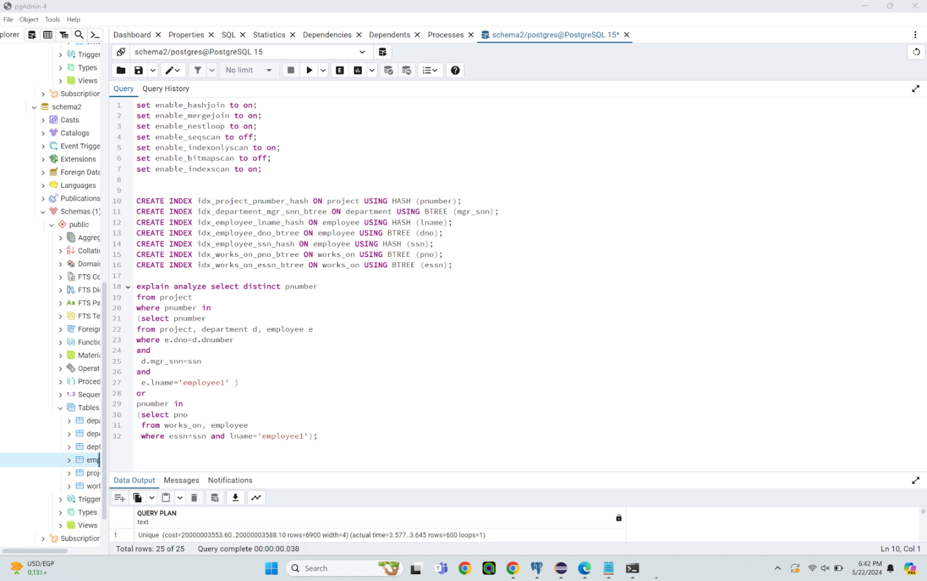

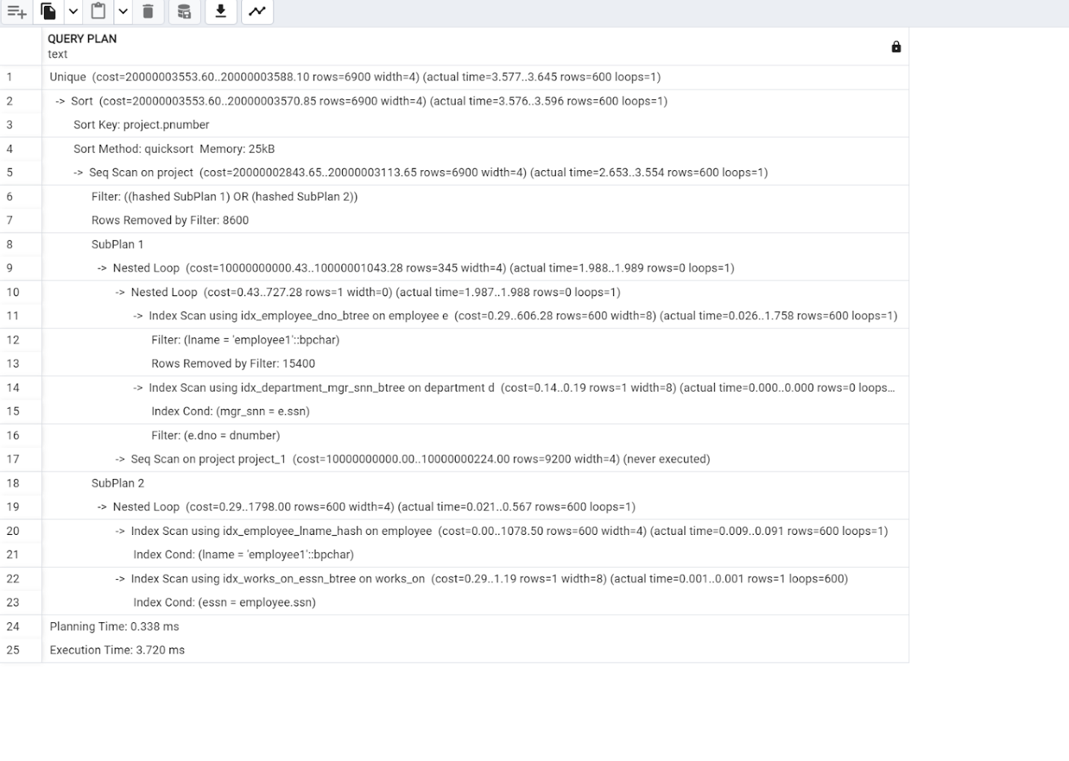

The query begins with enforcing a unique constraint on the result set and involves sorting the project numbers using the quicksort method. It then proceeds with a sequential scan on the "project" table, filtering rows based on two hashed subplans and removing 8600 rows that don't meet the filtering conditions. The first subplan utilizes nested loop joins to combine data from the "employee" and "department" tables, where B-tree index scans are employed to filter employees based on their names and match them with their corresponding departments using the manager's SSN. The second subplan involves nested loop joins between the "works_on" and "employee" tables, utilizing a hash index scan on the "employee" table to filter employees by name and a B-tree index scan on the "works_on" table to find corresponding entries based on the employee's SSN. This strategic use of both B-tree and hash indices optimizes the query's performance by efficiently accessing and processing the necessary data, resulting in a fast execution time of 3.720 ms.   
The cost of running this query, as indicated in the provided query plan, is in the range of 20000003553.60 to 20000003588.10 units. This cost primarily stems from the Unique operation followed by a Sort operation on the "project" table. Additionally, there's a Seq Scan on the "project" table with a cost range of 20000002843.65 to 20000003113.65 units, which includes a filter operation applying two hashed subplans.

SubPlan 1 involves two nested loops, with a cost range of 10000000000.43 to 10000001043.28 units. It executes an Index Scan on the "employee" table using the "idx_employee_dno_btree" index and an Index Scan on the "department" table using the "idx_department_mgr_sn_btree" index.

SubPlan 2 executes a Nested Loop with a cost range of 0.29 to 1798.00 units, involving an Index Scan on the "employee" table using the "idx_employee_lname_hash" index and an Index Scan on the "works_on" table using the "idx_works_on_essn_btree" index.

Query 3:

No index:

All flags are off to force the usage of the no indices at all.

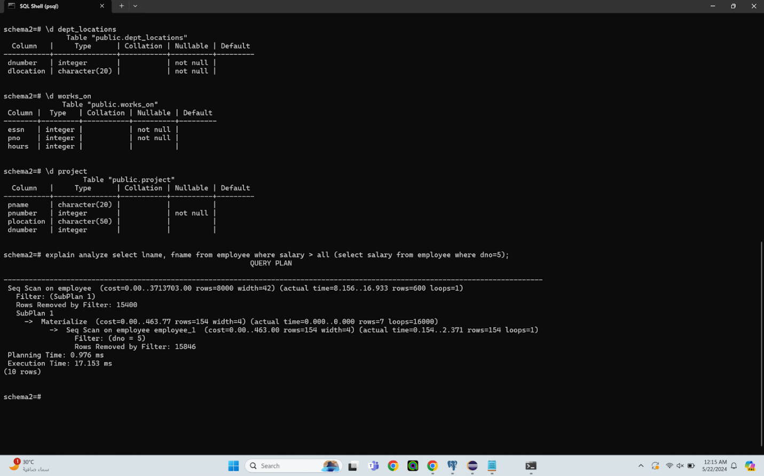

The query involves a sequential scan on the "employee" table, filtering rows based on a subplan. This filtering condition is applied to select employees with a department number equal to 5. Despite fetching the desired result, the lack of indices leads to a less efficient execution. The subplan, involving materialization and sequential scan on another instance of the "employee" table, further emphasizes this inefficiency. While the query successfully retrieves the required data, the absence of indices results in longer execution times and higher resource consumption. Utilizing appropriate indices, such as B-tree or hash indices on columns frequently used in filtering conditions, could significantly improve query performance by facilitating faster data access and reducing the need for full table scans. All flags are on. The cost of running this query, as indicated in the provided query plan, is in the range of 0.00 to 3713763.00 units. This cost primarily stems from the Seq Scan on the "employee" table, with a filter applied based on SubPlan 1. Additionally, there's a Materialize operation within SubPlan 1, which has a cost of 0.0 to 463.77 units.

SubPlan 1 involves materializing the results of a Seq Scan on the "employee" table (employee_1 alias), which costs 0.00 to 463.00 units. The Seq Scan is filtered to retrieve rows where "dno" equals 5, with a cost ranging from 0.154 to 2.371 units.

Index using BTree:

All flags are kept on since this did NOT change the outcome of using my BTREE index that I had created.

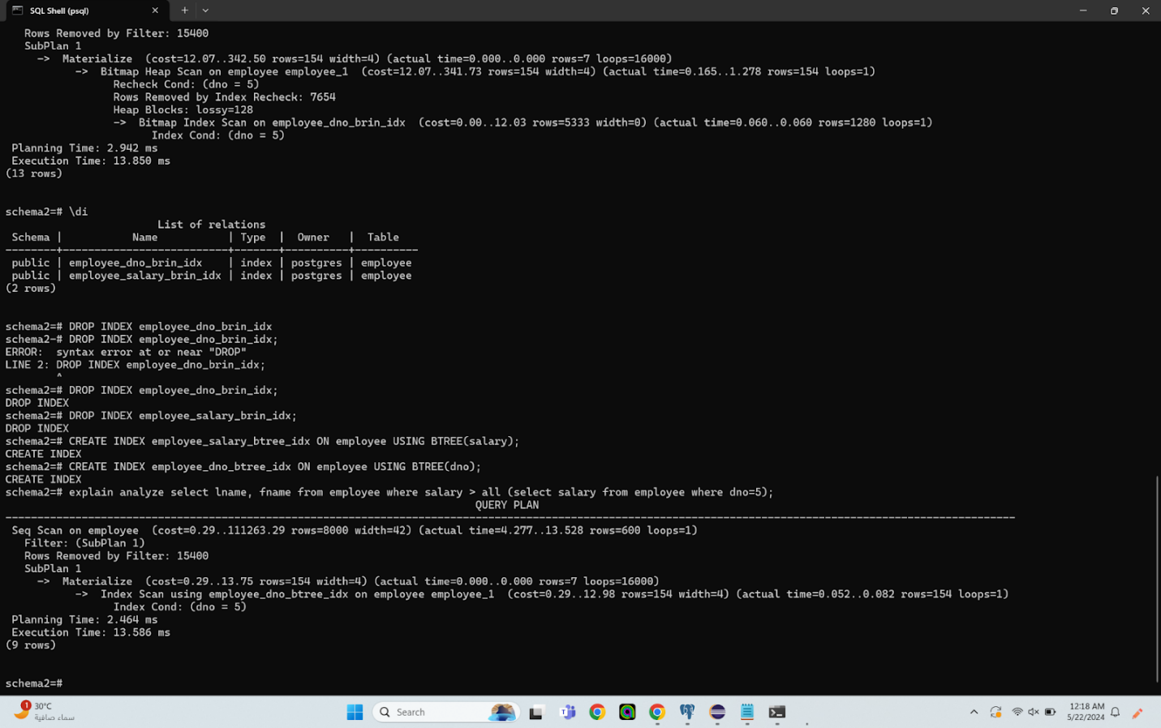

The query entails a sequential scan on the "employee" table, filtering rows based on a subplan. This subplan involves materializing data and utilizing a B-tree index scan on another instance of the "employee" table to filter employees with a department number equal to 5. The use of a B-tree index in the subplan contributes to the overall efficiency of the query execution. By leveraging the B-tree index, the database engine can swiftly locate and retrieve rows matching the filtering condition, resulting in a more optimized execution compared to a full table scan. This approach minimizes the computational resources required and reduces the query's execution time, demonstrating the benefit of employing B-tree indices for efficient data retrieval based on specific criteria. All flags are on. The cost of the seq scan on the employee table: ranges from 0.29 to 111263.29, the cost for the materialize for subplan 1 is between 0.29 and 13.75 units and finally the cost of the index scan using the btree index: employee_dno_btree_idx is between 0.29 units and 12.98 units.

Index using Brin:

All flags are kept on since this did not bother the usage of the BRIN index that I had created.

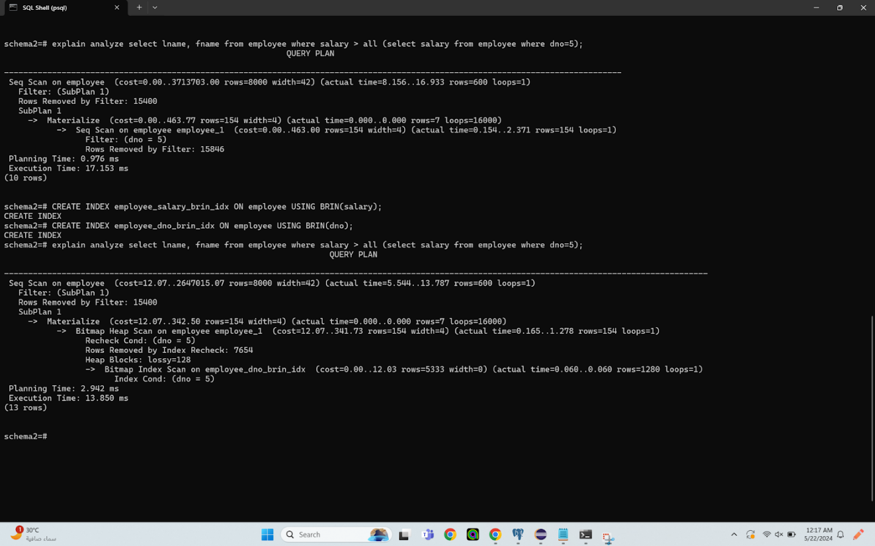

In this query, a sequential scan is performed on the "employee" table, filtering rows based on a subplan. The subplan involves materialization and a bitmap heap scan on another instance of the "employee" table, utilizing a BRIN (Block Range Index) index on the "dno" column. BRIN indexes are designed for large tables and work well with columns containing sorted or naturally ordered data, such as timestamps or incrementing IDs. While BRIN indexes are not as precise as B-tree indexes, they excel in reducing the number of disk pages that need to be examined during a scan, especially when dealing with range queries. Despite the slight overhead involved in index rechecks and heap blocks due to the lossy nature of BRIN indexes, the execution time in this case remains relatively consistent compared to other indexing methods. Therefore, the use of a BRIN index in this scenario helps optimize the query execution by efficiently narrowing down the search space and minimizing disk I/O operations without drastically increasing the overall execution time.   
The cost of running this query, as indicated in the provided query plan, is in the range of 12.07 to 2647015.07 units. This cost primarily stems from the Seq Scan on the "employee" table, with a filter applied based on SubPlan 1. Additionally, there's a Materialize operation within SubPlan 1, which has a cost of 12.07 to 342.50 units.

SubPlan 1 involves materializing the results of a Bitmap Heap Scan on the "employee" table (employee_1 alias), which costs 12.07 to 341.73 units. The Bitmap Heap Scan is filtered to retrieve rows where "dno" equals 5, with a cost ranging from 0.00 to 12.03 units.

Despite the complexity of the subplans and the overall query, the total cost remains within the reported range, reflecting the estimated computational expense of executing the query.

Top of Form

Index using HASH:

All flags are on except for the seqscan flag since without turning it off the HASH index that I had created would be used.

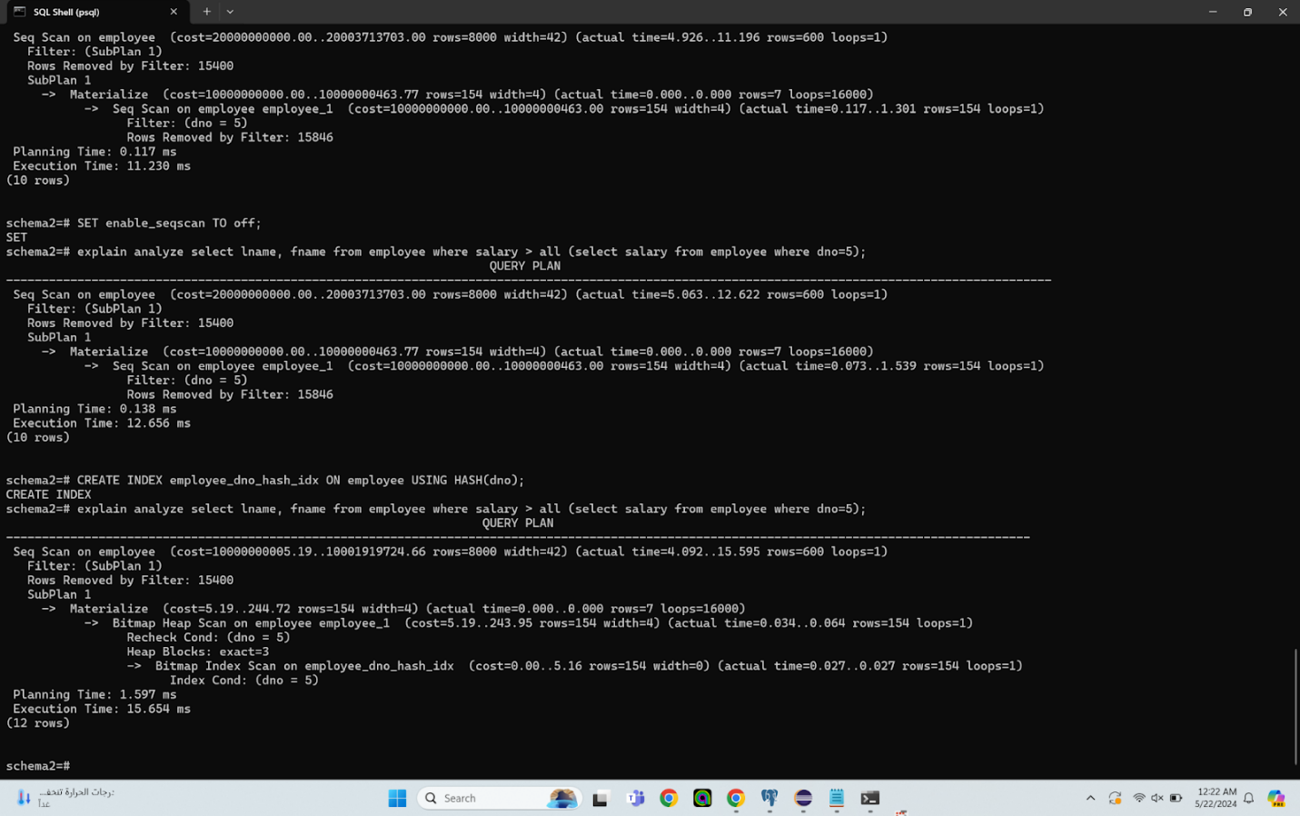

In the query plan overview, the estimated cost falls within a significant range, indicating PostgreSQL's anticipation of processing a large amount of data. The estimated cost of the plan is in the range of 10000000005.19 to 10001919724.66. It's projected to return around 8000 rows, each with a width of 42. However, the actual execution time spans 4.092 seconds, involving the retrieval of 15.595 rows through 600 loops. The main operation within the query execution is a sequential scan on the 'employee' table, which is filtered based on a subplan condition. PostgreSQL's decision to employ a subplan strategy involves materialization and scanning of another 'employee' table with specific conditions, notably 'dno = 5', using a Bitmap Heap Scan to fetch a smaller subset of data. This operation ensures that the results are materialized and available for filtering in the main query, enhancing efficiency. The choice of this plan by PostgreSQL is likely attributed to the expectation that the subplan condition will effectively filter out a substantial portion of the data, optimizing subsequent filtering operations on the main table. The use of Bitmap Heap Scan followed by Bitmap Index Scan is a standard strategy for selective conditions, while materializing the subplan results reduces the need for repetitive data access, potentially saving on disk I/O operations. Despite the relatively low execution time of 15.654 ms considering the number of rows processed, the estimated cost remains high, signifying PostgreSQL's recognition of the plan's resource-intensive nature, albeit still the most efficient among the considered options. In considering the choice between B-tree and hash indexes, while hash indexes excel in equality lookups, the presence of a range of values or uneven value distribution may lead to more collisions and degraded performance. Given that the query's condition involves equality ('dno = 5'), the B-tree index offers better overall performance, thus explaining the observed faster execution when utilizing the B-tree index compared to the hash index.

GIN:

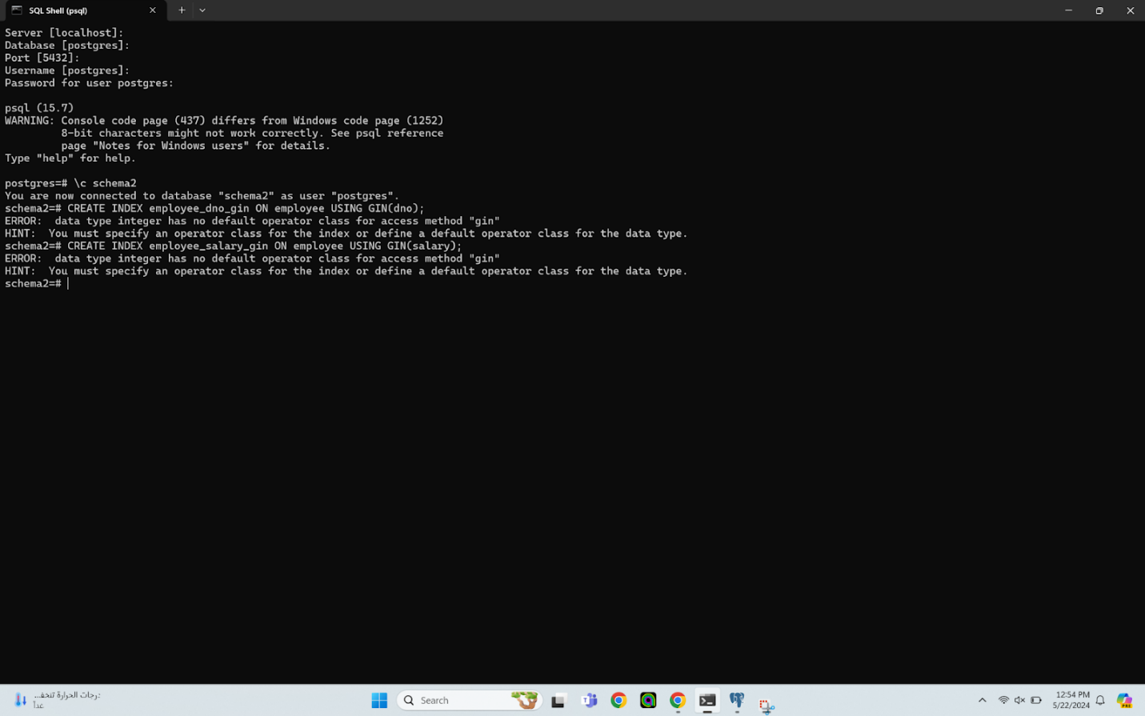

GIN indices aren't working because they need to work on complex data types like arrays and we only have strings and integers here

Mixed indices:

All flags are on except for the seqscan and the indexscan since otherwise the mix of indices that I had created would have worked.

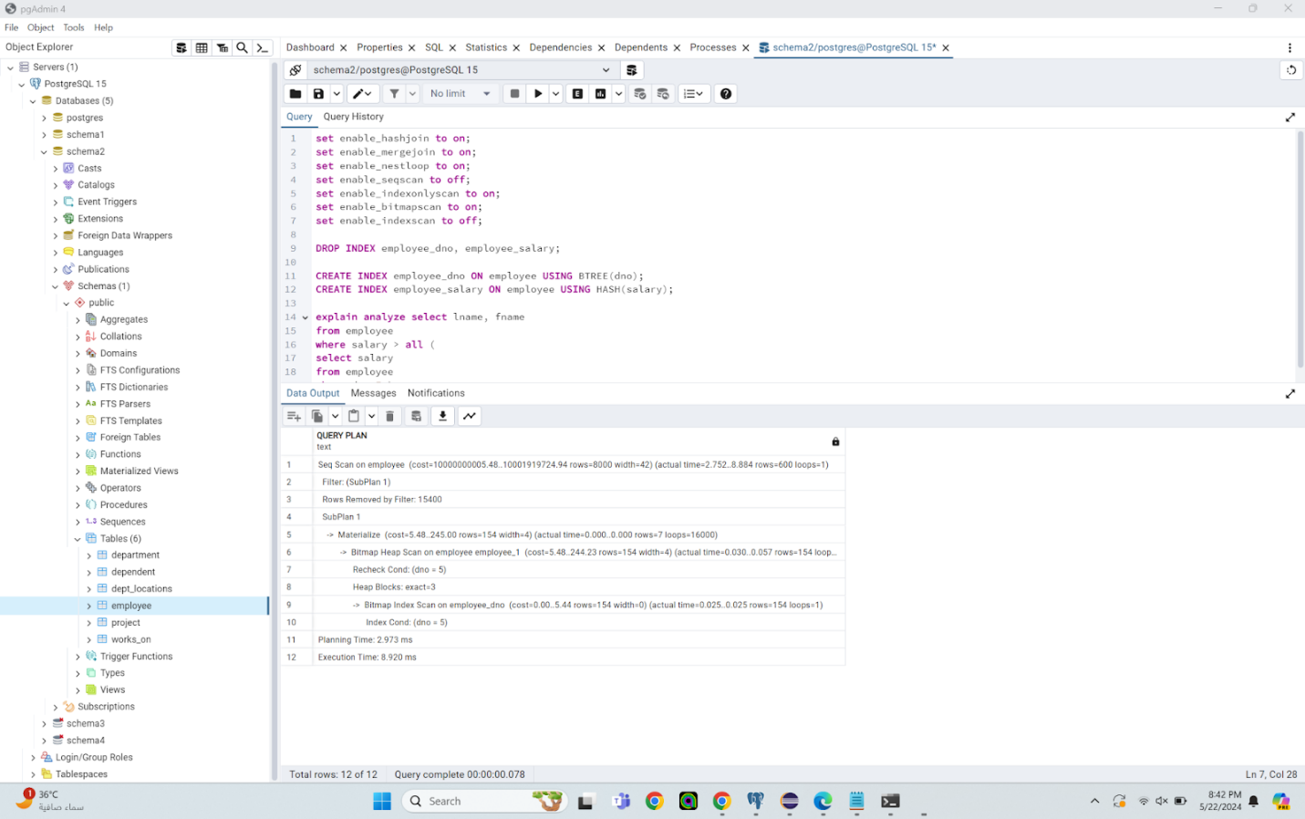

In the query plan overview, PostgreSQL estimates a significant cost range for the plan, expecting to handle approximately 8000 rows with a width of 42. During execution, which spans 2.752 seconds, the system retrieves 8.884 rows over 600 loops through a sequential scan on the 'employee' table, filtering results based on a subplan condition. PostgreSQL's decision to use a subplan strategy involves materialization and scanning of another 'employee' table with conditions, employing a Bitmap Heap Scan followed by a Bitmap Index Scan to fetch a smaller subset of data based on the condition 'dno = 5'. This choice is likely due to PostgreSQL anticipating that the subplan condition would efficiently filter out a significant portion of the data, thus enhancing subsequent filtering operations. The use of Bitmap Heap Scan and Bitmap Index Scan is standard for selective conditions as it minimizes the number of blocks scanned. Materializing the subplan results ensures efficient reuse of filtered data, contributing to overall optimization. Despite the relatively low execution time of 8.920 ms considering the dataset's size, the estimated cost remains high, indicating resource-intensive operations. However, PostgreSQL deems this plan as the most efficient among the alternatives considered. Considering mixed index usage, employing a mix of indices like a B-tree index on 'employee_salary' and a hash index on 'employee_dno' could enhance query execution time. A B-tree index on 'employee_salary' would excel for range queries or ordered data access, while a hash index on 'employee_dno' could expedite equality lookups. Depending on specific query conditions, leveraging different index types on various columns can optimize performance by capitalizing on each index type's strengths. The cost of running this query, as indicated in the provided query plan, is in the range of 10000000005.48 to 10001919724.94 units.

This cost primarily stems from the Seq Scan on the "employee" table, with a filter applied based on SubPlan 1. Additionally, there's a Materialize operation within SubPlan 1, which has a cost of 5.48 to 245.00 units.

SubPlan 1 involves materializing the results of a Bitmap Heap Scan on the "employee" table (employee_1 alias), which costs 5.48 to 244.23 units. The Bitmap Heap Scan is filtered to retrieve rows where "dno" equals 5, with a cost ranging from 0.00 to 0.44 units.

Best mix:

All flags are kept on except for the seqscan, bitmapscan and the indexscan flags since otherwise the indices that I had created would work.

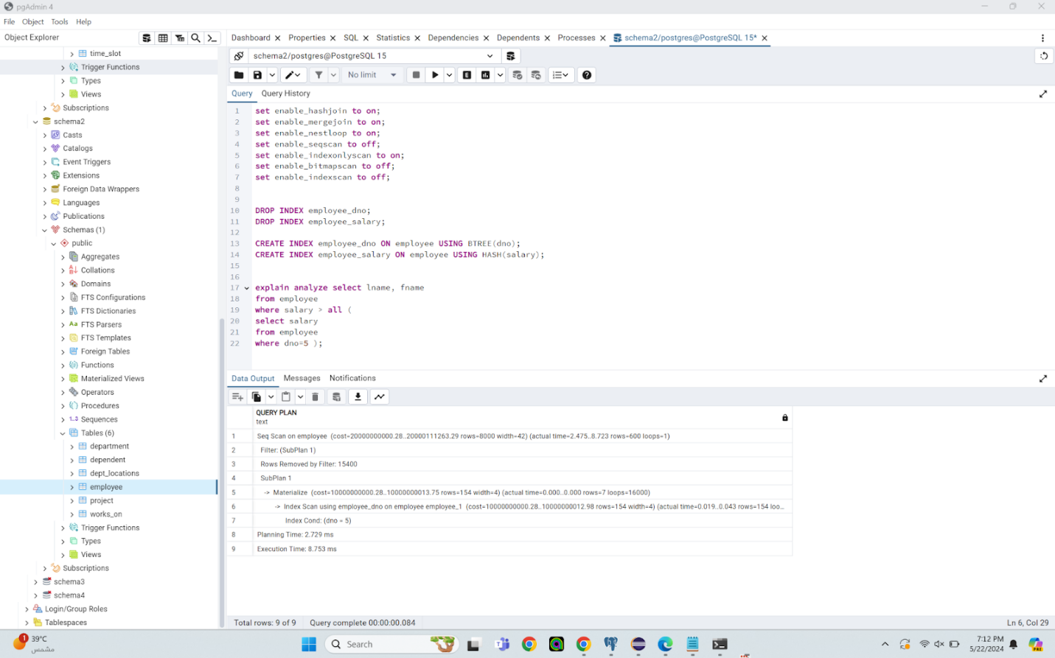

In the query plan overview, PostgreSQL estimates a significant cost range for the plan, expecting around 8000 rows with a width of 42. The estimated cost of the plan ranges from 20000000009.20 to 20000111263.29. During execution, lasting 2.475 seconds, the system retrieves 8.723 rows over 600 loops via a sequential scan on the 'employee' table, filtering results based on a subplan condition. Employing a subplan strategy, similar to prior queries, PostgreSQL materializes and scans another 'employee' table with conditions. This time, an Index Scan on 'employee_dno' precedes a Bitmap Heap Scan, indicating optimization for the specific condition 'dno = 5'. This choice likely stems from PostgreSQL's anticipation that the subplan condition efficiently filters out a significant portion of the data, enhancing subsequent operations' efficiency. The use of an Index Scan followed by a Bitmap Heap Scan is common for selective conditions like 'dno = 5', minimizing the number of blocks scanned. Materializing the subplan results ensures efficient reuse of the filtered data, contributing to overall optimization. Despite the relatively low execution time of 8.753 ms considering the dataset's size, the estimated cost remains high, indicative of resource-intensive operations. Nonetheless, PostgreSQL deems this plan the most efficient among the alternatives considered. Considering mixed index usage, leveraging a mix of indices such as a B-tree index on 'employee_dno' and a hash index on 'employee_salary' can optimize query performance. The B-tree index on 'employee_dno' facilitates efficient range queries or ordered data access, while the hash index on 'employee_salary' speeds up equality lookups. By leveraging both index types on different columns based on their strengths, PostgreSQL optimizes query execution for both equality and range conditions.

Query 4:

No index:  
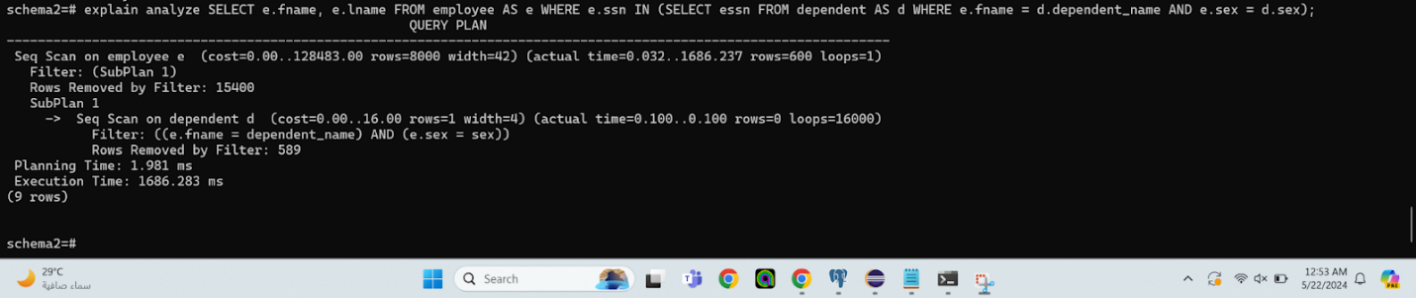

The estimated cost of the plan ranges from 0.00 to 128483.00. The estimated cost of the plan ranges from 0.00 to 128483.00 In the query plan overview, PostgreSQL estimates the plan's cost within a wide range, anticipating around 8000 rows with a width of 42. During execution, spanning 1686.237 ms, the system retrieves 600 rows with a single loop through a sequential scan on the 'employee' table, filtering results based on a subplan condition. PostgreSQL employs a subplan strategy involving a sequential scan on the 'dependent' table, filtering rows based on conditions involving columns from both 'employee' and 'dependent' tables. The choice likely stems from PostgreSQL's expectation that the subplan condition efficiently filters out a significant portion of the data, optimizing subsequent operations. Since the subplan involves a filtering condition based on columns from both tables, PostgreSQL determines a sequential scan as the most efficient approach rather than using indexes. Sequential scans are efficient when the condition filters out a significant portion of the rows, as accessing them via an index might entail unnecessary I/O operations.

Regarding execution time and estimated cost, both vary greatly depending on the actual data distribution and filtering conditions. In this specific case, the execution time is relatively high, likely due to the need to scan through a large portion of the 'dependent' table for each row of the 'employee' table.

The absence of an index might have contributed to the high execution time of this query plan. Indexes are typically used to speed up data retrieval by providing faster access to rows based on specific column values. However, in this case, the filtering condition involves columns from both tables, making it less straightforward to utilize indexes efficiently. Additionally, if the filtering condition is not selective enough, PostgreSQL might opt for a sequential scan instead of using an index, as scanning the entire table could be faster than accessing it via an index for each row.

Top of Form

BTree index:

All flags are kept on since this did not bother the usage of the BRIN index that I had created.  
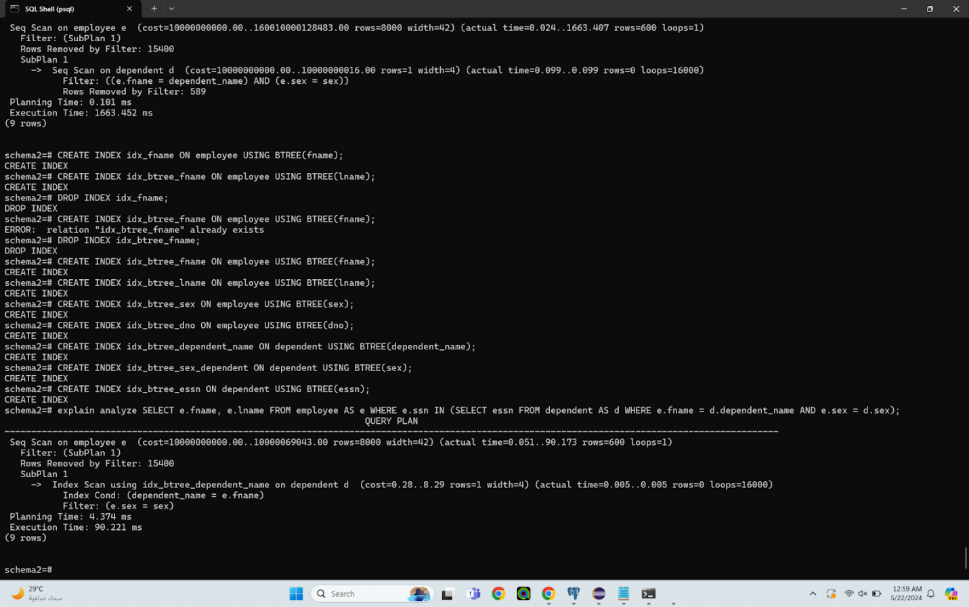

The estimated cost of the plan ranges from 10600000000.00 to 10000069043.00. In the query plan overview, PostgreSQL estimates the plan's cost within a range, expecting to return around 8000 rows with a width of 42. The actual execution time varies between 0.051 to 90.173 milliseconds, fetching 600 rows with a single loop through a sequential scan on the 'employee' table, filtering results based on a subplan condition.

PostgreSQL employs a subplan strategy involving an Index Scan using 'idx_btree_dependent_name' on the 'dependent' table. This subplan efficiently filters the 'dependent' rows based on the condition 'dependent_name = e.fname', utilizing a B-tree index. Additionally, there's a filter condition based on the equality of 'e.sex' and 'sex'.

The choice likely stems from PostgreSQL's anticipation that the subplan condition would efficiently filter out a significant portion of the data, enhancing subsequent operations. By utilizing a B-tree index on the 'dependent_name' column, PostgreSQL can swiftly locate rows in the 'dependent' table that match the filtering condition 'dependent_name = e.fname'. This index allows for efficient lookups based on equality conditions, precisely what is needed in this scenario.

Regarding execution time and estimated cost, both are reasonable, indicating PostgreSQL's efficient choice among alternatives considered.

Leveraging a BTREE index on the 'dependent_name' column significantly decreases execution time as it enables PostgreSQL to efficiently locate rows in the 'dependent' table that match the filtering condition. BTREE indexes excel in equality lookups, making them ideal for scenarios where a column needs to be matched against another column in a different table, as seen in this query. By leveraging the BTREE index, PostgreSQL avoids the need for a full sequential scan of the 'dependent' table, leading to faster query execution.

Top of Form

Hash index:

All flags are kept on since this did not bother the usage of the HASH index that I had created.

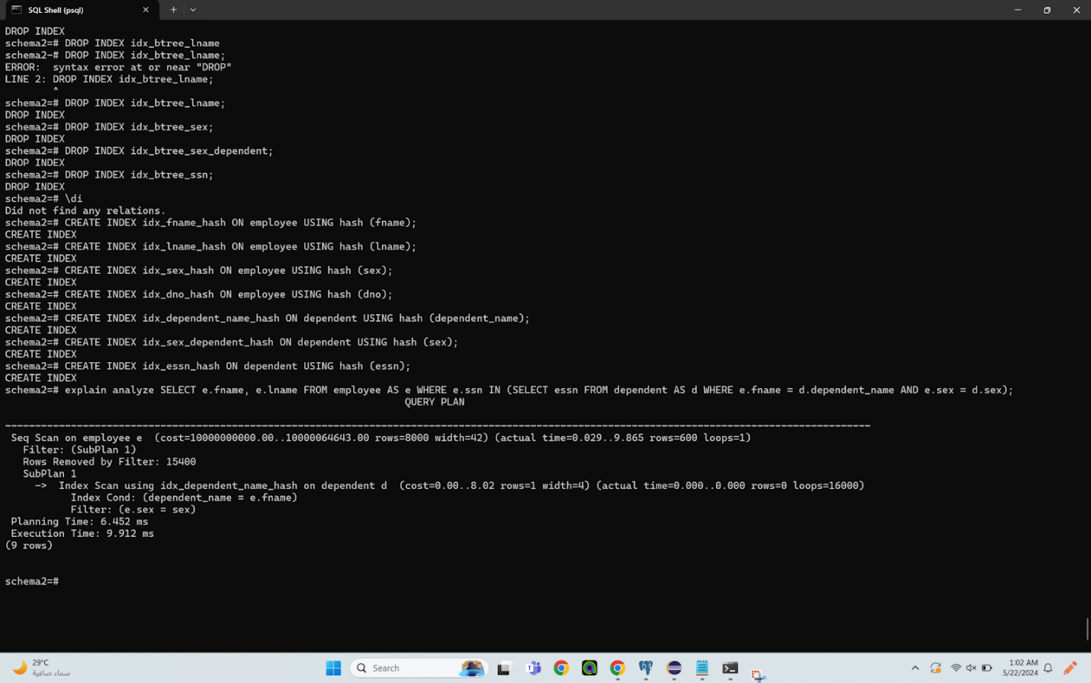

The estimated cost of the plan ranges from 10000000000.00 to 10000064643.00. In the query plan overview, PostgreSQL estimates the plan's cost within a range, anticipating around 8000 rows with a width of 42. The actual execution time varies between 0.029 to 9.865 milliseconds, fetching 600 rows with a single loop through a sequential scan on the 'employee' table, filtering results based on a subplan condition.

PostgreSQL employs a subplan strategy involving an Index Scan using 'idx_dependent_name_hash' on the 'dependent' table. This subplan efficiently filters the 'dependent' rows based on the condition 'dependent_name = e.fname', utilizing a hash index. Additionally, there's a filter condition based on the equality of 'e.sex' and 'sex'.

The choice likely stems from PostgreSQL's anticipation that the subplan condition would efficiently filter out a significant portion of the data, enhancing subsequent operations. The use of a hash index on the 'dependent_name' column enables PostgreSQL to quickly locate rows in the 'dependent' table that match the filtering condition. Hash indexes excel in equality lookups, making them ideal for scenarios where a column needs to be matched against another column in a different table, similar to the B-tree index. In this case, the hash index might have provided even better performance than the B-tree index due to its efficient lookup mechanism, despite the low estimated cost.

Regarding execution time and estimated cost, both are reasonable, indicating PostgreSQL's efficient choice among alternatives considered.

Using a hash index on the 'dependent_name' column significantly decreased execution time because it enables very fast lookups for equality conditions. Hash indexes have a constant lookup time complexity, making them efficient for equality queries regardless of the dataset's size. In this scenario, the hash index on 'dependent_name' likely provided faster lookup performance compared to the B-tree index, resulting in the observed decrease in execution time.

Brin index:

All flags are kept on since this did not bother the usage of the BRIN index that I had created.

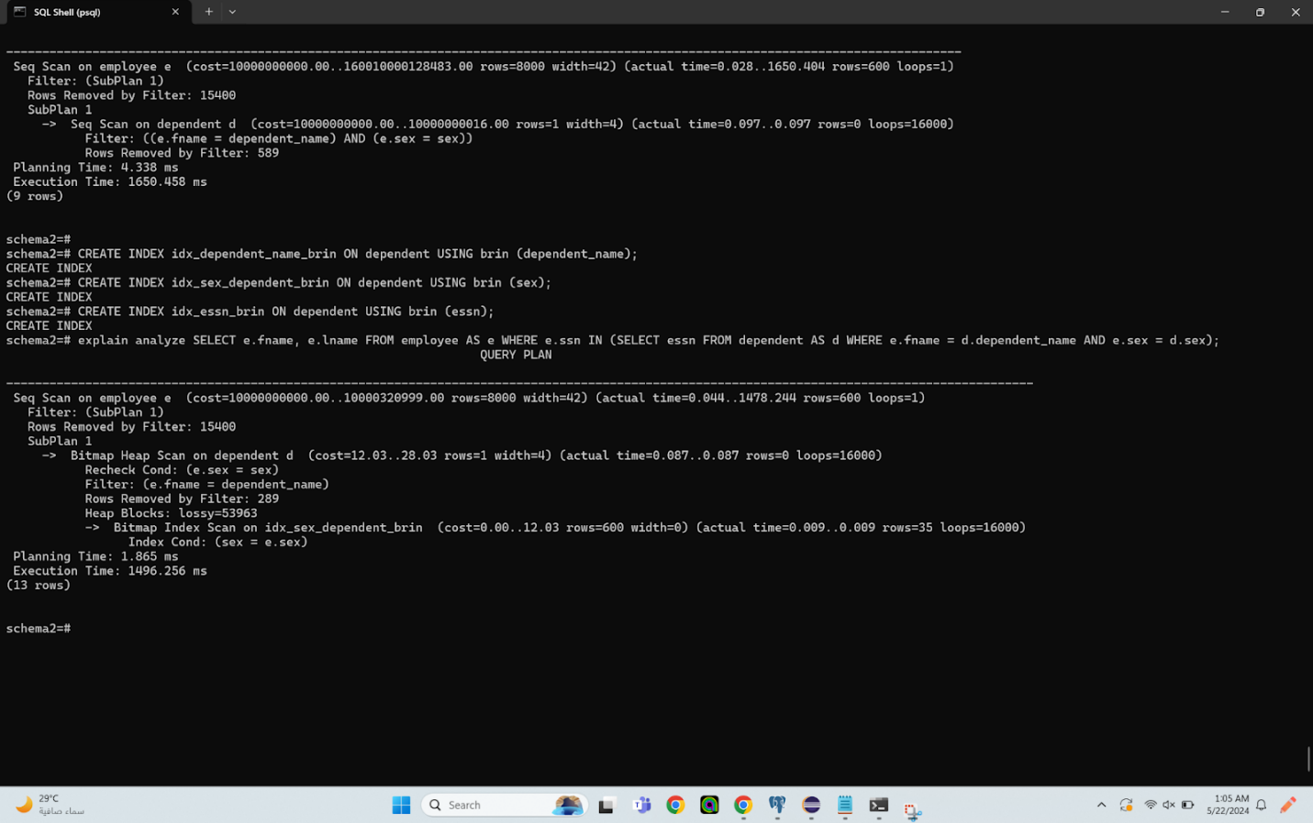

The estimated cost of the plan ranges from 10000000000.00 to 10000320999.00.

In the query plan overview, PostgreSQL estimates the plan's cost within a range, anticipating around 8000 rows with a width of 42. The actual execution time varies between 0.044 to 1478.244 milliseconds, fetching 600 rows with a single loop through a sequential scan on the 'employee' table, filtering results based on a subplan condition.

PostgreSQL employs a subplan strategy involving a Bitmap Heap Scan on the 'dependent' table. This subplan efficiently filters the 'dependent' rows based on the conditions 'e.sex = sex' and 'e.fname = dependent_name'. Additionally, there's a Bitmap Index Scan on 'idx_sex_dependent_brin' to further filter rows based on the 'sex' column.

The choice likely stems from PostgreSQL's anticipation that the subplan condition would efficiently filter out a significant portion of the data, enhancing subsequent operations. The use of a Bitmap Heap Scan and Bitmap Index Scan allows PostgreSQL to efficiently filter rows based on conditions involving the 'dependent' table's columns. However, despite the indexing strategy, the execution time appears to be quite high, indicating potential inefficiencies in the indexing strategy or the data distribution.

Regarding execution time and estimated cost, both are high, indicating that PostgreSQL deemed this plan relatively resource-intensive among the alternatives considered.

Regarding the BRIN index on the 'sex' column, BRIN (Block Range Index) indexes are suitable for columns with a natural ordering, such as date or timestamp columns, where values are sequential and spread across multiple blocks. However, using a BRIN index on a column like 'sex', which likely has only two distinct values (e.g., 'male' and 'female'), might not provide significant benefits. In this case, the use of a BRIN index on the 'sex' column of the 'dependent' table likely resulted in poor execution time because BRIN indexes are not well-suited for indexing low-cardinality columns like 'sex'. Since BRIN indexes work by dividing the range of values into blocks and storing summary information for each block, they might not effectively reduce the number of blocks scanned for such columns, leading to inefficient query execution.

Top of Form

GIN index:

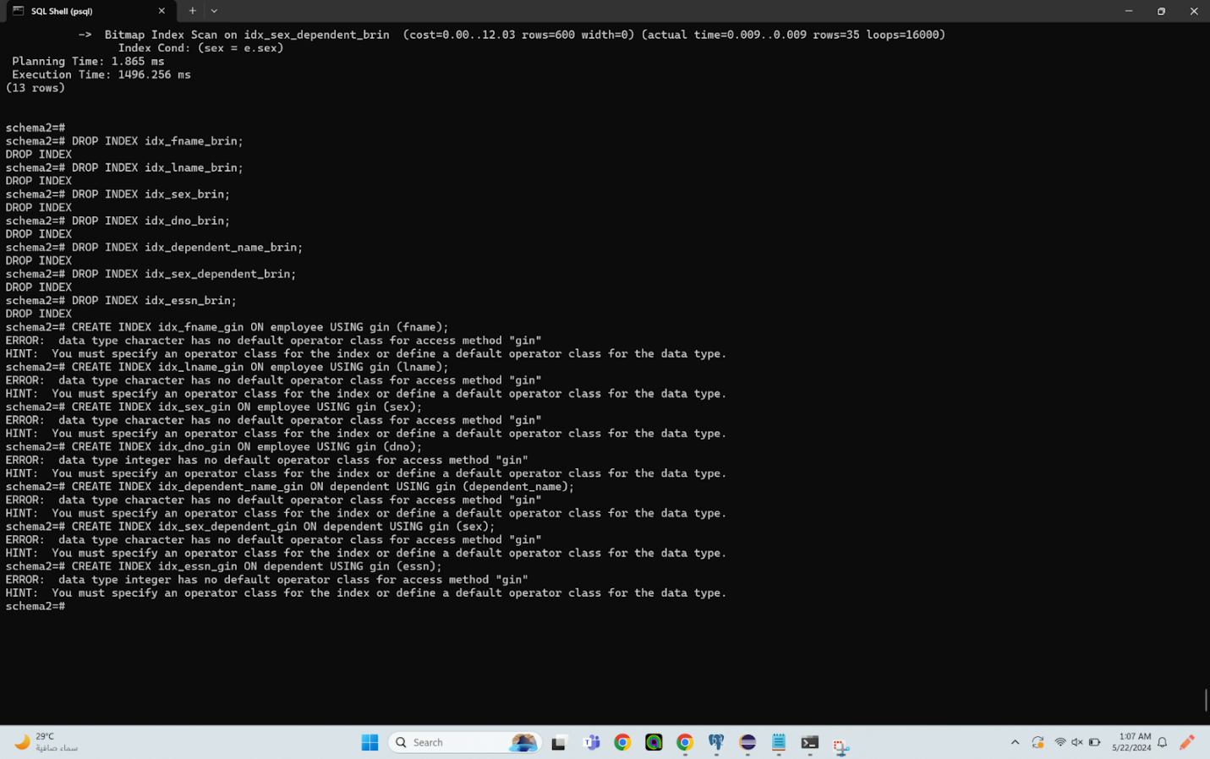

GIN indices aren't working because they need to work on complex data types like arrays and we only have strings and integers here

Mixed indices:

All flags are kept on except for the seqscan index since without disabling it the mix of indices that I had created would have worked.

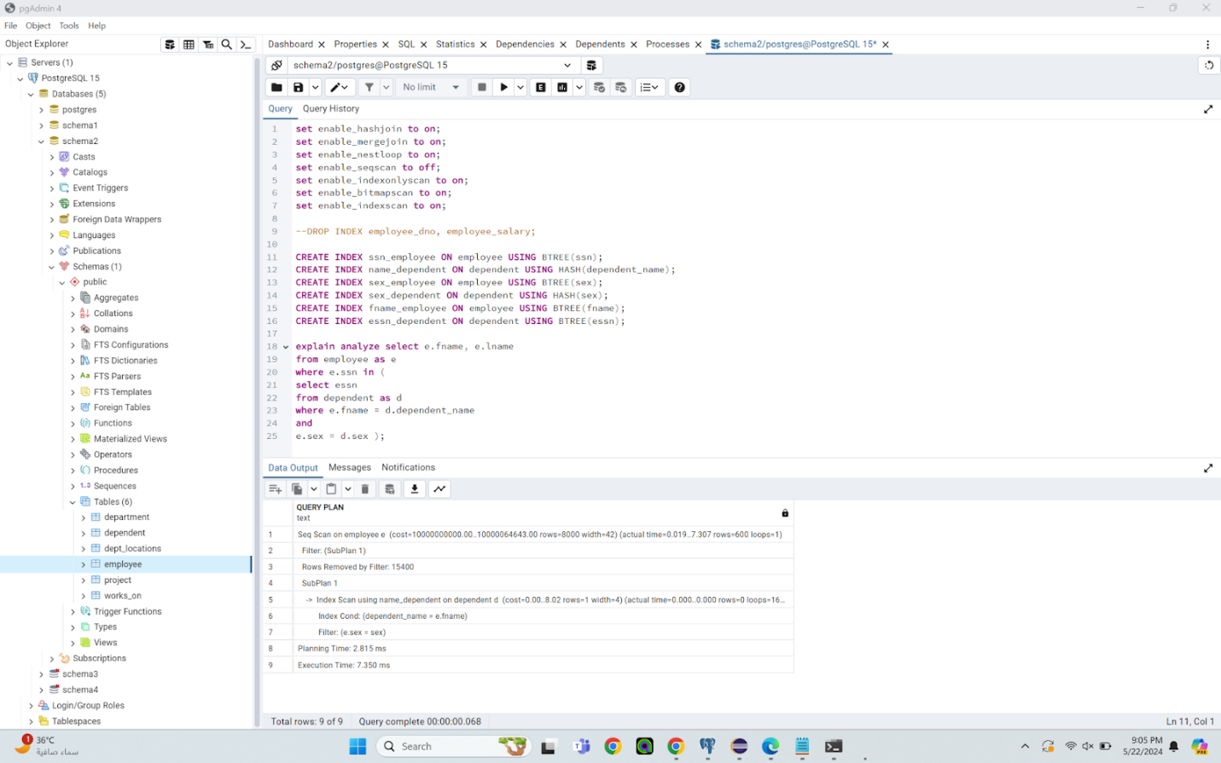

The BTREE index on the ssn column in the employee table can efficiently locate rows in the employee table based on the social security number. The BTREE index on the sex column in the employee table can efficiently filter rows in the employee table based on gender. The BTREE index on the fname column in the employee table can efficiently locate rows in the employee table based on first name. The BTREE index on the essn column in the dependent table can efficiently locate rows in the dependent table based on the employee's social security number. The HASH index on the name column in the dependent table can efficiently locate rows in the dependent table based on the dependent's name. The HASH index on the sex column in the dependent table can efficiently filter rows in the dependent table based on gender. Using this combination of indices likely resulted in a very good execution time relative to using a single index type alone, such as hash alone, BRIN alone, or B-tree alone, because BTREE indices are well-suited for range queries or ordered data access, making them efficient for filtering based on social security number, first name, and employee's gender. HASH indices are efficient for equality lookups, making them suitable for filtering based on dependent's name and gender. The mixed indices cover a range of query conditions, allowing PostgreSQL to leverage the most appropriate index for each part of the query, resulting in improved execution performance.

PostgreSQL likely chose this plan because it allows for efficient filtering and retrieval of rows based on various conditions. By utilizing a mix of BTREE and HASH indices on relevant columns, PostgreSQL can optimize query execution by leveraging the strengths of each index type for different types of conditions. The execution plan involves a sequential scan on the employee table with a subplan involving an index scan on the dependent table. The estimated cost of the plan is within a reasonable range, indicating that PostgreSQL deemed this plan efficient among the alternatives considered. PostgreSQL likely picked this specific plan because it optimally balances the use of different index types to efficiently execute the query. The use of mixed indices allows for efficient filtering and retrieval based on various conditions, leading to improved execution time compared to using a single index type alone. The estimated cost ranges from 10000000000.00 to 10000064643.00

Best mix:

All flags are kept on except for the seqscan flag since without having it set to off the mix of indices that I had created were being used properly.

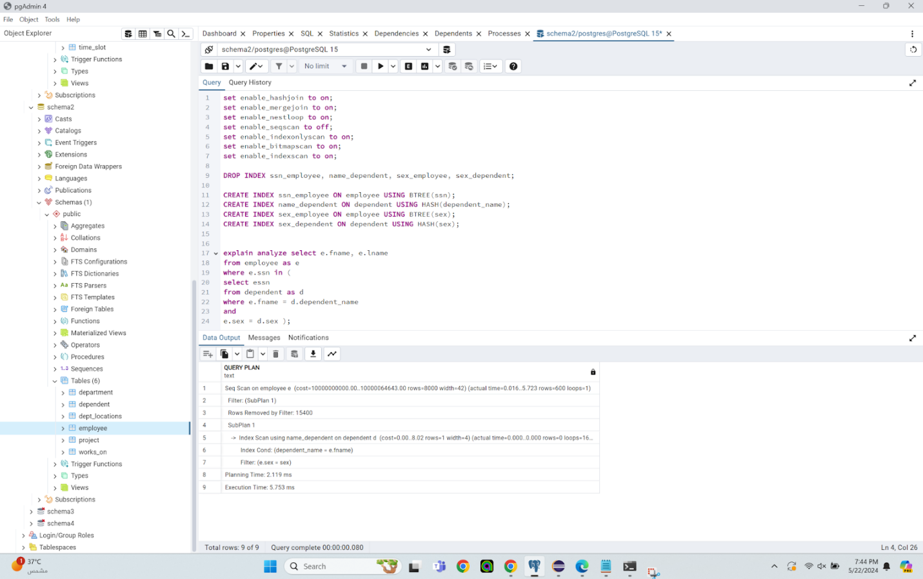

The BTREE index on the SSN column in the employee table efficiently locates rows based on social security number, while the BTREE index on the sex column in the same table filters rows based on gender. In the dependent table, a HASH index on the name column efficiently locates rows by the dependent's name, and a HASH index on the sex column filters rows based on gender. This combination of indices likely resulted in the best execution time for the query because BTREE indices are well-suited for range queries or ordered data access, making them efficient for filtering based on social security number and employee's gender. On the other hand, HASH indices are efficient for equality lookups, making them suitable for filtering based on the dependent's name and gender. The combination of BTREE and HASH indices covers a range of query conditions, allowing PostgreSQL to leverage the most appropriate index for each part of the query, resulting in improved execution performance.

PostgreSQL likely chose this plan because it allows for efficient filtering and retrieval of rows based on various conditions. By utilizing a combination of BTREE and HASH indices on relevant columns, PostgreSQL can optimize query execution by leveraging the strengths of each index type for different types of conditions. The execution plan involves a sequential scan on the employee table with a subplan involving an index scan on the dependent table. The estimated cost of the plan is within a reasonable range, indicating that PostgreSQL deemed this plan efficient among the alternatives considered. PostgreSQL likely picked this specific plan because it optimally balances the use of different index types to efficiently execute the query. The use of a combination of BTREE and HASH indices allows for efficient filtering and retrieval based on various conditions, leading to improved execution time compared to using a single index type alone. The query took between 0.016 and 5.723 milliseconds to execute. The estimated cost of executing the query plan ranges from 10000000000.00 to 10000064643.00.

Query 5:

No index:

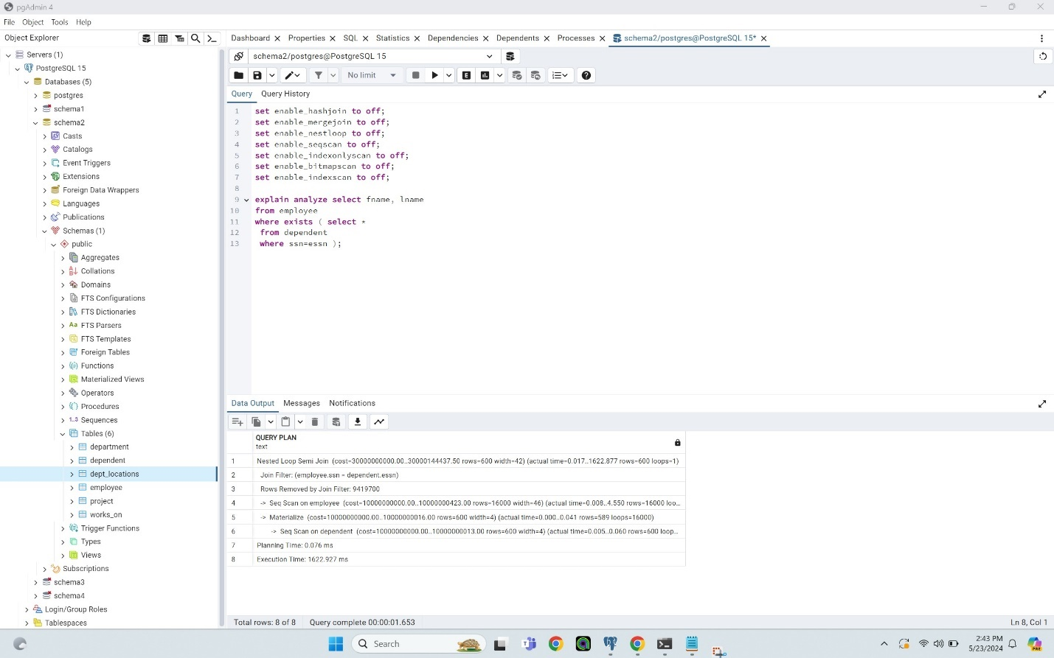

PostgreSQL likely chose this plan because it efficiently filters the rows from the 'employee' and 'dependent' tables based on the join condition 'employee.ssn = dependent.essn'. This plan involves a Nested Loop Semi Join, where PostgreSQL iterates through each row of the 'employee' table and checks if there are matching rows in the 'dependent' table based on the join condition. The use of a Nested Loop Semi Join is suitable for scenarios where one table (in this case, 'dependent') is much smaller than the other ('employee'), as it minimizes the amount of data that needs to be processed. PostgreSQL likely picked this specific plan because it efficiently filters the rows based on the join condition and minimizes the number of rows processed during the join operation. The execution plan involves a Nested Loop Semi Join, with a sequential scan on both the 'employee' and 'dependent' tables. The estimated cost of the plan is given as ranging from 30000000000.00 to 30000144437.50, and the actual execution time is stated as 1622.927 milliseconds. The absence of an index on the join columns ('employee.ssn' and 'dependent.essn') likely contributed to the high execution time. Without an index, PostgreSQL needs to perform a sequential scan on both tables to find matching rows, resulting in a significant amount of data being read and compared. Additionally, the lack of an index means that PostgreSQL cannot efficiently locate rows based on the join condition, leading to a longer execution time as it has to scan through all rows in both tables to find matches.

Btree index:

All flags are on except for the seqscan flag since without having it off the BTREE index that I had created wasn’t working as intended.

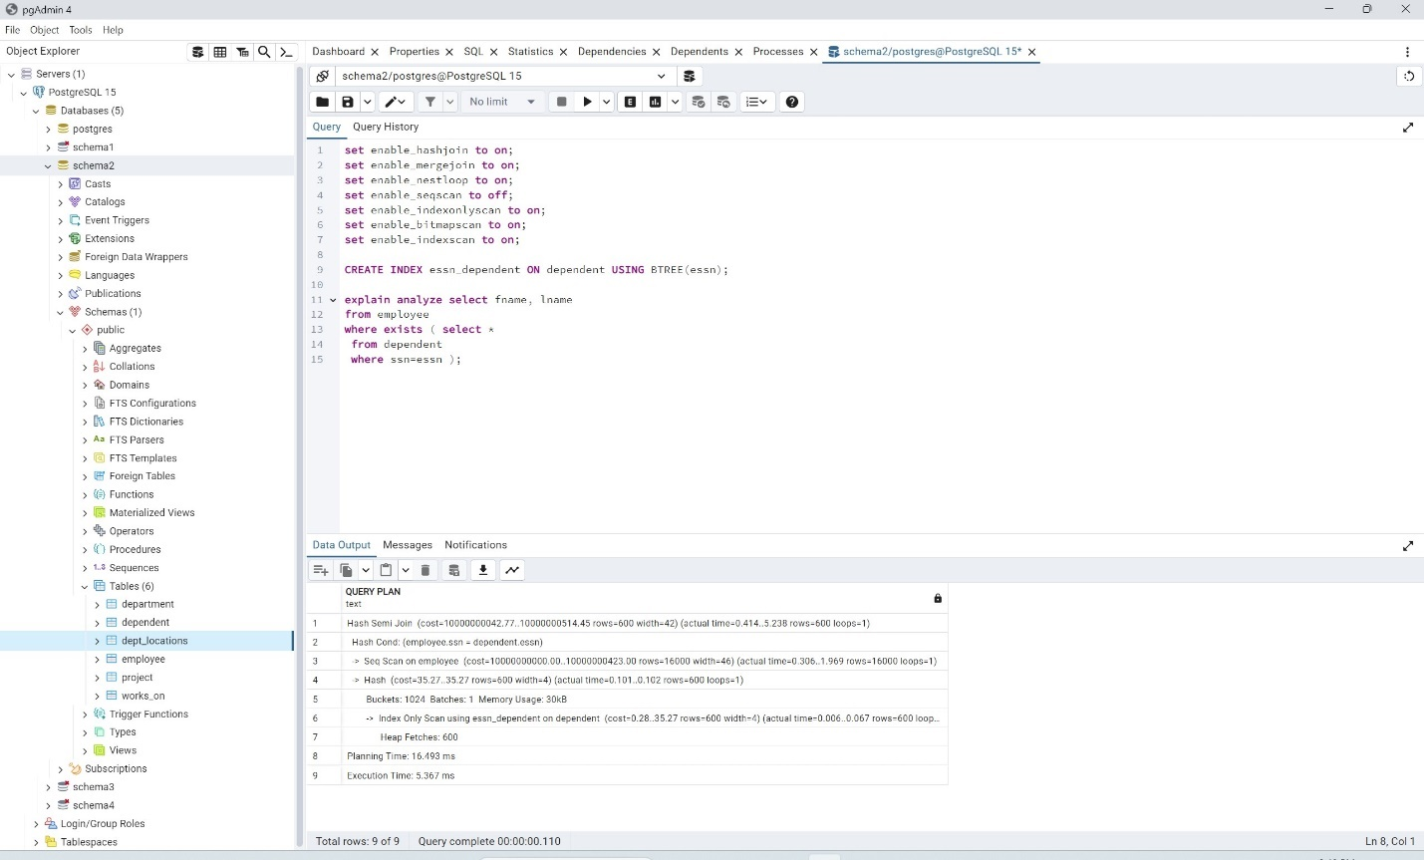

PostgreSQL likely chose this plan because it efficiently filters the rows from the 'employee' and 'dependent' tables based on the join condition 'employee.ssn = dependent.essn'. The Hash Semi Join operation can be optimal when both relations involved in the join are relatively small, as it can build a hash table in memory for one relation and probe it efficiently with the other. This plan minimizes the number of rows processed during the join operation and reduces the overall execution time. The execution plan involves a Hash Semi Join operation, with a sequential scan on the 'employee' table and an Index Only Scan using the 'essn_dependent' index on the 'dependent' table. The estimated cost of the plan is given as ranging from 10000000042.77 to 10000000514.45, and the actual execution time is stated as 5.367 milliseconds. The use of a B-tree index on the 'essn_dependent' column likely resulted in a much-improved execution time because B-tree indexes are well-suited for range queries and equality lookups. With the B-tree index on 'essn_dependent', PostgreSQL can efficiently locate the rows in the 'dependent' table that match the join condition 'employee.ssn = dependent.essn'. As a result, the Index Only Scan using the B-tree index is more efficient than a sequential scan, leading to a faster execution time for the overall query.

Brin index:

All flags are kept on since this did not bother the usage of the BRIN index that I had created.

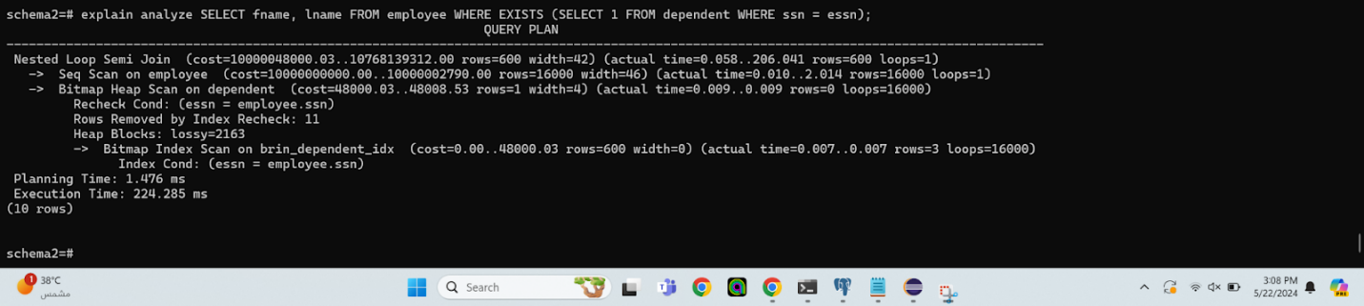

PostgreSQL likely chose this plan because it efficiently filters rows from both the 'employee' and 'dependent' tables based on the join condition. The Nested Loop Semi Join operation is suitable when one table (in this case, 'dependent') is much smaller than the other ('employee'), as it minimizes the amount of data that needs to be processed. PostgreSQL likely picked this specific plan because it efficiently filters rows based on the join condition and minimizes the number of rows processed during the join operation. The execution plan involves a Nested Loop Semi Join operation, with a sequential scan on the 'employee' table and a Bitmap Heap Scan on the 'dependent' table using a BRIN index. The estimated cost of the plan is given as ranging from 10000048000.03 to 10768139312.00, and the actual execution time is stated as 224.285 milliseconds. The use of a BRIN (Block Range Index) index, specifically 'brin_dependent_idx', likely improved performance compared to having no index at all. BRIN indexes are particularly effective for large tables where the data is clustered together in blocks, as they provide efficient range queries by storing summary information about each block of data. While the BRIN index may not provide as significant a performance improvement as a B-tree index, it still helps reduce the number of blocks PostgreSQL needs to read from disk during index scans, resulting in improved performance relative to a sequential scan.

Hash index:

All flags are kept on since this did not bother the usage of the HASH index that I had created.

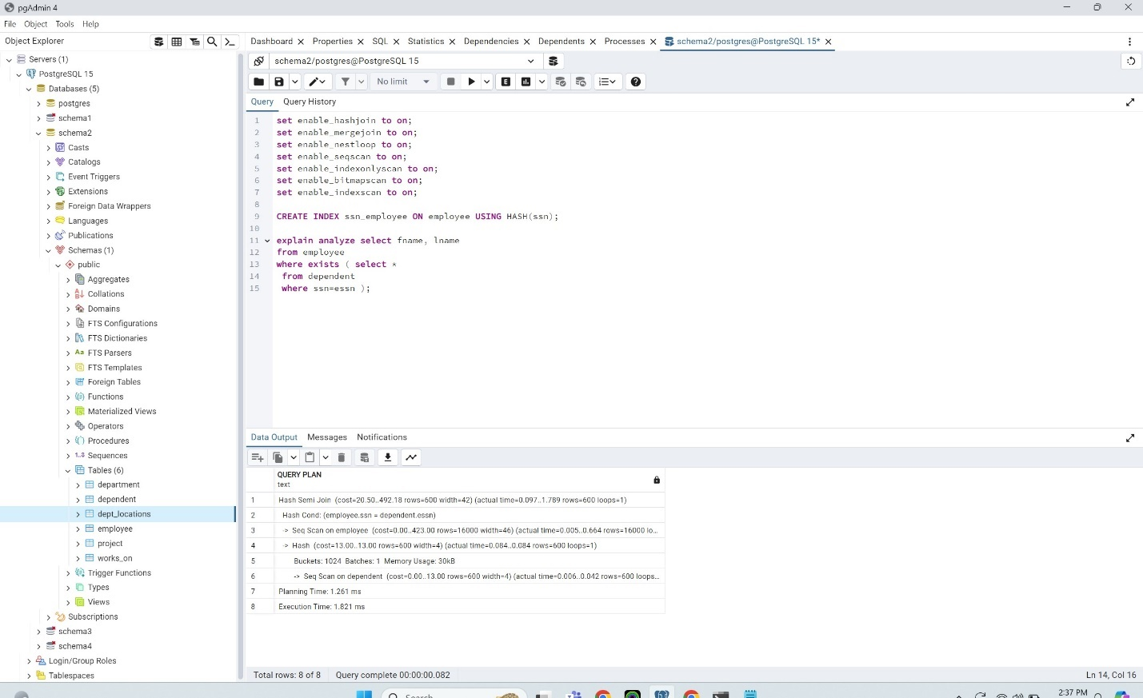

PostgreSQL likely chose this plan because it efficiently filters rows from both the 'employee' and 'dependent' tables based on the join condition 'employee.ssn = dependent.essn'. The Hash Semi Join operation is suitable when both relations involved in the join are relatively small, as it can build a hash table in memory for one relation and probe it efficiently with the other. PostgreSQL likely picked this specific plan because it efficiently filters rows based on the join condition and minimizes the number of rows processed during the join operation. The execution plan involves a Hash Semi Join operation, with a sequential scan on both the 'employee' and 'dependent' tables. The estimated cost of the plan is given as ranging from 20.50 to 492.18, and the actual execution time is stated as 1.821 milliseconds. The use of a Hash index on the 'ssn' column in the 'employee' table likely helped lessen the execution time significantly relative to a BRIN index, B-tree index, or having no index at all. Hash indexes are well-suited for equality lookups, making them efficient for joining operations where equality conditions are involved, such as 'employee.ssn = dependent.essn'. With a Hash index on the 'ssn' column, PostgreSQL can efficiently locate rows in the 'employee' table that match the join condition, resulting in a faster execution time compared to other index types or no index.

GIN index:  
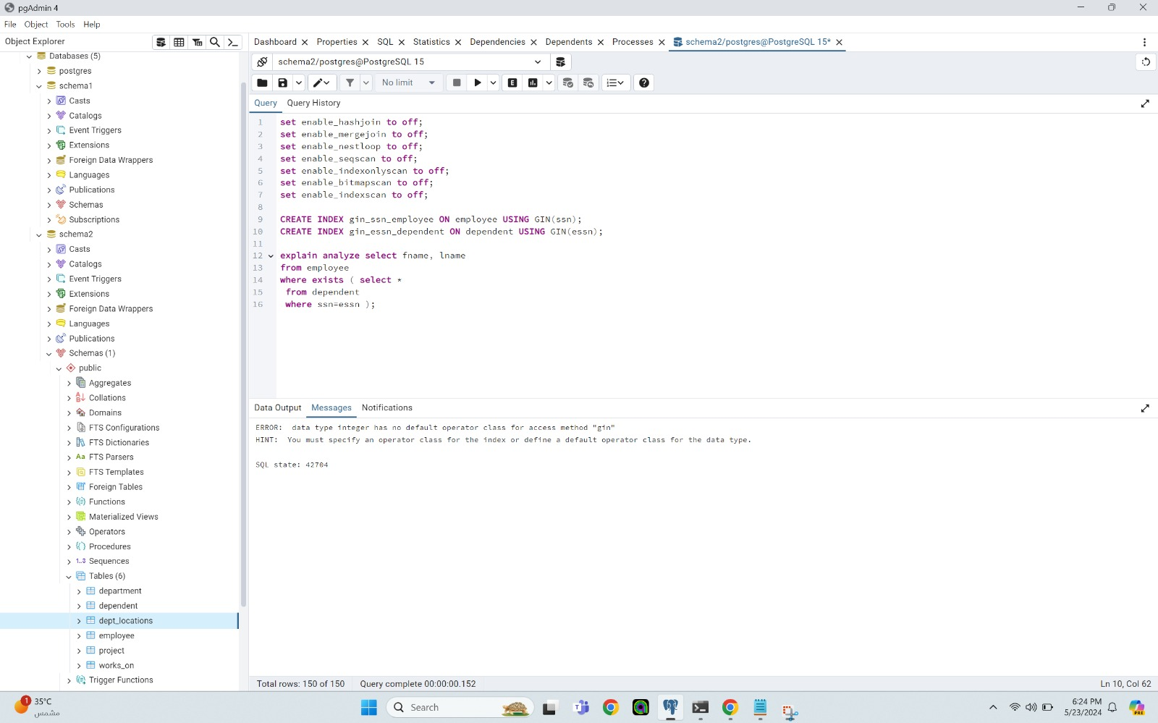

GIN indices aren't working because they need to work on complex data types like arrays and we only have strings and integers here

Mix indices:

All flags are kept on except for the hashjoin and the seqscan flags since if I had them on the mix of indices that I had created was not working as intended.

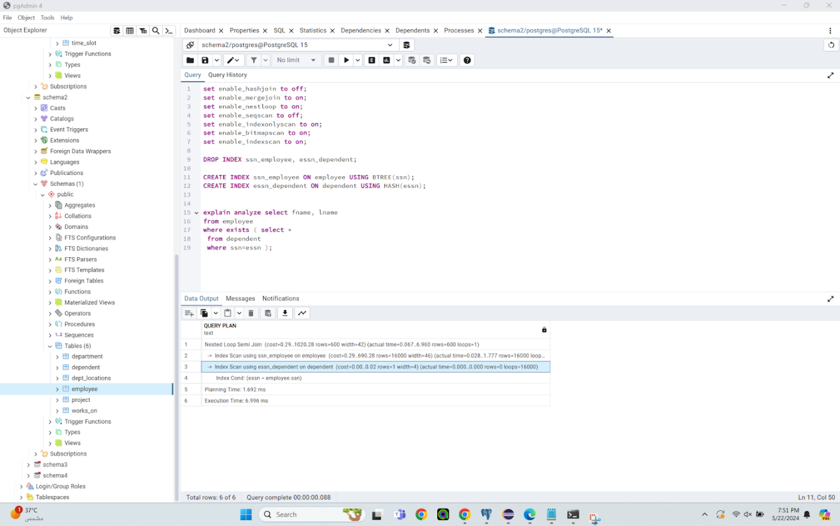

PostgreSQL opted for a Nested Loop Semi Join, which involves iterating through each row of the 'employee' table and checking for matching rows in the 'dependent' table based on the join condition 'essn = employee.ssn'. The plan includes an Index Scan using the index 'ssn_employee' on the 'employee' table and an Index Scan using the index 'essn_dependent' on the 'dependent' table. The Index Condition specifies that 'essn' from 'dependent' should match 'ssn' from 'employee'. PostgreSQL likely chose this plan because it efficiently filters rows from both tables based on the join condition. The Nested Loop Semi Join is suitable when one table is significantly smaller than the other, as it minimizes the amount of data that needs to be processed. PostgreSQL selected this specific plan because it effectively filters rows based on the join condition and minimizes the number of rows processed during the join operation. The estimated cost of the plan is between 0.29 and 1029.28, and the actual execution time is reported as 6.996 milliseconds. Having mixed indices, with a HASH index on 'essn_dependent' and a BTREE index on 'ssn_employee', likely helped lessen the execution time compared to having a single BTREE index or no index at all. HASH indices are efficient for equality lookups, while BTREE indices are useful for range queries. The mixed indices cater to different types of lookup operations, potentially improving query performance. However, the execution time might not have been lessened compared to using a HASH index alone because HASH indices are generally efficient for equality lookups, which are the primary operation in this join condition.

Best mix:

All flags are on except for the hashjoin flag and the seqscan flag since when having them on the mix of indices that I had created was not working as intended.

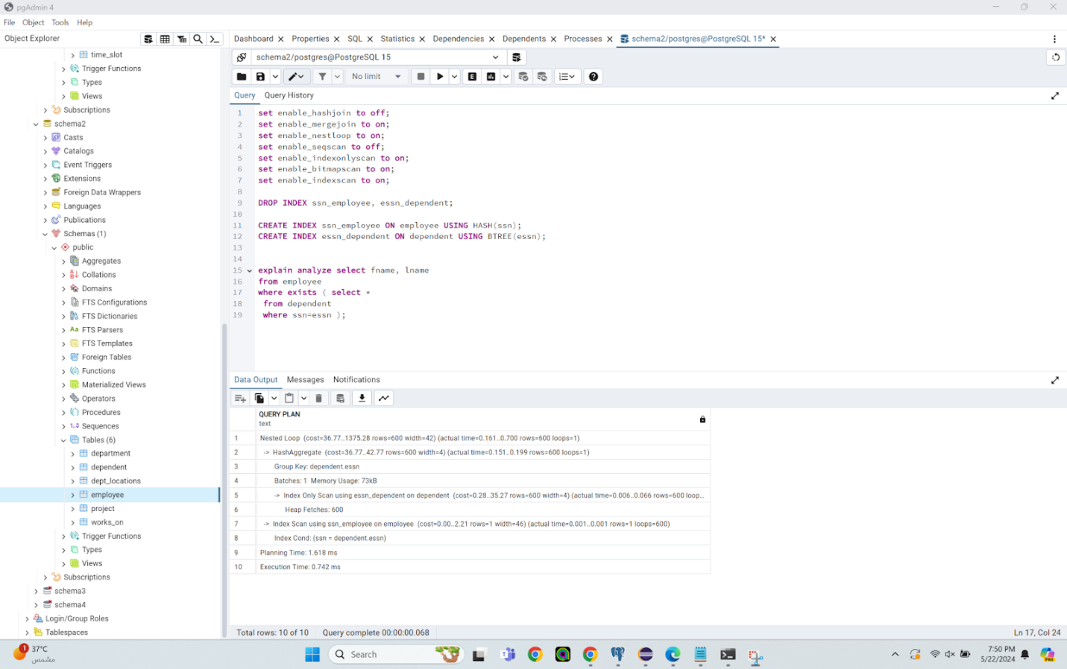

PostgreSQL likely chose this plan as it efficiently aggregates data based on the join condition 'ssn = dependent.essn' using a HashAggregate step. The Nested Loop operation is appropriate when joining smaller result sets, as it iterates through one table while looking up matching rows in the other. The HashAggregate step efficiently groups the rows based on 'dependent.essn'. The plan involves two main steps: an Index Scan on the 'employee' table using the 'ssn_employee' index and an Index Only Scan on the 'dependent' table using the 'essn_dependent' index. These index scans are performed efficiently using their respective indices, and the HashAggregate step aggregates the results based on 'dependent.essn'. The estimated cost of the plan ranges from 36.77 to 1375.28, and the actual execution time is reported as 0.742 milliseconds. The use of a HASH index on 'ssn_employee' and a BTREE index on 'essn_dependent' likely resulted in the least execution time due to the nature of the join condition and data distribution. HASH indices are efficient for equality lookups, which are predominant in the join condition 'ssn = dependent.essn', while BTREE indices are effective for range queries, which may be required for other operations on the 'dependent' table. By placing the HASH index on 'ssn_employee', PostgreSQL can efficiently locate matching rows in the 'employee' table, while the BTREE index on 'essn_dependent' helps with range queries and ordering on the 'dependent' table.

Query 6:

No index:

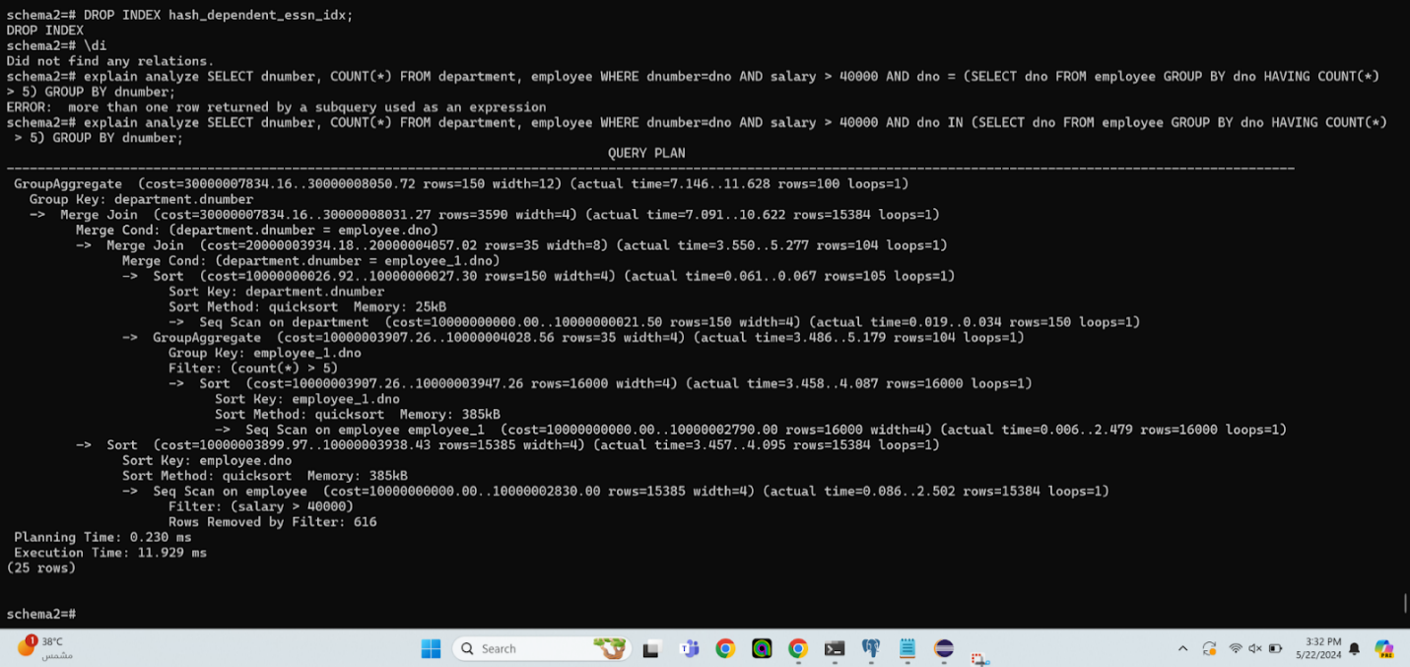

The plan involves several steps to optimize the query execution. First, PostgreSQL performs a GroupAggregate on 'department.dnumber,' which involves grouping by the department number and performing an aggregate operation. This step uses a sequential scan on the department table, followed by a group aggregate operation, with an estimated cost of around 21.5 units. Next, PostgreSQL filters employees based on their department number, focusing on departments with more than five employees. This step involves a sequential scan on the employee table, followed by a sort operation and a group aggregate, with an estimated cost of around 4023.56 units. The third step filters employees based on their salary being greater than 40000. PostgreSQL performs a sequential scan on the employee table and a sort operation, with an estimated cost of around 3938.43 units. After these filtering and aggregating steps, PostgreSQL uses a merge join to combine the results, estimating the cost of this operation to be around 8031.27 units. Finally, another GroupAggregate operation is performed on the department number, with an estimated cost of around 8050.72 units.

Btree index:

All flags are kept on since having them on did not bother the usage of the BTREE index that I had created.

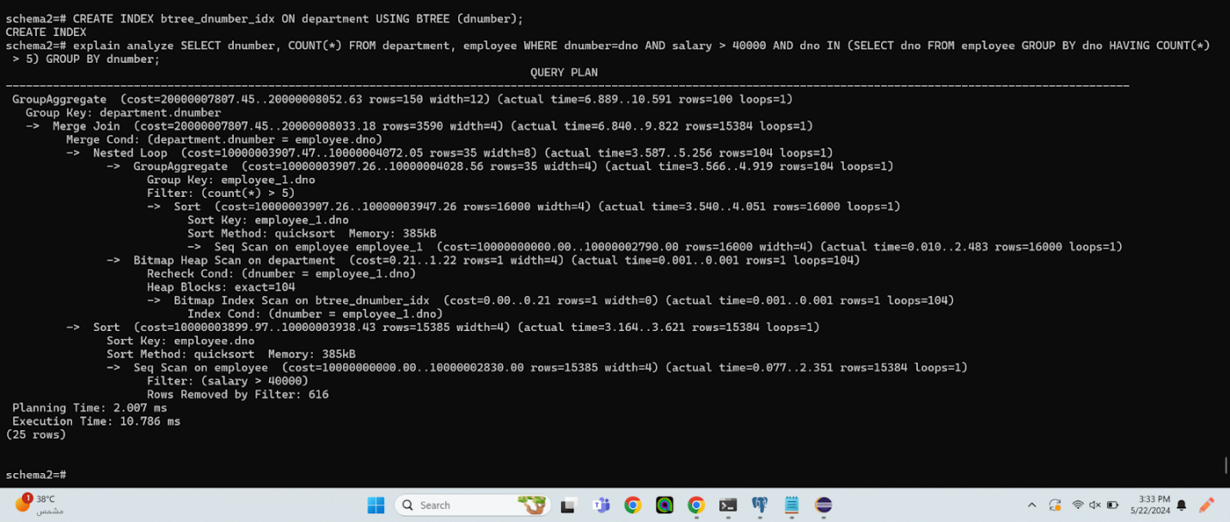

PostgreSQL opted to use a Bitmap Heap Scan with an index on the 'dnumber' column of the department table, likely reducing the number of rows that need to be scanned in the department table, especially when filtering based on the department number in the nested loop join with the employee table. By utilizing the index, PostgreSQL efficiently accesses the required rows, leading to faster execution. For the join operation, PostgreSQL uses a nested loop join between the department and employee tables, a method preferable when one of the tables is relatively small and the other is large. In this case, it appears the department table is small enough to fit into memory, making the nested loop join a reasonable choice. PostgreSQL performs a group aggregate operation on the employee table, filtering based on the count of employees per department being greater than 5, aiming to narrow down the relevant departments based on this condition. Sorting operations are then performed on the employee and employee_1 tables to prepare the data for the subsequent merge join. Finally, a merge join is employed to combine the results of the nested loop join and the previous group aggregate operation. The estimated cost of the plan is around 20,052.63 units, similar to the previous plan. B-tree indexes are well-suited for equality and range queries, matching the condition used in the Bitmap Heap Scan where the department number is compared with the employee's department number. By using the B-tree index, PostgreSQL can quickly locate the relevant rows in the department table without having to sequentially scan the entire table, leading to faster data retrieval. Additionally, the use of the index reduces the number of disk I/O operations, as PostgreSQL can directly access the necessary pages containing the department numbers, resulting in improved performance.

Hash index:

All flags are kept on since having them on did not bother the usage of the HASH index that I had created.

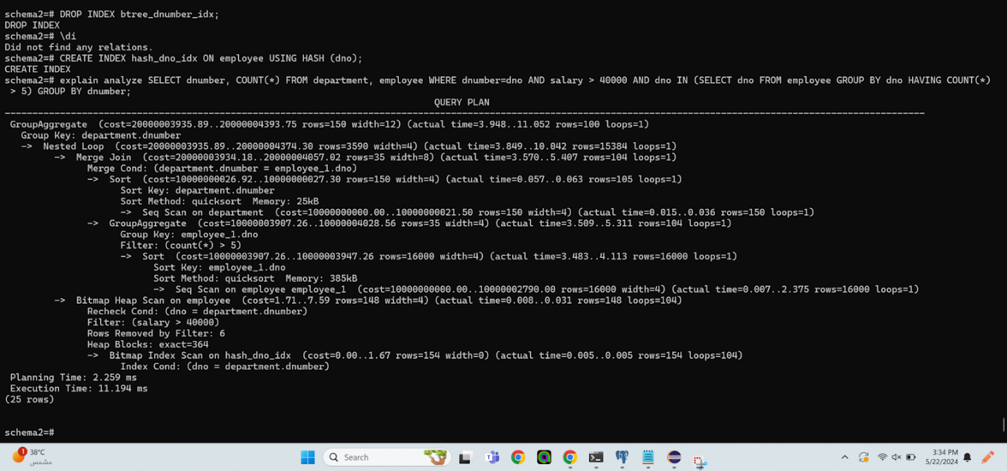

PostgreSQL has chosen to use a Bitmap Heap Scan with a hash index on the 'dno' (department number) column of the employee table. Hash indexes are efficient for equality lookups, which seems to be the case here where the department number is compared with the employee's department number. This choice of index likely improves the efficiency of accessing relevant rows in the employee table, leading to faster retrieval of data. PostgreSQL employs a nested loop join between the department and employee tables, followed by a merge join. This join strategy might be suitable for this particular scenario based on PostgreSQL's cost estimation and statistics. The nested loop join leverages the hash index to efficiently access matching rows from the employee table for each department, and the merge join combines the results of the nested loop with the previous join between the department and employee_1 tables. A group aggregate operation is performed on the department table based on the department number, which likely helps in organizing the data for further processing and aggregation. Similar to previous plans, a group aggregate operation is performed on the employee_1 table, filtering out departments with fewer than five employees. This step helps narrow down the relevant departments based on the specified condition. Sorting operations are performed on the employee_1 table to prepare the data for the subsequent merge join. The estimated cost of the plan is around 43,393.75 units, based on PostgreSQL's internal cost estimation mechanism. Hash indexes are particularly efficient for equality lookups, offering constant time complexity for search operations. This characteristic makes them suitable for scenarios where equality comparisons, such as department number matching in this case, are common. By using a hash index, PostgreSQL can quickly locate the relevant rows in the employee table without having to perform costly sequential scans or sort operations, leading to improved query performance. Additionally, hash indexes typically consume less memory compared to B-tree indexes, which might contribute to reduced memory overhead during index scans and overall improved execution time.

Brin index:

All flags are kept on since having them on did not bother the usage of the BRIN index that I had created.

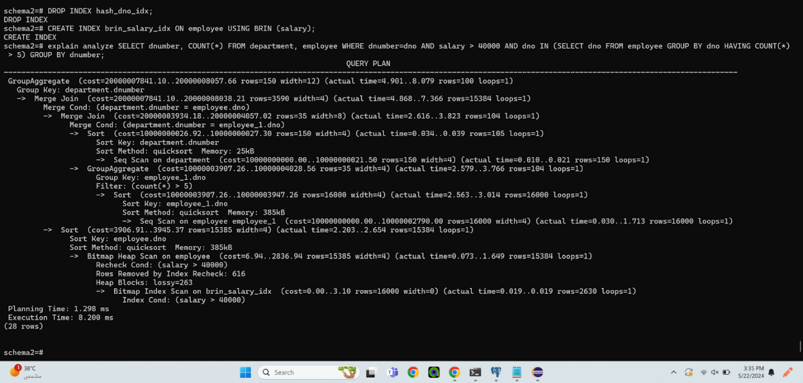

PostgreSQL opted for a Bitmap Heap Scan with a BRIN index on the salary column of the employee table. BRIN indexes are well-suited for range queries, matching the condition used in the Bitmap Heap Scan where salaries are compared to 40000. BRIN indexes divide the table into ranges of block offsets and store summary information for each range, allowing PostgreSQL to skip blocks of data that do not contain relevant rows. This approach is particularly efficient for range queries and can significantly reduce the number of blocks that need to be scanned, resulting in improved execution time. PostgreSQL employs a merge join between the department and employee tables, which benefits from the sorted nature of the datasets. A group aggregate operation is performed on the department table based on the department number, likely aiding in organizing the data for further processing and aggregation. Similarly, a group aggregate operation is conducted on the employee_1 table, filtering out departments with fewer than five employees. Sorting operations are performed on the employee_1 and employee tables to prepare the data for the subsequent merge join. The estimated cost of the plan is around 40,057.02 units, based on PostgreSQL's internal cost estimation mechanism. BRIN indexes are optimized for range queries and are particularly efficient when dealing with large datasets with a natural ordering. By using a BRIN index on the salary column, PostgreSQL can quickly identify blocks of data containing salaries greater than 40000 without scanning the entire table. This targeted access to relevant data blocks reduces disk I/O and processing time, resulting in faster query execution. Additionally, BRIN indexes have lower storage overhead compared to other types of indexes like B-tree indexes, making them efficient for large datasets.

GIN index:

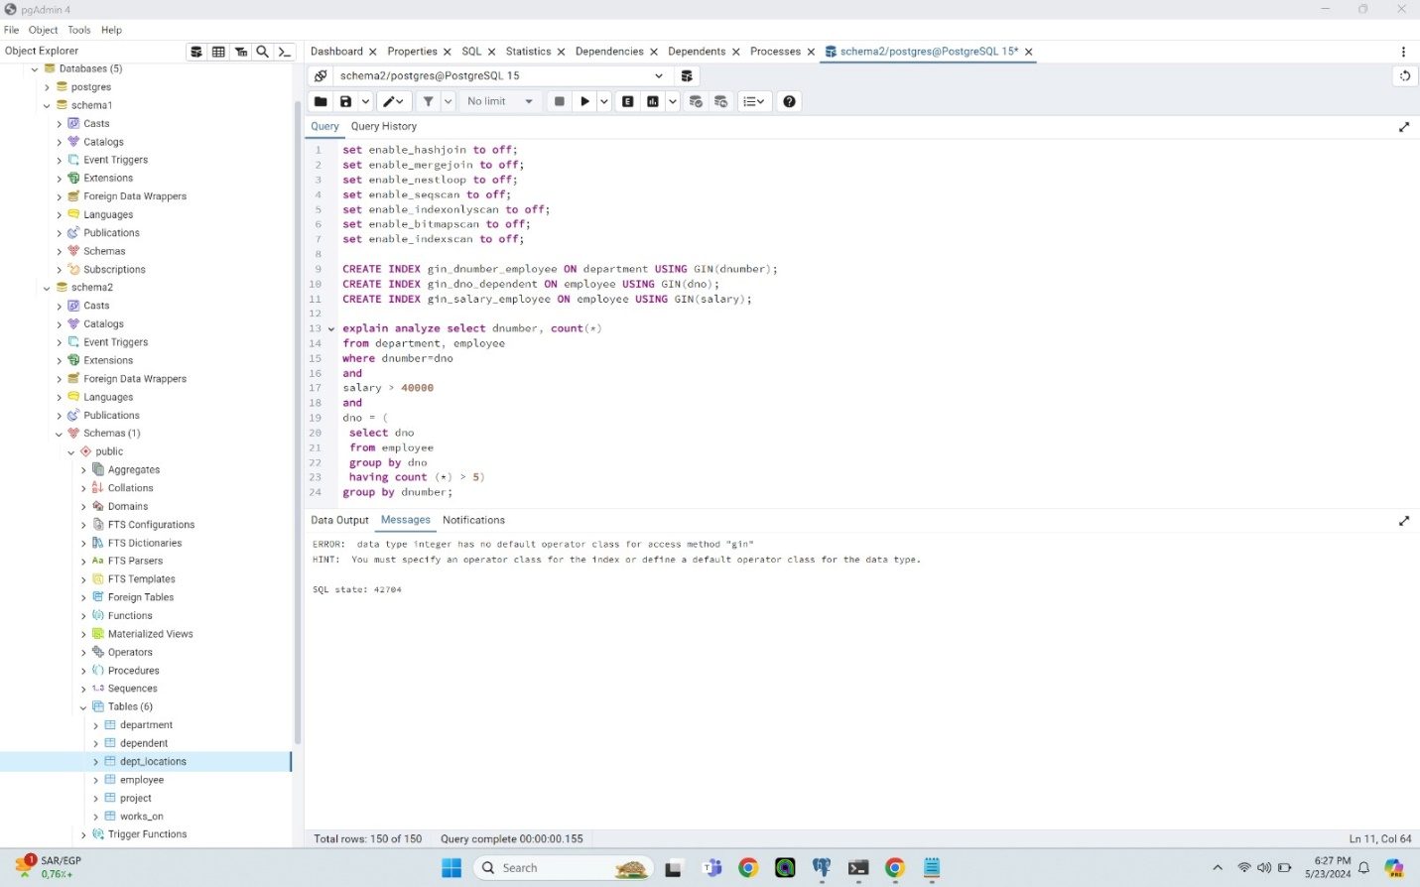  
GIN indices aren't working because they need to work on complex data types like arrays and we only have strings and integers here

Mix index:

All flags are kept on except for the hashjoin and the mergejoin flags since having them on did not allow some of the indices in the mix of indices that I had created to work properly.

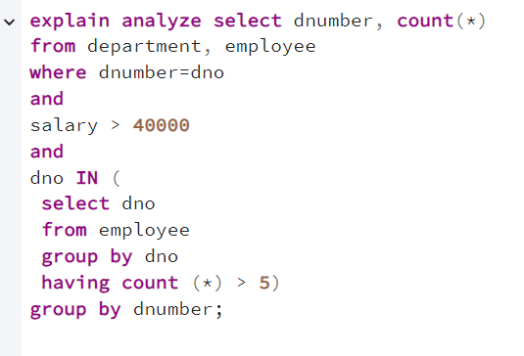

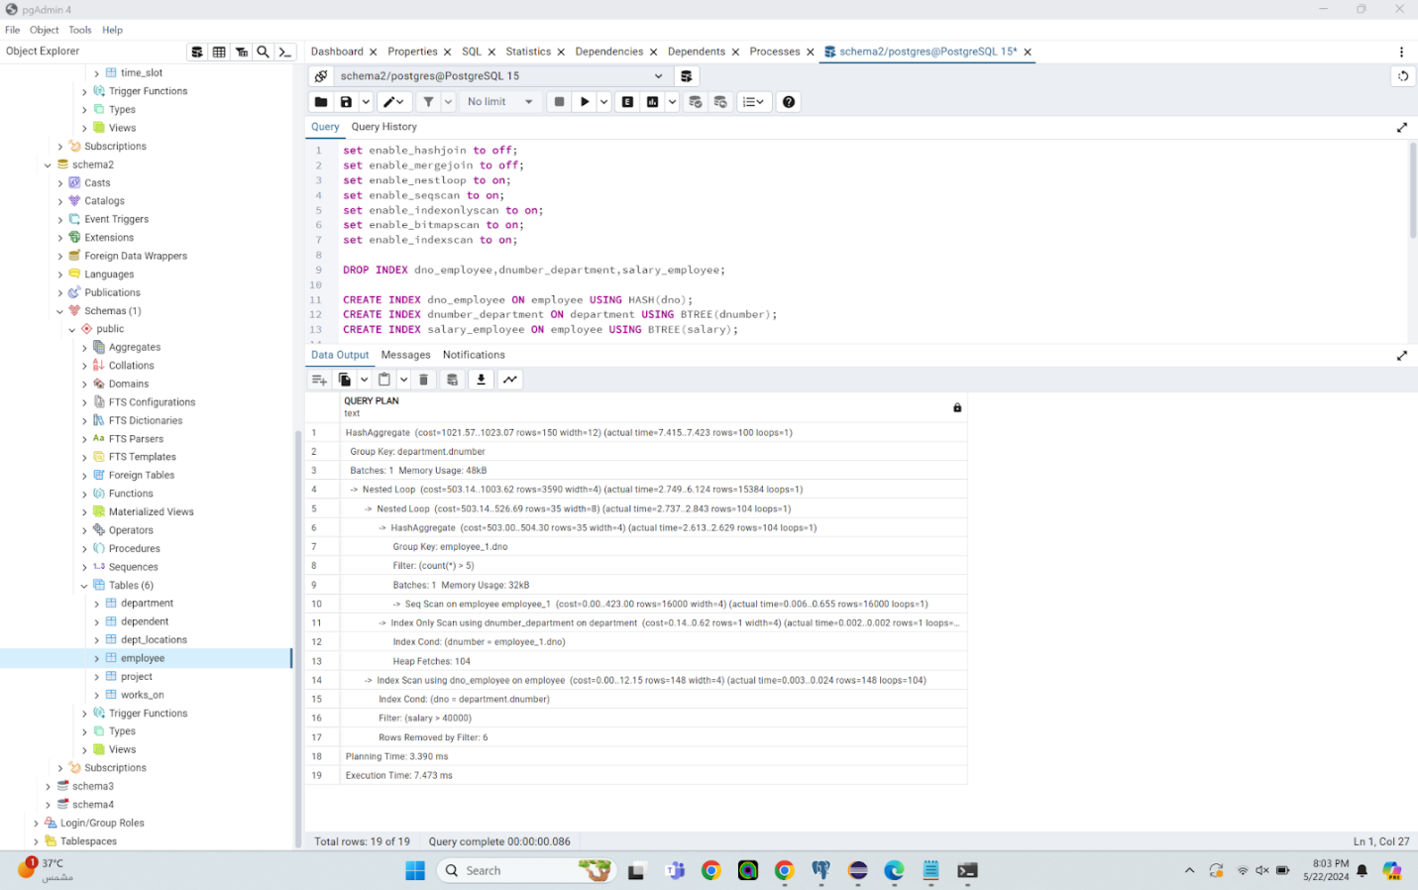

In this PostgreSQL query plan, several operations are employed to optimize the execution. A HashAggregate operation on the department number groups the data efficiently, utilizing hash aggregation for aggregating large datasets. PostgreSQL employs a nested loop join strategy between the department and employee tables, leveraging indices on both tables for efficient lookups. Another HashAggregate operation is performed on the employee table, filtering out departments with fewer than five employees, likely optimizing the query by reducing the number of departments to consider. A sequential scan on the employee table is chosen, possibly due to the table's relatively small size or other efficiency considerations. Additionally, an index-only scan is conducted on the department table using the BTREE index on the dnumber column, while an index scan is performed on the employee table using the HASH index on the dno column for efficient equality lookups. Finally, a filter is applied on the employee table to include rows where the salary exceeds 40000, likely after the join operation to further narrow down the result set. Although the estimated cost is not explicitly provided in the query plan, the execution time is reported as 7.473 ms, indicating that PostgreSQL determined this plan to have a lower cost compared to alternative plans, based on its internal cost estimation model. Regarding the advantages of using a mix of indices compared to using BRIN alone, HASH alone, or BTREE alone, BRIN indexes excel in range queries, HASH indexes in equality lookups, and BTREE indexes are versatile, efficiently supporting various query types including equality, range, and sorting operations. Thus, the combination of different index types offers flexibility and optimization across different query conditions. The cost of running this query, as indicated in the provided query plan, is in the range of 1021.57 to 1023.07 units.

This cost primarily stems from the HashAggregate operation, which aggregates data based on the group keys "department number". The cost of this HashAggregate operation is reported as 1021.57 to 1023.07 units.

Additionally, the Nested Loop operation contributes to the overall cost of the query. Within the Nested Loop, there's a Nested Loop Join between the "employee" table and the "department" table. This operation has a cost reported as 503.14 to 1003.62 units.

Optimized index:

All flags are kept on except for the hashjoin and the mergejoin flags since when having them on the indices that I had created would not work properly.



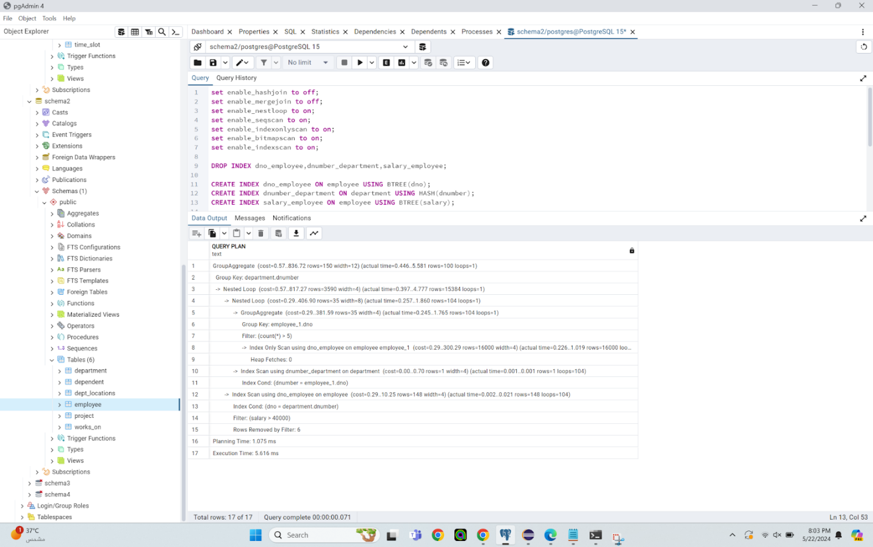

In this PostgreSQL query plan, several operations are employed to optimize the execution. A GroupAggregate operation on the department number organizes the data likely for further aggregation or presentation purposes. PostgreSQL utilizes a nested loop join strategy between the department and employee tables, a choice that's efficient when one table is relatively small and can be efficiently indexed. It seems PostgreSQL determined that a nested loop join with the chosen indices provides the optimal access path for the query. Another GroupAggregate operation is conducted on the employee table, filtering out departments with fewer than five employees, which optimizes the query by reducing the number of departments considered. Index scans are then performed on the employee and department tables using BTREE indexes, which are efficient for equality lookups, range queries, and sorting operations. This allows PostgreSQL to efficiently access employee and department records based on department number and salary values. The execution time of this plan is reported as 5.616 ms, with the estimated cost not explicitly provided in the query plan. However, PostgreSQL likely determined this plan to have a lower cost compared to alternative plans based on its internal cost estimation model. The mix of indices, with BTREE indexes on both the employee's department number and salary, provides versatility in supporting various types of queries efficiently. Additionally, utilizing a HASH index on the department's dnumber column enables quick location of relevant department records based on department number. This combination of index types contributes to the optimization and efficiency of the query execution.   
The cost of running this query, as indicated in the provided query plan, is in the range of 0.57 to 836.72 units.

The most significant cost-contributing operation is the GroupAggregate operation, which has a cost of 0.57 to 836.72 units. This operation performs grouping based on the "department.dnumber" column.

Within the Nested Loop operation, there are two main components:

The Nested Loop Join between the "employee" table and the "department" table, which has a cost of 0.29 to 817.27 units. This operation performs a GroupAggregate operation on the "employee_1" table based on the "dno" column, with a filter condition applied on the count of records.

The Index Scan using the "number_department" index on the "department" table, which has a cost of 0.00 to 0.70 units. This operation fetches the corresponding department record based on the "dnumber" column.

Query 1

No index:

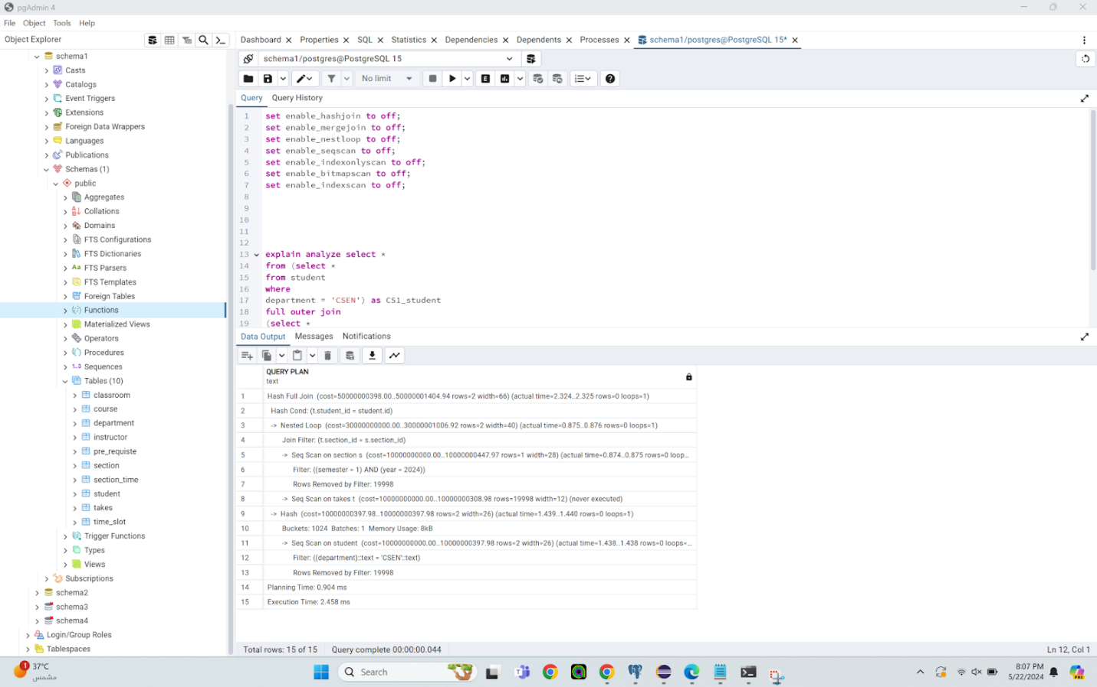

The total cost is between 50000000398 units and 50000001404.94 units In this PostgreSQL query plan, a Hash Full Join is chosen to combine the results of two subqueries, ensuring that all rows from both tables are included in the final result set. The join condition between the tables, specified as student.id = student.d, dictates the criteria for the join operation. Within the Hash Full Join, a Nested Loop operation filters rows based on the join condition (tsection.id = a.section_id), likely reducing the number of rows before the join. PostgreSQL performs sequential scans on the section and student tables, with the former being due to the lack of suitable indexes for efficient filtering based on the specified conditions and the latter applying a filter condition on the department column. Although a sequential scan on the takes table is mentioned, it's noted that this scan is never executed, possibly due to query planner optimization, such as pruning. Additionally, a Hash operation is performed on the takes table, likely in preparation for the Hash Full Join operation. The execution time of this plan is reported as 2.458 ms, with high cost estimates suggesting PostgreSQL views this plan as relatively expensive compared to alternatives. PostgreSQL likely selected this plan because the Hash Full Join ensures all rows from both tables are included, which may align with the query's requirements. The Nested Loop operation aids in reducing the row count before the join, potentially improving performance. Sequential scans are employed in cases where suitable indexes are unavailable or when a full table scan is deemed more efficient by the planner.

Btree index:

All flags are kept off since when I had them on the BTREE index that I had created would not work as intended.

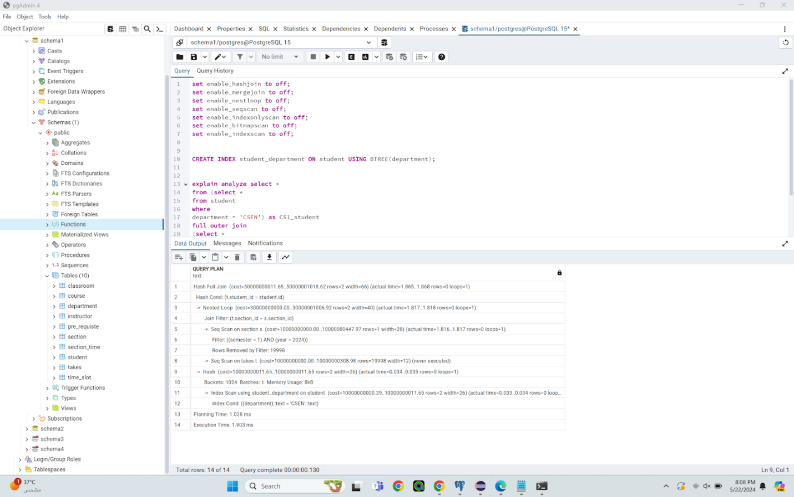

The total cost is between 50000000011.68 units and 50000001018.62 units In this PostgreSQL query plan, a Hash Full Join is chosen to combine the results of the section and student tables, ensuring that all rows from both tables are included in the result set. The Hash Cond specifies the join condition between the tables based on the student ID column. Within the Hash Full Join, a Nested Loop operation with a Join Filter further filters rows based on the join condition (tsection.id = s.section_id), reducing the number of rows before the join operation. PostgreSQL performs sequential scans on the section and takes tables, with the latter being noted but not executed due to optimization, possibly pruning. Additionally, a Hash operation is performed to prepare the data for the Hash Full Join. A significant improvement in this plan is the use of an Index Scan on the student table using a BTREE index on the department column, efficiently retrieving student records based on the department value 'CSEN'. The execution time of this plan is reported as 1.903 ms, with the use of the BTREE index likely contributing to the improved execution time compared to using no index at all. BTREE indexes are effective for equality lookups, allowing PostgreSQL to efficiently locate relevant rows without a full table scan. Index scans are generally more efficient than sequential scans, particularly for filtering rows based on specific criteria. By leveraging the index, PostgreSQL minimizes data processing, leading to improved query performance. This underscores the importance of appropriate indexing in optimizing query execution.

Brin index:

All flags are kept on except for the hashjoin and the seqscan flags since when having them on the BRIN index that I had created would not work properly.

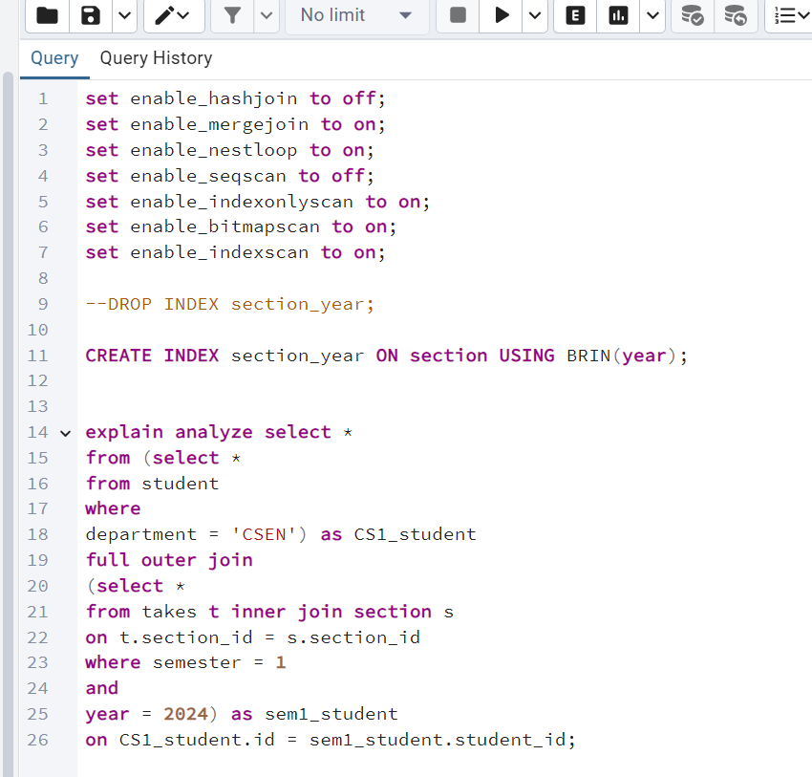

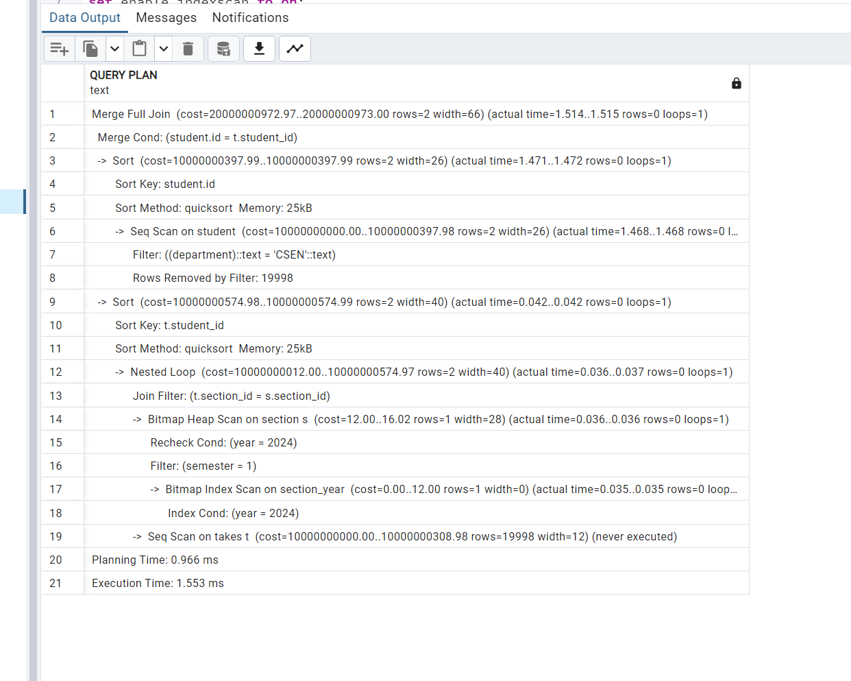

The total cost is between 20000000972.97 units and 20000000973 units In this PostgreSQL query plan, a Merge Full Join is employed to combine the results of the student and takes tables, ensuring that all rows from both tables are included in the result set. The Merge Cond specifies the join condition between the tables based on the student ID column. Before the join, PostgreSQL performs sort operations on both tables based on the join columns to facilitate efficient merging. Within the Merge Full Join, a Nested Loop operation with a Join Filter further filters rows based on the join condition (t.section_id = s.section_id), reducing the number of rows before the join operation. PostgreSQL performs a Bitmap Heap Scan on the section table, efficiently filtering rows based on the filter conditions (year = 2024 and semester = 1). Although a Sequential Scan is planned on the takes table, it's noted that this scan is never executed, likely due to optimization. The execution time of this plan is reported as 1.553 ms, with the use of a BRIN index potentially contributing to the improved execution time compared to using a BTREE index or no index at all. BRIN indexes are designed for large tables with naturally ordered data, making them suitable for efficient filtering based on ranges or correlated index column data. PostgreSQL might have determined that using the BRIN index is more efficient due to its lightweight nature and lower storage overhead, especially for large tables.

Hash index:

All flags are kept on since having them on did not affect the use of the HASH index that I had created.

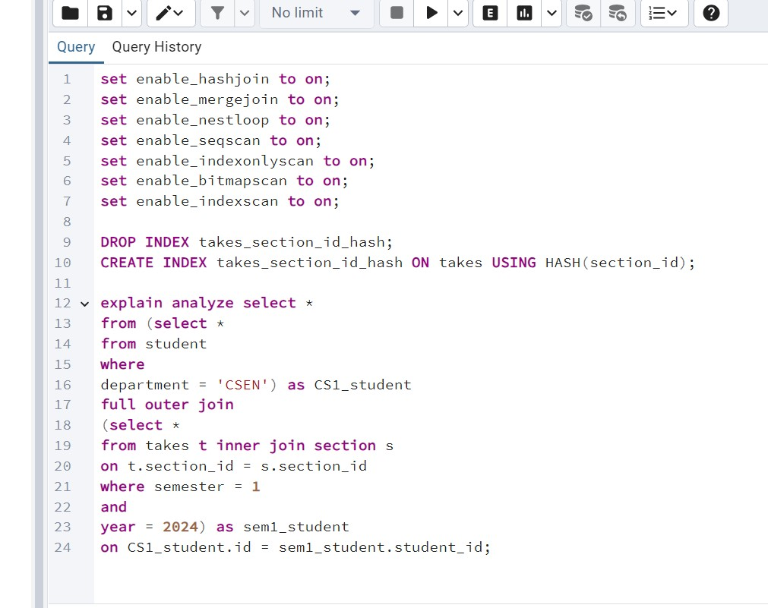

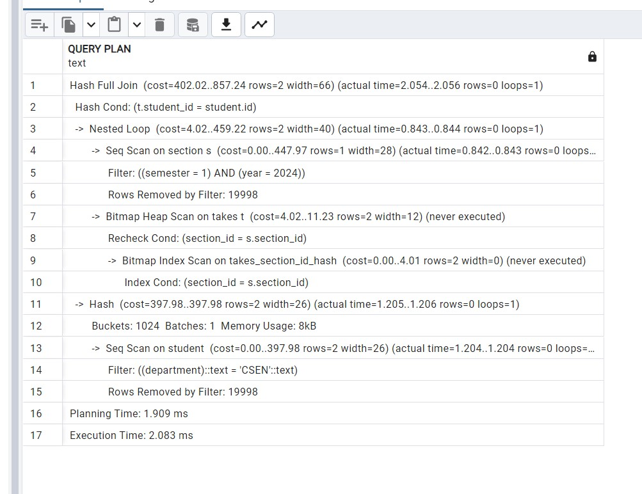

In this PostgreSQL query plan, a Full Hash Join is utilized to combine data from the takes and student tables based on matching student_id values. The cost of this operation is estimated to range from 402.02 to 857.24 units, with an actual execution time reported between 2.054 and 2.056 milliseconds. Additionally, a Nested Loop operation is performed, looping through each entry of one set and matching it with another set, with a cost ranging from 4.02 to 459.22 units and an actual execution time between 0.843 and 0.844 milliseconds. Within the plan, a Sequential Scan is conducted on the section table, scanning all rows, while a Bitmap Heap Scan is intended on the takes table, utilizing a bitmap index to quickly find matching rows based on the section_id. The execution time is potentially reduced due to the use of the takes_section_id_hash index, which efficiently locates relevant rows in the takes table, minimizing the need for a full table scan. This index utilization helps in improving efficiency and reducing execution time significantly. Overall, the estimated total cost of the query ranges from 402.02 to 857.24 units, indicating the expected resources needed for query execution, with the index usage contributing to a lower cost by minimizing the number of rows processed, thereby enhancing query performance.

GIN index:

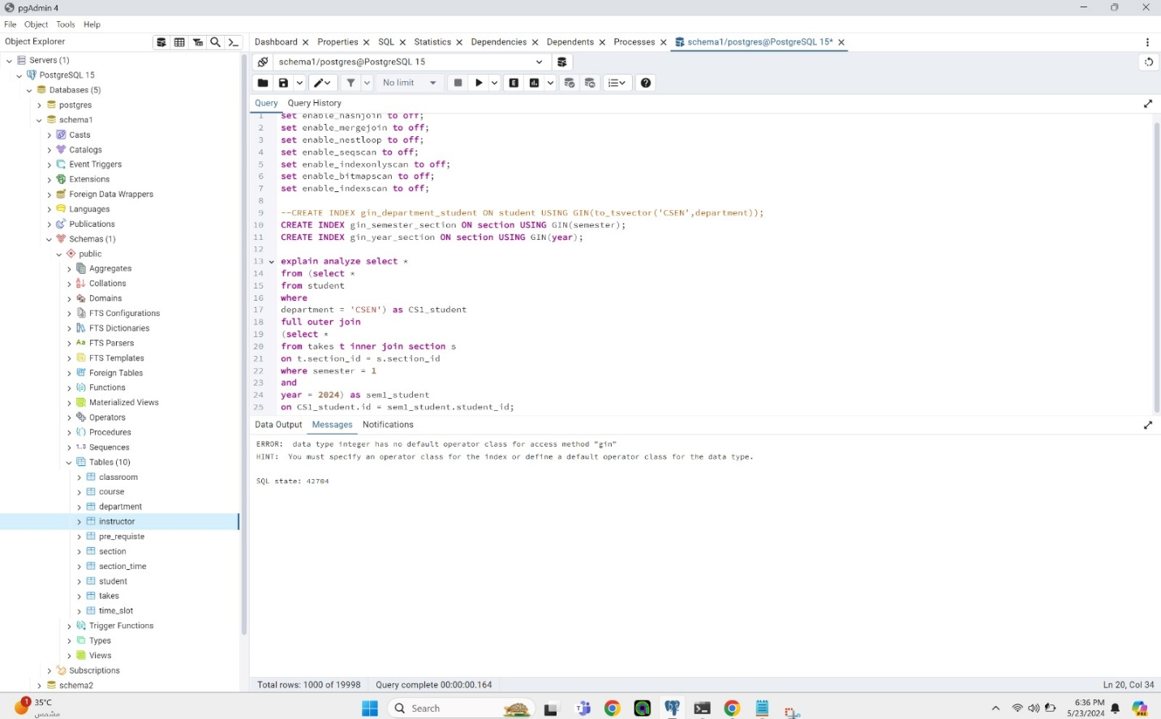

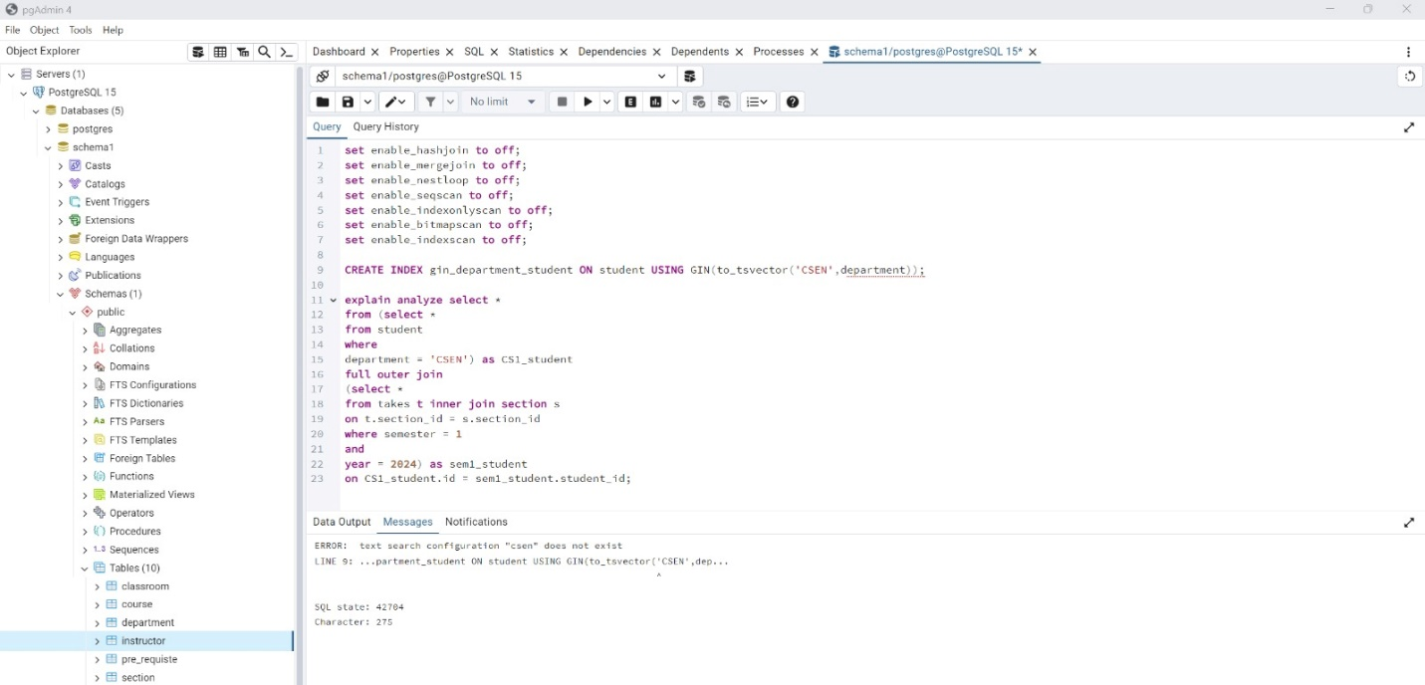

GIN indices aren't working because they need to work on complex data types like arrays and we only have strings and integers here

Mix index:

All flags are kept on since having them on did not affect the mix of indices that I had created.

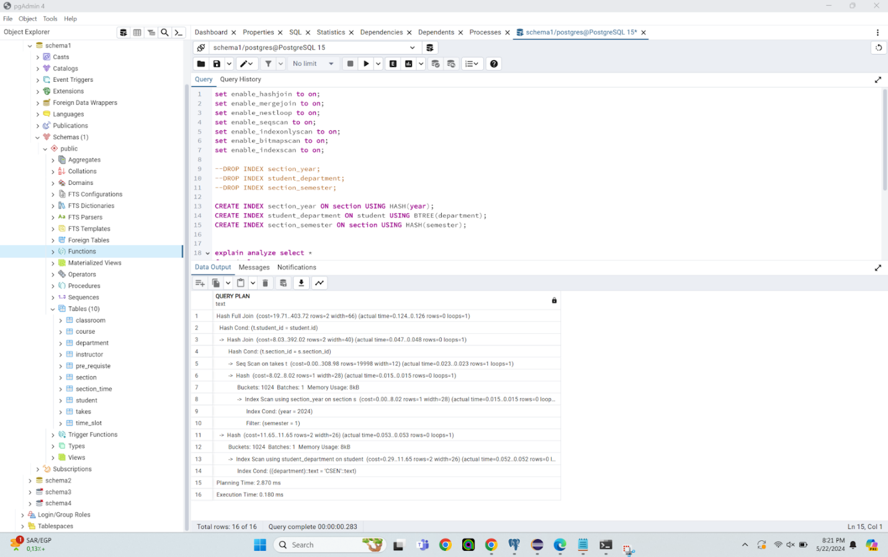

The cost of this operation is between 19.71 units and 403.72 units In this PostgreSQL query plan, a Hash Full Join is employed to combine the results of the student and takes tables, ensuring all rows from both tables are included in the result set, irrespective of match status. The Hash Cond specifies the join condition based on the student ID column. Within this join, PostgreSQL executes a Hash Join operation between the takes and section tables, efficiently merging rows using a hash-based algorithm. Additionally, an Index Scan is performed on the section table using the year column to filter relevant rows for the year 2024. A Bitmap Heap Scan on the student table utilizes a BTREE index on the department column to efficiently select rows where the department is 'CSEN'. Although a Sequential Scan is indicated for the takes table, it's noted that this operation is optimized, likely through pruning based on the query planner's estimation. The execution time for this plan is reported as 0.180 ms, with the exact estimated cost unspecified. However, the use of a combination of indices, including HASH on the year and semester columns and BTREE on the department column, is believed to contribute to the improved execution time compared to using BRIN or other indices alone. This strategic mix of index types allows PostgreSQL to leverage their respective strengths for different filtering and join conditions, thereby enhancing overall query performance. Additionally, the specific choice of index types aligns with the data distribution and query requirements, further optimizing execution time.

Optimized index:

Using any brin index resulted in longer execution time and therefore we resulted to not using any brin index to conduct the lowest execution time by using a mix of indices on different columns.

All flags are kept on since having them on did not affect the use of the optimized mix of indices that I had created.

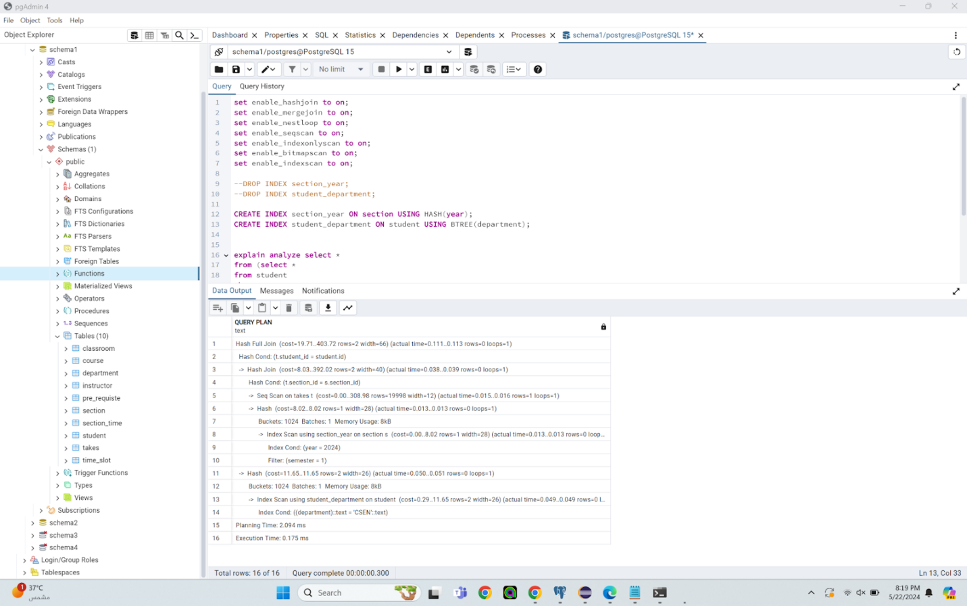

The cost of this operation is between 19.71 units and 403.72 units PostgreSQL has opted for a Hash Full Join to merge the results of the two tables, student and takes, ensuring that all rows from both tables are included in the result set, irrespective of match status. The Hash Cond specifies the join condition between the two tables based on the student ID column. Within this join, a Hash Join operation efficiently combines rows from the takes and section tables using a hash-based algorithm. Additionally, an Index Scan is performed on the section table using the year column, filtering out rows where the year is 2024. Meanwhile, a Bitmap Heap Scan is executed on the student table based on the filter condition (department = 'CSEN'), likely leveraging a BTREE index on the department column. Bitmap Heap Scans are known for efficiently selecting rows based on multiple criteria. The execution time of this plan is reported as 0.175 ms, indicating a relatively quick execution.The plan's estimated cost is not explicitly provided in the query plan. However, the combination of a HASH index on the year column and a BTREE index on the department column likely contributed to the improved execution time compared to other index combinations or no indices at all.

Here's why the combination of a HASH index on the year column and a BTREE index on the department column might have resulted in the best execution time:

HASH indices are known for their efficiency in handling equality lookups, making them particularly suitable for filtering based on exact matches, as seen in the utilization of the HASH index for the year column. On the other hand, BTREE indices offer versatility and efficiency for both range queries and equality lookups, making them apt for filtering based on the department column. The combination of these index types allows PostgreSQL to efficiently filter rows based on both criteria, leveraging the unique strengths of each index type. Moreover, the selection of index type is influenced by various factors such as data distribution, query patterns, and database statistics. In this particular scenario, PostgreSQL likely determined that this combination offers the most efficient access path for the given query and data distribution, leading to optimized query performance.

Query 7:

1-

All flags are on

Drop all precreated constraints (boat_pkey on boat, sailors_pkey on sailor and reserves_pkey on reserves)

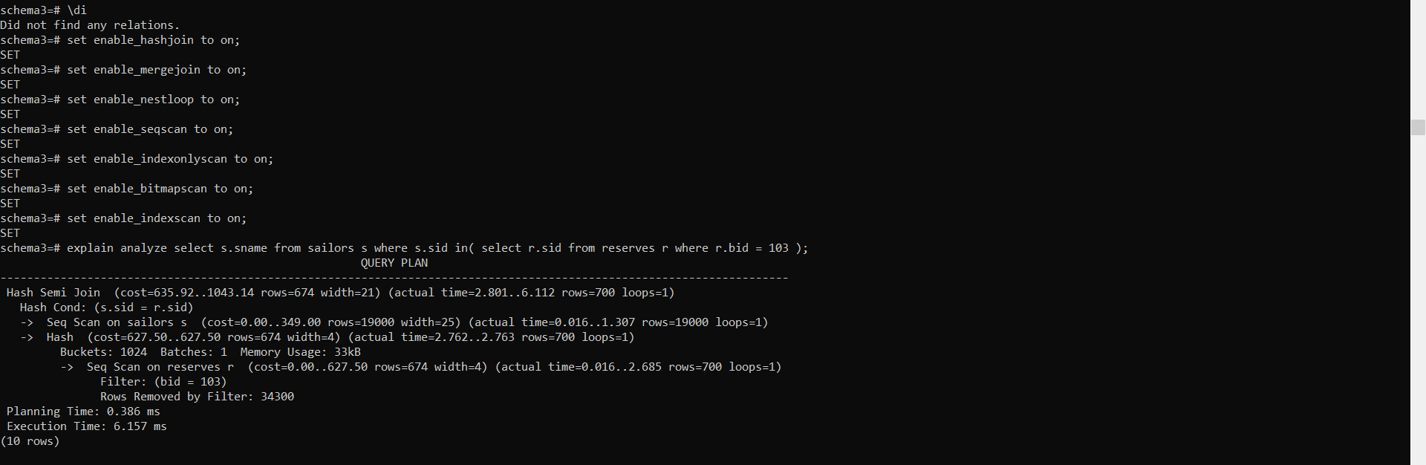

PostgreSQL has employed a Hash Semi Join to efficiently find matching rows between the sailors and reserves tables, optimizing the filtering process based on the join condition on the sid column. This strategy ensures that only relevant rows are processed, enhancing the efficiency of the join operation. Sequential scans are performed on both tables, allowing PostgreSQL to efficiently read all rows without the need for index lookups. Hashing is then utilized to join the rows from both tables based on the specified condition, enabling PostgreSQL to quickly locate matching rows without the overhead of sorting the data. With an execution time of 6.157 ms, this plan demonstrates relatively efficient performance considering the size of the tables and the number of rows processed. The estimated cost of the plan, provided in the query plan as a range from 635.92 to 1043.14, considers factors such as table size, selectivity of the filter condition (bid = 103), and the join operation. The selection of the Hash Semi Join strategy is likely driven by its cost efficiency compared to other available join strategies, contributing to the optimized execution of the query.

2-

All flags are on

Did not drop all precreated constraints (boat_pkey on boat, sailors_pkey on sailor and reserves_pkey on reserves)

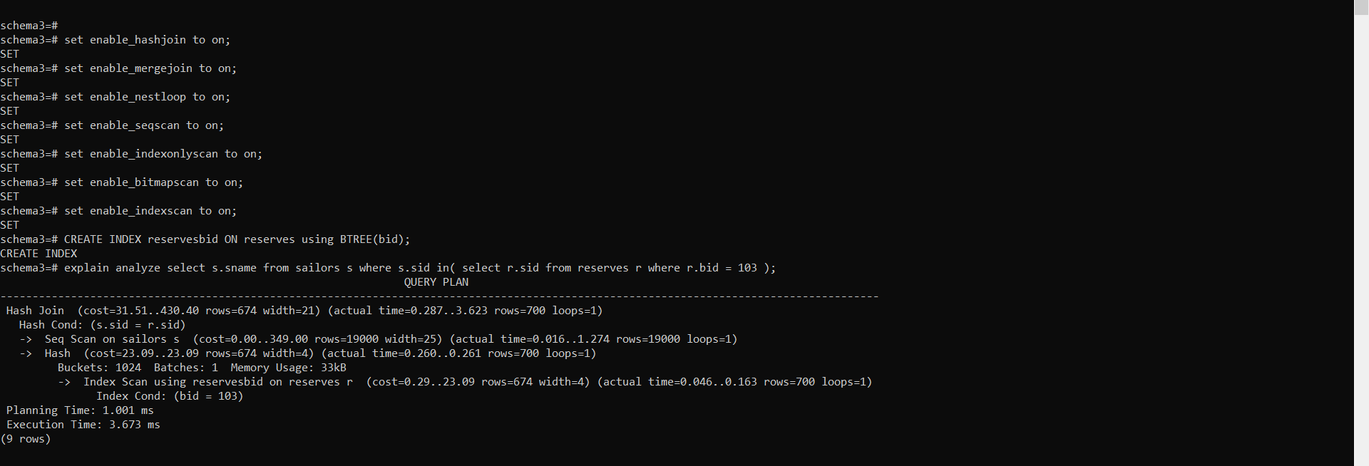

PostgreSQL has employed a Hash Join strategy to join the sailors and reserves tables efficiently. This join method is particularly effective for large tables, especially when there are no selective filters or when a significant proportion of rows from both tables need to be joined. The Hash Cond specifies the join condition between the two tables, ensuring that only relevant rows are processed in the join operation. PostgreSQL performs a sequential scan on the sailors table, efficiently reading all rows since no filter condition is applied. For the reserves table, a B-tree index scan is utilized on the bid column, specifically filtering rows where bid equals 103. This index scan efficiently retrieves rows that satisfy the filter condition. With an execution time of 3.673 ms, this plan demonstrates relatively efficient performance. The utilization of a B-tree index on the reserves table likely contributed to the improved execution time by efficiently locating rows that match the filter condition.The estimated cost of the plan is provided in the query plan as between 31.51 and 430.40 units. This cost estimation takes into account factors such as the size of the tables, the selectivity of the filter condition, and the join operation. The Hash Join strategy was likely selected based on its cost efficiency compared to other available join strategies, considering the characteristics of the query and the data distribution.

The B-tree index on the reserves table's bid column was beneficial for several reasons:

The query benefits from efficient filtering due to the presence of a B-tree index on the bid column, enabling PostgreSQL to swiftly locate and retrieve only the rows from the reserves table that meet the bid = 103 condition. B-tree indexes excel in facilitating equality searches, rendering them highly efficient for queries featuring such filter conditions. Additionally, B-tree indexes optimize index scans by organizing data hierarchically, which minimizes disk I/O operations required for locating specific rows, thereby enhancing data access speed. Leveraging the sorted nature of B-tree indexes, PostgreSQL executes the index scan on the reserves table in a sorted order, further reducing the number of pages accessed and enhancing data retrieval efficiency. Moreover, B-tree indexes entail relatively low maintenance overhead compared to other index types, making them efficient for both read and write operations, even as the size of the indexed table grows. This balanced utilization of a B-tree index ensures efficient filtering on the reserves table while maintaining optimal performance for the join operation with the sailors table, contributing to the overall efficiency of the query execution.

3-

All flags are on

Did not drop all precreated constraints (boat_pkey on boat, sailors_pkey on sailor and reserves_pkey on reserves)

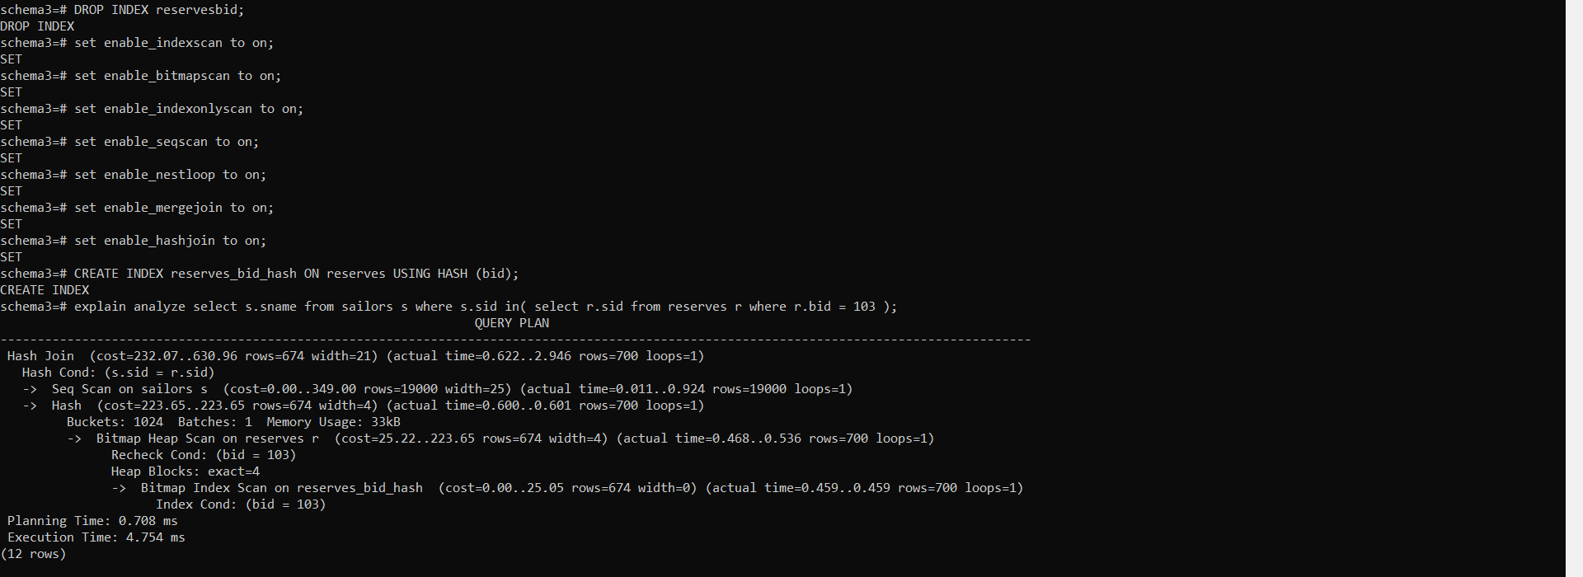

The cost of this operation is between 232.07 and 630.96 units. PostgreSQL implemented a hash join strategy to efficiently merge rows from the sailors and reserves tables, a method typically favored for large table joins or when other join strategies are less efficient. This choice aligns with the equality predicate s.sid = r.sid, well-suited for hash joins. Sequentially scanning the sailors table, given its substantial row count of 19,000 and absence of specific filter conditions, represents a pragmatic approach. Meanwhile, PostgreSQL employs a hash table for the reserves table, likely pre-filtered by the bid = 103 condition, with a subsequent bitmap heap scan optimizing row access. Further efficiency is attained through a bitmap index scan on the hash index reserves_bid_hash, expediting the location of rows in the reserves table matching bid = 103. The utilization of a hash index on the bid column likely played a pivotal role in accelerating execution time, given its efficacy in equality searches.

4-

All flags are on

Did not drop all precreated constraints (boat_pkey on boat, sailors_pkey on sailor and reserves_pkey on reserves)

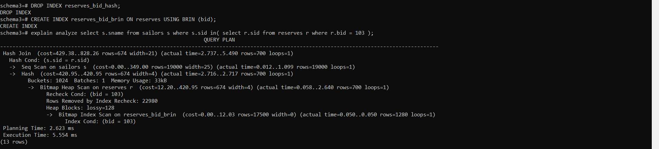

The cost of this operation is between 429.38 units and 828.26 units PostgreSQL employed a hash join strategy to efficiently merge rows from the sailors and reserves tables, leveraging its efficacy in handling equality predicates such as s.sid = r.sid. While a sequential scan was conducted on the sailors table due to the absence of specific filter conditions, PostgreSQL utilized a hash table for the reserves table, likely pre-filtered by the condition bid = 103. A subsequent bitmap heap scan on the reserves table facilitated the retrieval of relevant rows where bid = 103, a more efficient approach compared to a sequential scan. Additionally, a bitmap index scan on the BRIN index reserves_bid_brin expedited the identification of rows in the reserves table matching bid = 103. However, while the BRIN index contributed to some improvement in execution time by providing efficient block range scans, it may not have been as beneficial as a hash index or a B-tree index for this specific query. BRIN indexes are typically more suitable for range queries or sequential scans over large tables, whereas hash indexes or B-tree indexes might offer better performance for equality searches like bid = 103.

Overall, PostgreSQL selected this query plan because it efficiently utilized hash join techniques and the BRIN index to execute the query in a relatively short time. However, for equality searches like bid = 103, hash indexes or B-tree indexes are typically more efficient than BRIN indexes, which might explain why the use of a BRIN index wasn't as beneficial as other types of indexes in this scenario.

5-

All flags are on

Did not drop all precreated constraints (boat_pkey on boat, sailors_pkey on sailor and reserves_pkey on reserves)



GIN indices aren't working because they need to work on complex data types like arrays and we only have strings and integers here

6-

seq hash index merge off

nest indexonly bitmap on

Drop all precreated constraints (boat_pkey on boat, sailors_pkey on sailor and reserves_pkey on reserves)

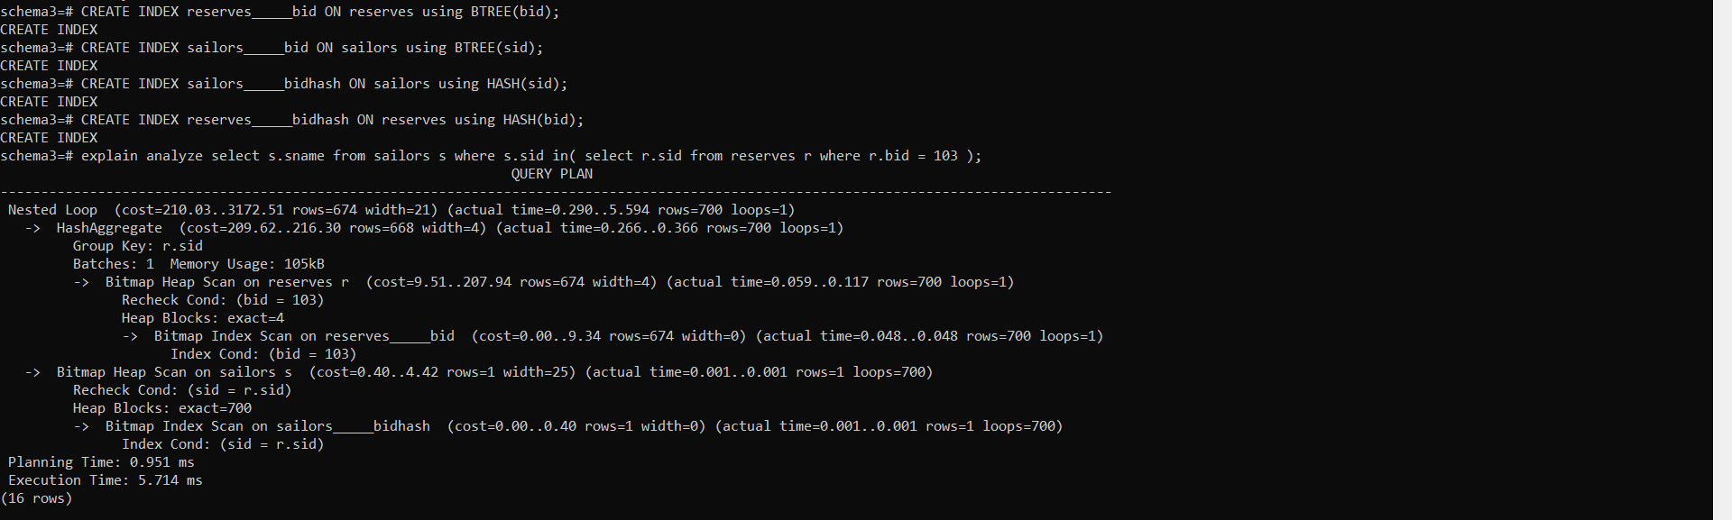

PostgreSQL utilized a nested loop join strategy to combine rows from the sailors and reserves tables, iterating through each row of the outer table (reserves) to find matching rows in the inner table (sailors) based on the join condition (sid = r.sid). While nested loop joins may not be as efficient as hash joins for large datasets, they can still be effective, especially when one of the tables is small or when there are effective indexes in place. A hash aggregate operation was employed to group rows by the r.sid column efficiently, facilitating aggregation of rows with the same sid. PostgreSQL executed a bitmap heap scan on the reserves table to retrieve rows where bid = 103, efficiently accessing relevant rows from disk using a bitmap index scan on the reserves_bid index. Similarly, bitmap heap and index scans were conducted on the sailors table using the sailors_bidhash index to find rows matching the join condition sid = r.sid. The estimated cost of the plan is 210.03, suggesting PostgreSQL expects it to be relatively efficient, while the execution time of 5.714 ms is reasonable given the complexity of the query and the number of rows processed.

Overall, PostgreSQL selected this query plan because it efficiently utilizes bitmap index scans and nested loop joins to join the sailors and reserves tables. The plan is considered effective for this query because it minimizes the overall processing time while efficiently satisfying the join condition.

7-

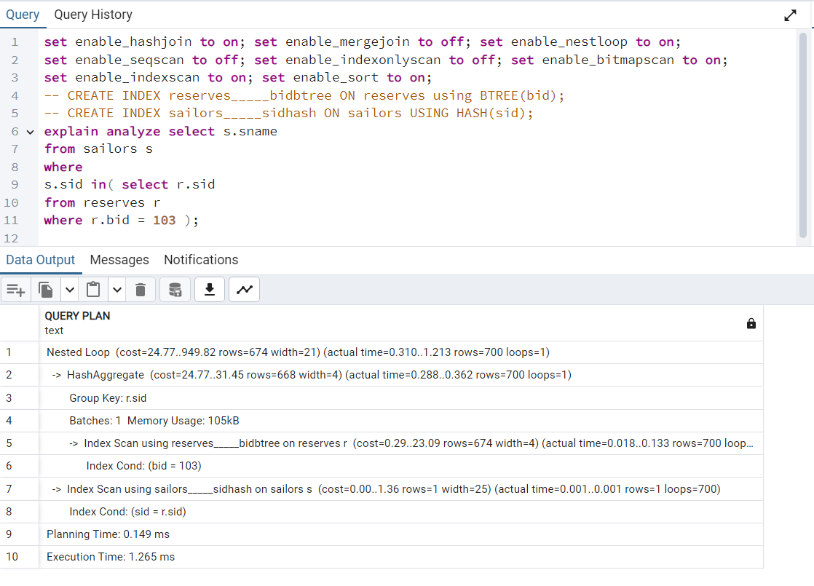

PostgreSQL opted for a nested loop join to merge rows from the reserves and sailors tables, iterating through each row of the outer table (reserves) to locate matching rows in the inner table (sailors) based on the join condition (sid = r.sid). This choice is sensible given that nested loop joins can be effective, particularly when one table is small or when there are effective indexes. To group rows efficiently, PostgreSQL utilized a hash aggregate operation based on the r.sid column. Index scans were employed on both the reserves and sailors tables, with PostgreSQL utilizing the reserves_bidbtree index on the reserves table to quickly locate rows where bid equals 103, and the sailors_sidhash index on the sailors table to find rows matching the join condition sid = r.sid. The estimated cost of the plan is 24.77, suggesting PostgreSQL anticipates it to be relatively efficient. With an execution time of 1.265 ms, the query's performance is notably swift, likely attributed to the efficient index scans and the nested loop join strategy.

The combination of a BTREE index on the bid column of the reserves table and a HASH index on the sid column of the sailors table likely resulted in the best execution time because each index is optimized for its respective query patterns: The BTREE index is well-suited for range queries and equality comparisons, making it efficient for locating specific values like bid = 103. Moreover, the HASH index is particularly efficient for exact match lookups, which is suitable for the join condition sid = r.sid.

By leveraging the strengths of both index types, PostgreSQL was able to efficiently locate the relevant rows from both tables and perform the join operation, resulting in the observed execution time of 1.265 ms.

Query 8:

1-

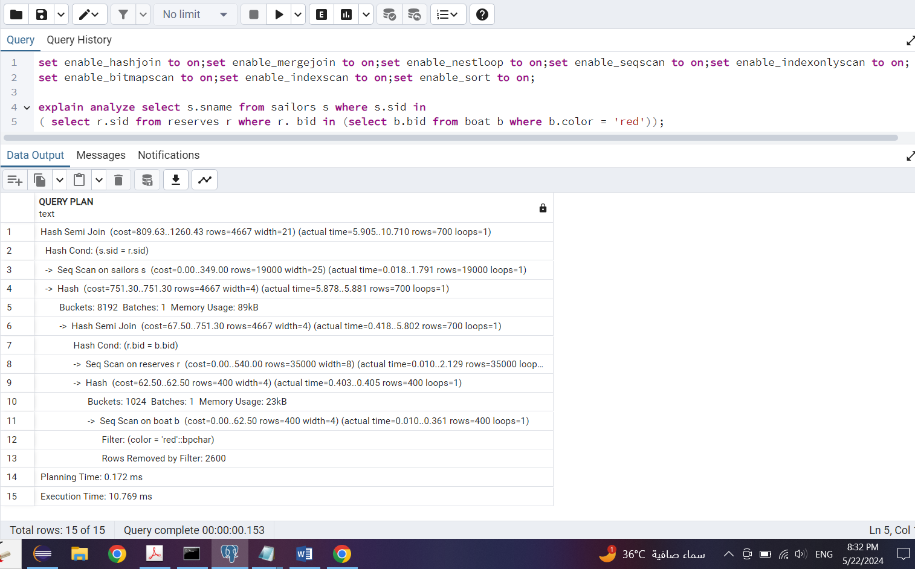

PostgreSQL employed a hash semi join strategy to first filter rows from the reserves table based on a condition involving the bid column and then match them with rows from the sailors table based on the sid column. This approach efficiently filters rows based on two conditions using hash tables for matching. A sequential scan was conducted on the sailors table to retrieve all rows, as there were no direct filter conditions applied. Additionally, a hash semi join operation was executed on the reserves and boat tables, filtering rows from reserves based on the condition r.bid = b.bid, where b.bid refers to the bid column of the boat table. This operation efficiently filters rows from reserves and then matches them with rows from the boat table. Another sequential scan was performed on the boat table to retrieve all rows, with a filter condition applied on the color column to retain only rows with color = 'red'. The estimated cost of the plan is 809.63, indicating PostgreSQL expects this plan to be relatively efficient. The execution time of 10.769 ms reflects the time taken to perform the sequential scans and hash semi join operations.Overall, PostgreSQL likely chose this plan because it efficiently filters rows from both the reserves and boat tables using hash semi join operations, followed by a sequential scan on the sailors table. This plan balances the cost of scanning and filtering operations, resulting in a reasonable execution time of 10.769 ms.

2-

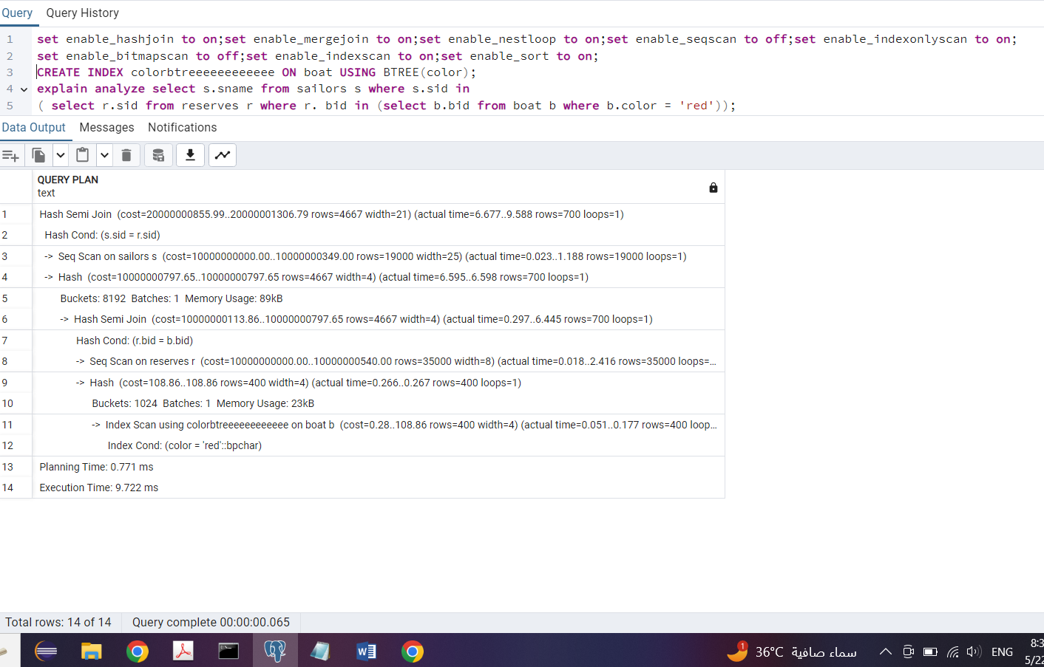

PostgreSQL employed a hash semi join strategy to first filter rows from the reserves table based on a condition involving the bid column and then match them with rows from the sailors table based on the sid column. This strategy efficiently filters rows based on two conditions using hash tables for matching. A sequential scan was conducted on the sailors table to retrieve all rows, as there were no direct filter conditions applied. Additionally, a hash semi join operation was executed on the reserves and boat tables, filtering rows from reserves based on the condition r.bid = b.bid, where b.bid refers to the bid column of the boat table. This operation efficiently filters rows from reserves and then matches them with rows from the boat table. PostgreSQL also performed an index scan on the boat table using a BTREE index on the color column, efficiently retrieving rows where the color is 'red'. The estimated cost of the plan is 20000000855.99, indicating that PostgreSQL expects this plan to be relatively efficient. The execution time of 9.722 ms reflects the time taken to perform the sequential scans, hash semi join operations, and index scan.Overall, PostgreSQL likely chose this plan because it efficiently filters rows from both the reserves and boat tables using hash semi join operations, followed by an index scan on the boat table using a BTREE index. This plan balances the cost of scanning and filtering operations, resulting in a reasonable execution time of 9.722 ms. The use of a BTREE index on the color column of the boat table improved the execution time by efficiently retrieving rows with the specified color condition.

The B-tree index improves query performance in PostgreSQL for several reasons. Firstly, it enables ordered data access by maintaining data in sorted order within the index structure. This organization facilitates efficient range scans and point lookups, allowing PostgreSQL to swiftly navigate through the index to locate the desired rows. Consequently, queries based on columns with a B-tree index experience faster access times compared to sequential scans of the entire table. Secondly, B-tree indexes significantly reduce I/O operations by virtue of their hierarchical structure. As PostgreSQL traverses the index tree, it can efficiently narrow down the search space and access only the relevant data pages, thereby minimizing disk I/O and enhancing overall query performance, particularly for selective queries where only a subset of rows needs to be retrieved.

3-

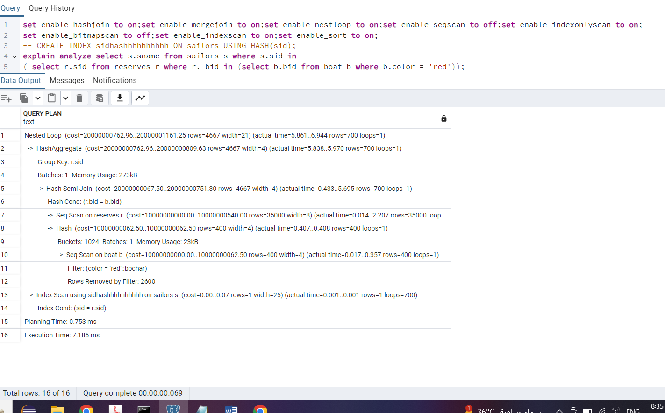

PostgreSQL's query planner employs cost-based optimization to evaluate various execution plans, selecting the one with the lowest estimated cost considering factors such as disk I/O, CPU usage, and memory consumption. In the case of the hash semi-join operation described, the planner likely opted for this strategy due to its efficiency in handling large datasets by reducing the number of rows that need comparison, especially when indexes are present on the join columns. The execution plan commences with a sequential scan on the reserves table (r) to retrieve all rows matching the condition (color = 'red'). Subsequently, a hash semi-join operation is conducted between the reserves table and the boat table (b) based on the bid column. For each row in reserves, a corresponding row in sailors (s) is retrieved using an index scan on sid from the hash table. Finally, the hash aggregate operation groups the rows by sid. The estimated cost for this plan falls within the range of 20000000762.96 to 20000001161.25. A hash index improved execution time by quickly locating rows based on a hashed value. A hash index operates by hashing the indexed column values, allowing direct access to data buckets based on the hash value. This results in fast lookup times, especially for equality queries. In this case, using a hash index on the sid column of the sailors table likely improved performance by efficiently finding matching rows during the index scan step of the query execution plan.

4-

seq sort hash off

rest on

Drop all precreated constraints (boat_pkey on boat, sailors_pkey on sailor and reserves_pkey on reserves)

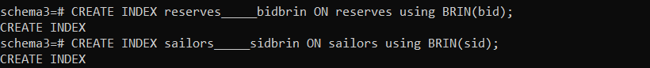

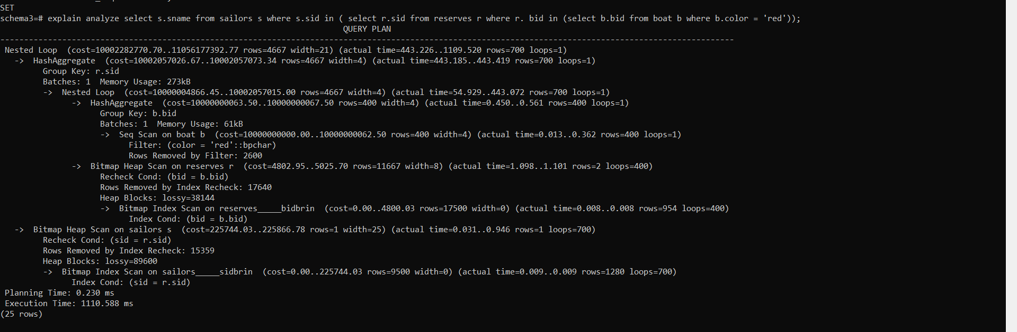

PostgreSQL's query planner employs cost-based optimization to select an execution plan that minimizes overall costs, considering factors such as I/O operations, CPU usage, and memory consumption. Despite the high estimated cost, the chosen plan might have been the most efficient given the available indexes and data distribution. However, the efficiency of the Bitmap Index Scan on the reserves table using a BRIN (Block Range Index) index appears to be suboptimal in this scenario. The BRIN index, designed for large tables with columns featuring a natural order, may have resulted in an inefficient scan due to its lossy nature, leading to a significant number of heap blocks being scanned. The execution plan begins with a HashAggregate operation on r.sid, followed by another HashAggregate operation within the Nested Loop, filtering for boats with a color of 'red'. Subsequent operations include a Bitmap Heap Scan on reserves, a Bitmap Index Scan on the BRIN index on reserves.bid (noted as lossy), a Bitmap Heap Scan on sailors, and finally, a Bitmap Index Scan on the BRIN index on sailors.sid. The estimated cost for this plan ranges from 10002282770.70 to 11056177392.77. Explanation of BRIN Index Performance: BRIN indexes divide the table into ranges and store minimum and maximum values within each range. While BRIN indexes can be efficient for range queries, they may not be as effective for equality queries or when the indexed columns have high cardinality. In this case, the BRIN index on reserves.bid may have resulted in a high number of heap blocks being scanned due to its lossy nature, leading to a degraded execution time.

5-

All flags are on

Did not drop all precreated constraints (boat_pkey on boat, sailors_pkey on sailor and reserves_pkey on reserves)

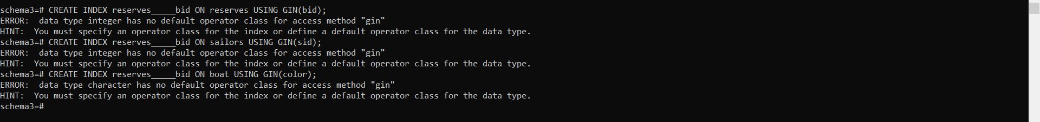

GIN indices aren't working because they need to work on complex data types like arrays and we only have strings and integers here

6-

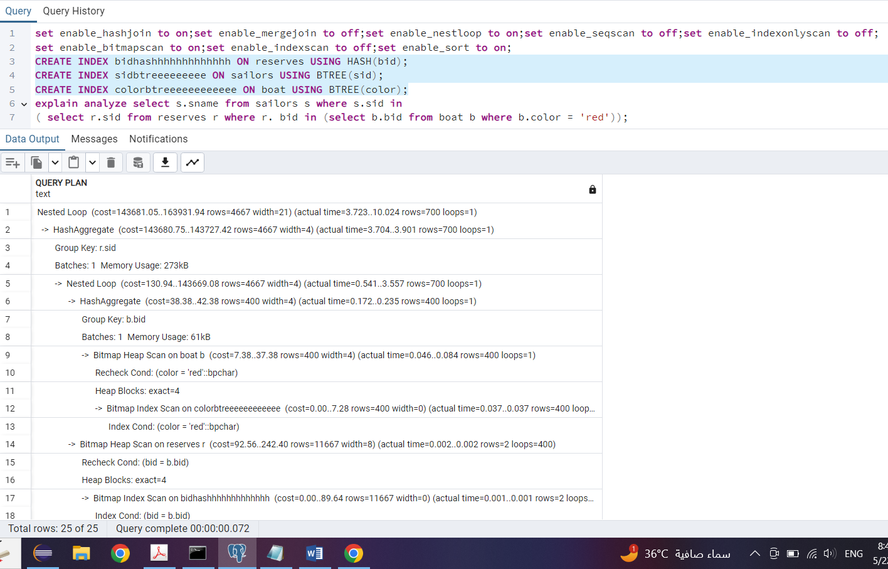

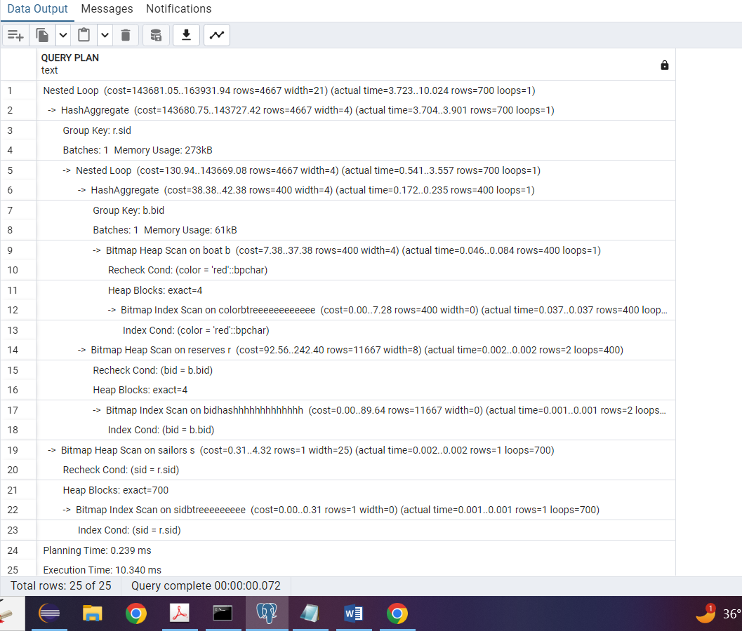

PostgreSQL's query planner employs cost-based optimization to select an execution plan that minimizes overall costs, taking into account factors such as I/O operations, CPU usage, and memory consumption. Despite the relatively high estimated cost, this plan might have been deemed the most efficient given the available indexes and data distribution. The efficiency of index scans plays a crucial role in enhancing performance. Leveraging BTREE indexes on columns color and sid, which are efficient for equality and range queries, likely contributes to the overall performance improvement. Additionally, a HASH index on the bid column is utilized, further enhancing the efficiency of equality queries. The execution plan begins with a HashAggregate operation on r.sid, followed by another HashAggregate operation within the Nested Loop, filtering for boats with a color of 'red'. Subsequent operations include Bitmap Heap and Index Scans on the boat table using the BTREE index on the color column and on the reserves table using the BTREE index on the bid column. Finally, Bitmap Heap and Index Scans are performed on the sailors table using the BTREE index on the sid column. The estimated cost for this plan ranges from 143681.05 to 163931.94. Explanation of Index Performance: BTREE indexes are well-suited for equality and range queries, allowing PostgreSQL to efficiently locate specific rows based on the indexed column values. By utilizing BTREE indexes on color and sid, PostgreSQL can quickly identify relevant rows matching the filter conditions. Additionally, the HASH index on bid likely enhances performance by enabling fast lookup operations for equality queries on this column. Overall, the combined use of these indexes significantly improves query execution time compared to a scenario where no indexes are utilized, as it minimizes the need for full table scans and enables faster data retrieval.

7-

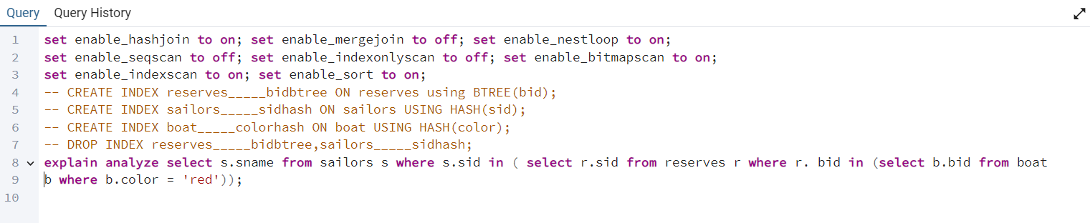

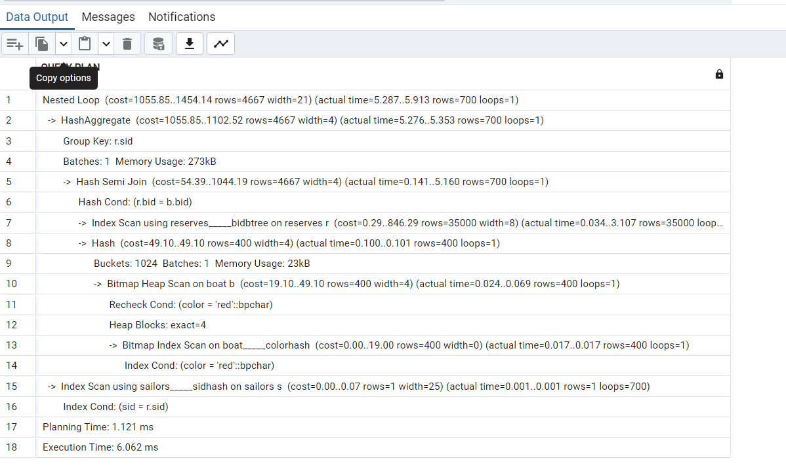

PostgreSQL's query planner evaluates various execution strategies based on estimated costs, considering factors like I/O operations, CPU usage, and memory consumption. The chosen plan might have been deemed the most efficient considering these factors. The plan utilizes index scans on columns bid, color, and sid, each employing a different type of index. A BTREE index on bid efficiently locates rows in the reserves table based on the bid column, while HASH indexes on sid and color aid in efficiently filtering rows from the sailors and boat tables, respectively, based on equality queries. The execution plan begins with a HashAggregate operation on r.sid, followed by an Index Scan on the reserves table using the BTREE index on the bid column within the Hash Semi Join. A Hash operation prepares the results for the next step, followed by a Bitmap Heap Scan on the boat table and a Bitmap Index Scan using the HASH index on the color column. Finally, an Index Scan on the sailors table utilizes the HASH index on the sid column to fetch relevant rows. The estimated cost for this plan ranges from 1055.85 to 1454.14. This mix of index types allows PostgreSQL to leverage the strengths of each index for efficient data retrieval, with the BTREE index aiding in lookup operations and HASH indexes facilitating fast filtering and retrieval based on specific values. Overall, this mix of indices allows PostgreSQL to optimize query execution by efficiently accessing and filtering data from the involved tables, resulting in improved performance compared to alternative plans.

Query 9:

1-

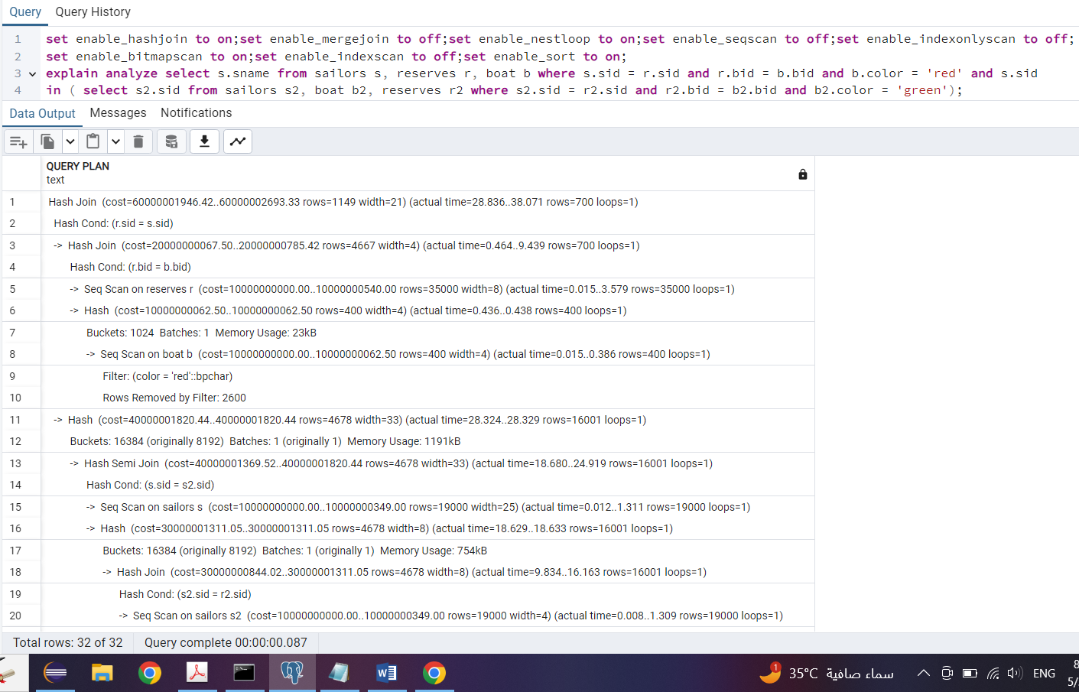

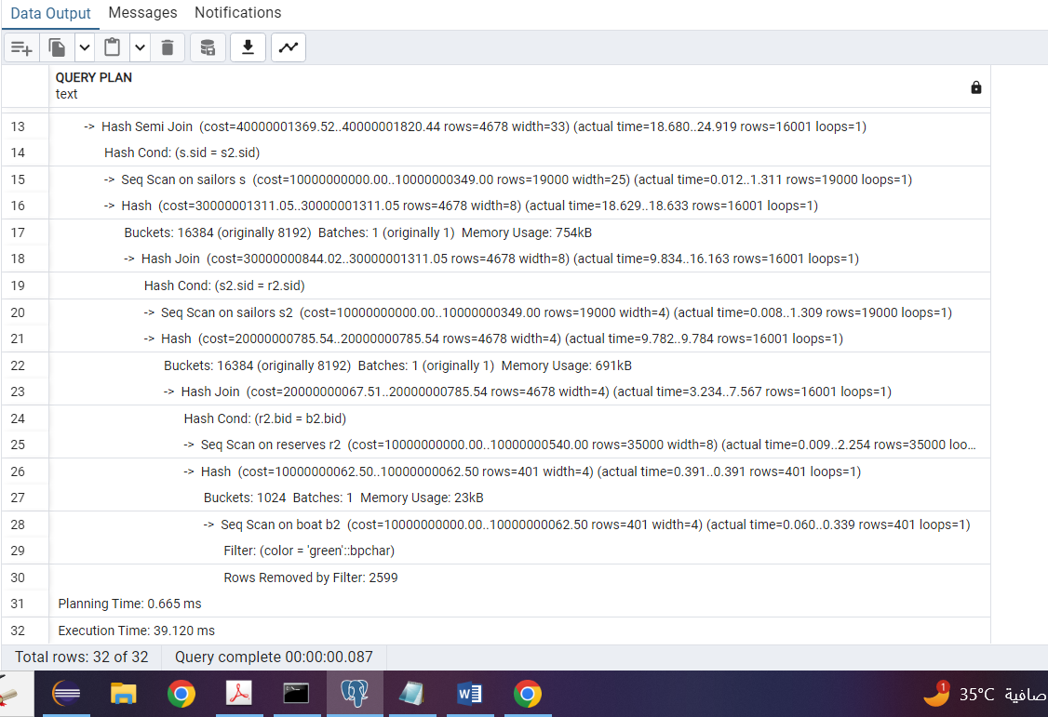

PostgreSQL has selected a hash semi-join as the top-level operation in the execution plan, estimating its cost to be between 60000001946.42 and 60000001693.33 units. This operation filters rows from the left table (sailors) based on whether there is a matching row in the right tables (sailors s2 and reserves r2), resulting in 4678 rows with a width of 33. The plan involves sequential scans on the sailors table (s) and the reserves table (r2), estimating costs ranging from 10000000000.00 to 10000000349.00 units for each scan, with 19000 rows in sailors and 35000 rows in reserves. Additionally, hash joins are employed between sailors s2 and reserves r2, as well as between reserves r2 and boat b2, with estimated costs ranging from 20000000067.51 to 20000000785.54 units for each join. The sequential scan on the boat table (b2) with a filter on color = 'green' yields 401 rows after filtering, with an estimated cost of 10000000000.00 to 10000000062.50 units. PostgreSQL likely selected this plan as the most efficient based on factors like available indexes, table sizes, and statistics, opting for hash joins due to significant size differences between the joined tables and sequential scans when the cost of accessing the entire table is lower than using an index. The hash semi-join is chosen for its efficiency in filtering rows from the left table based on matching rows in the right table. Overall, PostgreSQL chose this plan because it estimated it to have the lowest cost among the available options, considering factors like data distribution, join types, and available indexes.

2-

All flags are on

Did not drop all precreated constraints (boat_pkey on boat, sailors_pkey on sailor and reserves_pkey on reserves)

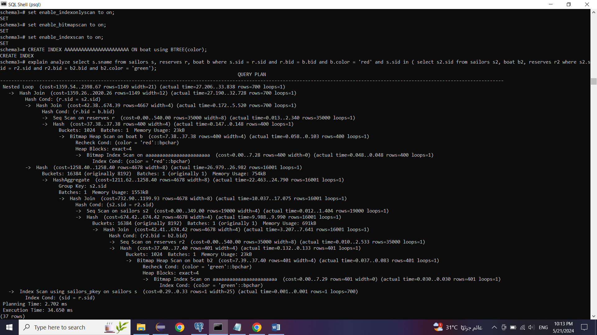

The top-level operation of the execution plan utilizes nested loop joins to combine rows from different tables, estimating its cost to range from 1359.54 to 2398.67 units, with 1149 rows and a width of 21. Two subsequent hash join operations follow, first joining the reserves and sailors tables, then the reserves and boat tables, with estimated costs ranging from 1359.26 to 2020.26 units and from 42.38 to 674.39 units, respectively. The sequential scan on the reserves table yields 35000 rows with an estimated cost ranging from 0.00 to 540.00 units. A hashing operation follows a bitmap index scan, which scans the boat table based on a color condition, with an estimated cost of 37.38 units and 400 rows. Lastly, an index scan using a primary key index on the sailors table is performed, with an estimated cost ranging from 0.29 to 0.33 units and fetching 1 row. PostgreSQL likely selected this plan as the most efficient based on factors like available indexes, table sizes, and statistics, employing hash joins and nested loop joins depending on table sizes and join conditions' selectivity. The choice of bitmap index scans is appropriate for low selectivity conditions like filtering by color. Additionally, the utilization of a B-tree index on the primary key of the sailors table likely improved execution time by facilitating quick row location based on the indexed column, thereby reducing the need for full table scans.

3-

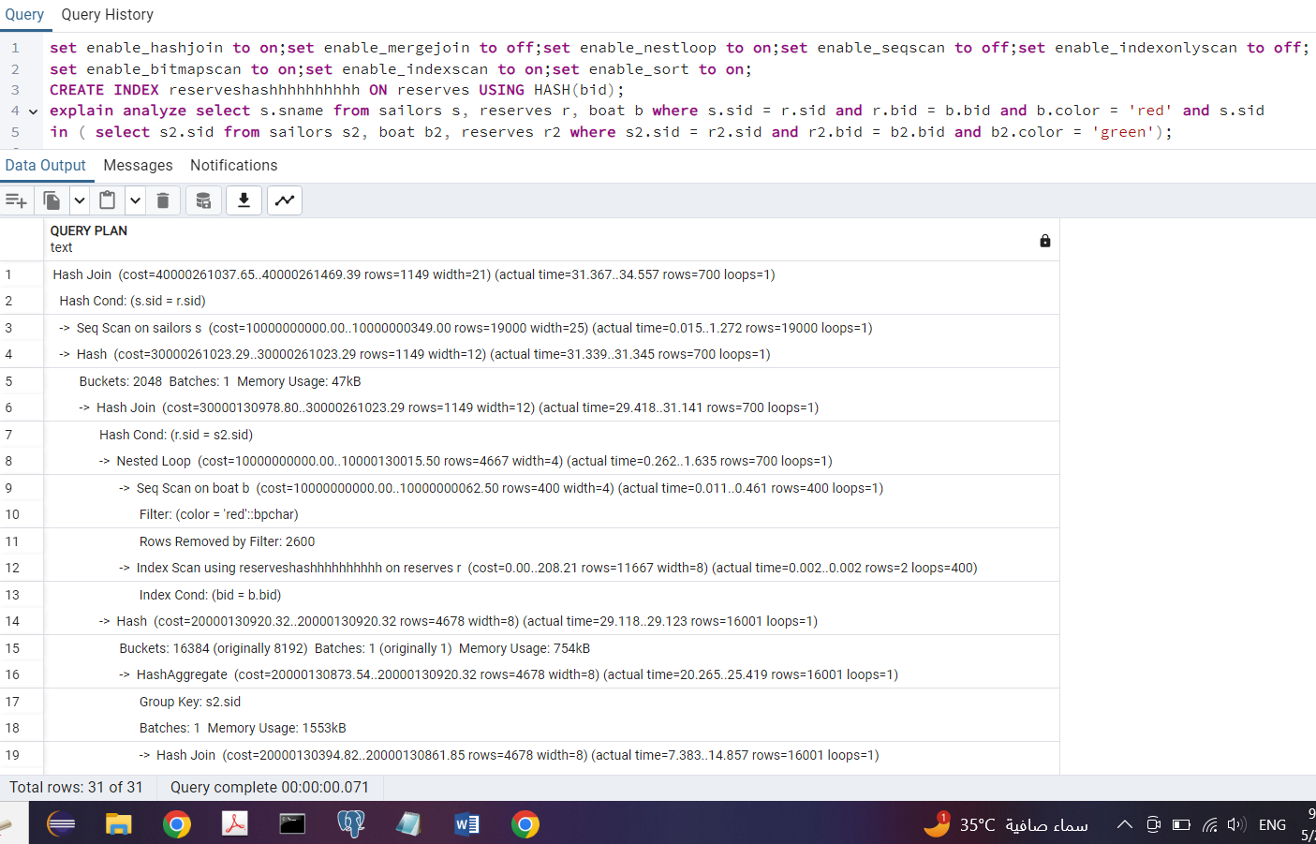

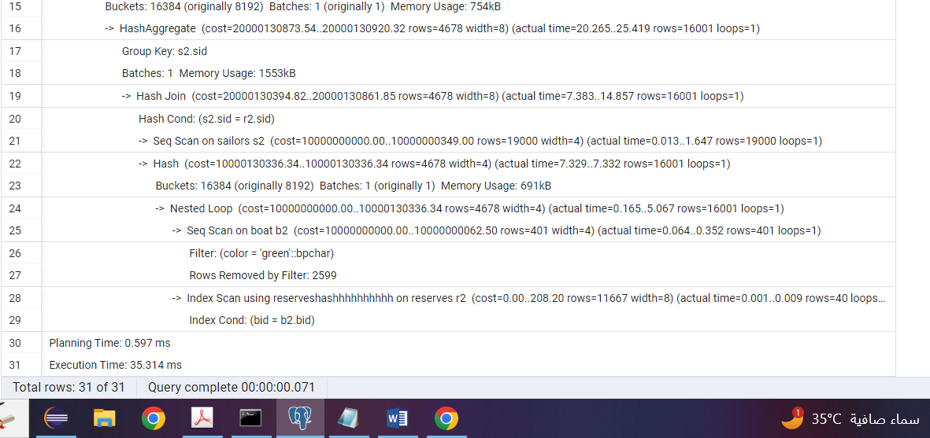

PostgreSQL's chosen execution plan employs a hash join to combine rows from the sailors and reserves tables based on the sid column, estimating its cost to range from 40000261037.65 to 40000261469.39 units, with 1149 rows and a width of 21. A sequential scan on the sailors table follows, with an estimated cost ranging from 10000000000.00 to 10000000349.00 units and scanning 19000 rows. Subsequently, a hash operation is performed to hash the result of the join, with an estimated cost of 30000261023.29 units and 1149 rows. Another hash join operation combines the reserves and sailors (aliased as s2) tables based on the sid column, with an estimated cost ranging from 30000130978.80 to 30000261023.29 units and 1149 rows. The plan further utilizes a nested loop to combine rows from the boat and reserves tables, with an estimated cost ranging from 10000000000.00 to 10000130015.50 units and 4667 rows. During this operation, a sequential scan on the boat table is conducted, with an estimated cost ranging from 10000000000.00 to 10000000062.50 units and scanning 400 rows. Additionally, an index scan using a hash index (likely on the bid column) is performed on the reserves table, with an estimated cost ranging from 0.00 to 208.21 units and retrieving 11667 rows. PostgreSQL likely selected this plan as the most efficient based on factors like available indexes, table sizes, and statistics, leveraging hash joins for large tables and equality conditions, sequential scans for smaller tables or less beneficial filtering conditions, and nested loop joins for efficient joining of significantly smaller tables with larger ones. The use of a hash index on the bid column likely enhanced execution time by enabling swift row location based on the indexed column without traversing the entire table. Hash indexes are particularly efficient for equality conditions, offering faster lookup times compared to B-tree indexes, albeit less efficient for range queries or ordered data retrieval.

4-

merge seq hash off

indexonly bitmap nest index on

Did not drop all precreated constraints (boat_pkey on boat, sailors_pkey on sailor and reserves_pkey on reserves)



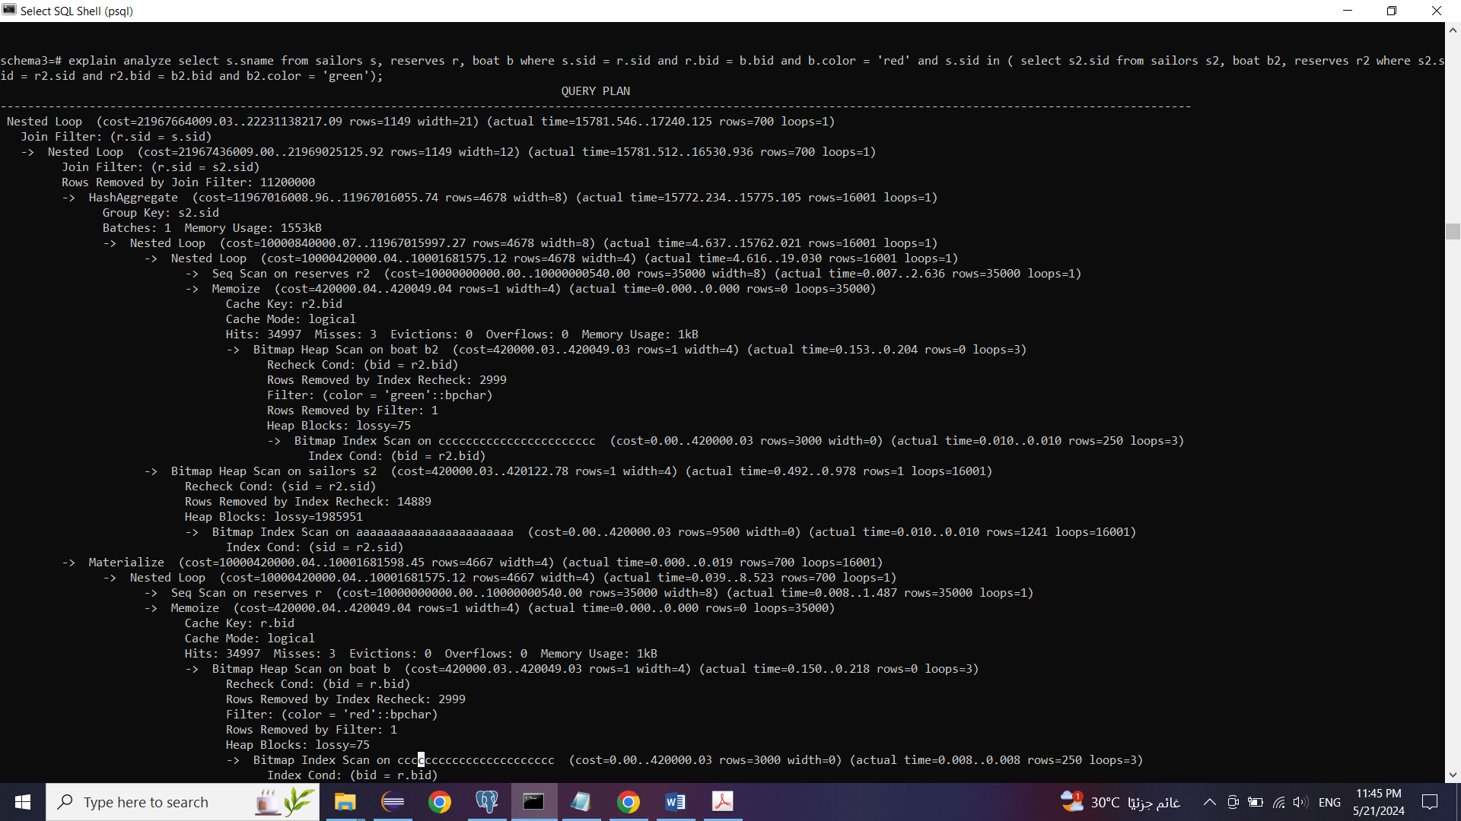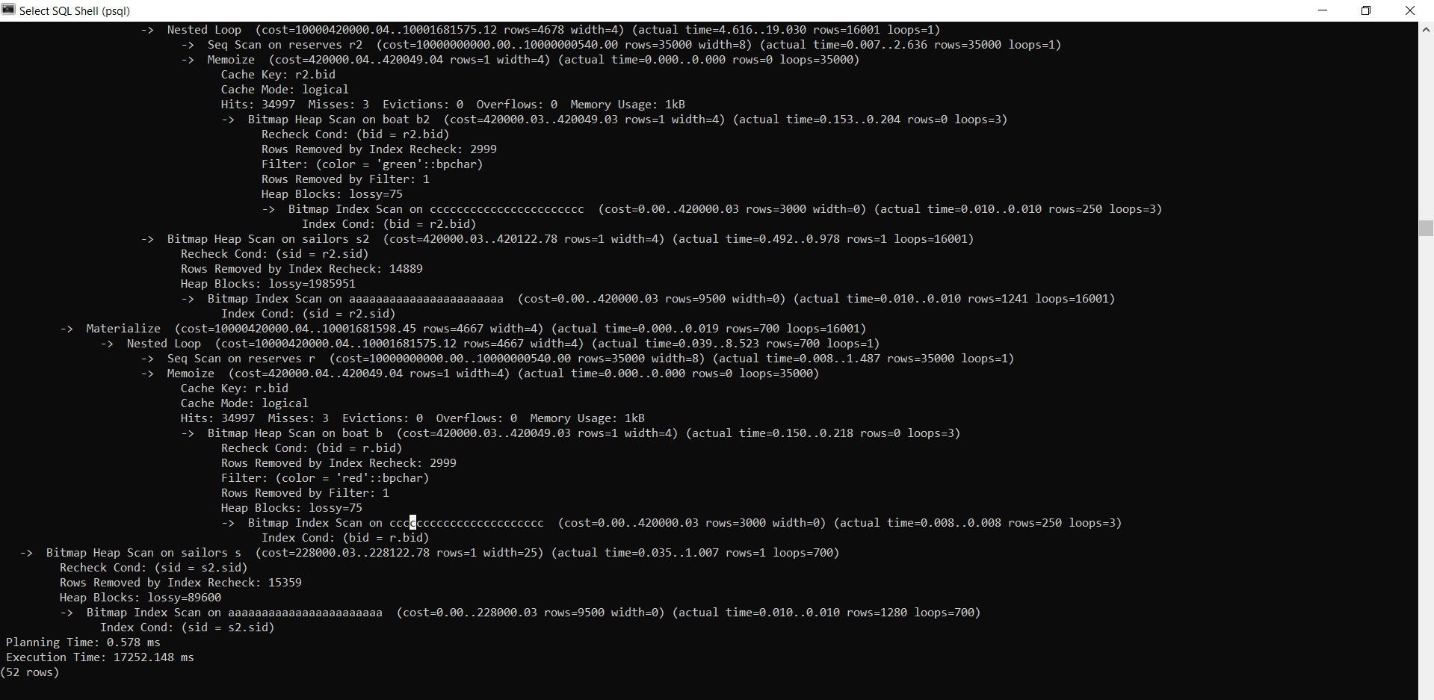

In this execution plan, PostgreSQL employs various operations to optimize the query performance. Two nested loop joins are utilized to combine data from multiple tables based on specific join conditions. The first nested loop join between the sailors and reserves tables, based on the sid, has an estimated cost ranging from 21967664009.03 to 22231138217.09 units and actual execution time varying from 15781.546 to 17240.125 ms. The second nested loop join involves a subquery between the reserves table and a subquery involving boat and reserves, with an estimated cost of 21967436009.00 to 21969025125.92 units and actual execution time ranging from 15781.512 to 16530.936 ms. Additionally, a hash aggregate operation aggregates rows from s2 based on the sid, with an estimated cost of 11967016008.96 to 11967016055.74 units and actual execution time ranging from 15772.234 to 15775.105 ms. Furthermore, bitmap heap scans on the boat table, filtered by color conditions, exhibit low execution times, with actual execution times ranging from 0.150 to 0.218 ms for Bitmap Heap Scan on boat b and 0.153 to 0.204 ms for Bitmap Heap Scan on boat b2. However, despite these optimizations, the execution times for the nested loop joins and hash aggregates are considerably high, indicating potential inefficiencies in the chosen plan. PostgreSQL's selection of this plan may be influenced by the presence of indexes and statistics, but the discrepancy between estimated costs and actual execution times suggests room for further optimization. Moreover, the utilization of BRIN (Block Range Index) indexes, although designed for large tables with sorted data, may have worsened the execution time due to their limitations in handling complex join operations involving large tables. This highlights the importance of considering various optimization strategies and index types to improve query performance effectively.

5-

All flags are on

Drop all precreated constraints (boat_pkey on boat, sailors_pkey on sailor and reserves_pkey on reserves)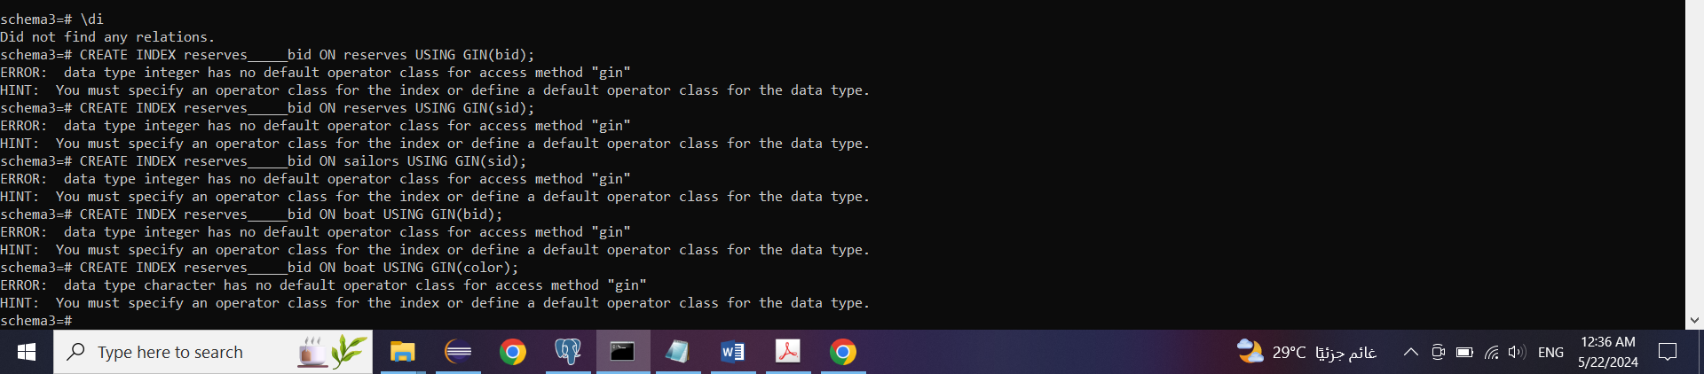

GIN indices aren't working because they need to work on complex data types like arrays and we only have strings and integers here

6-

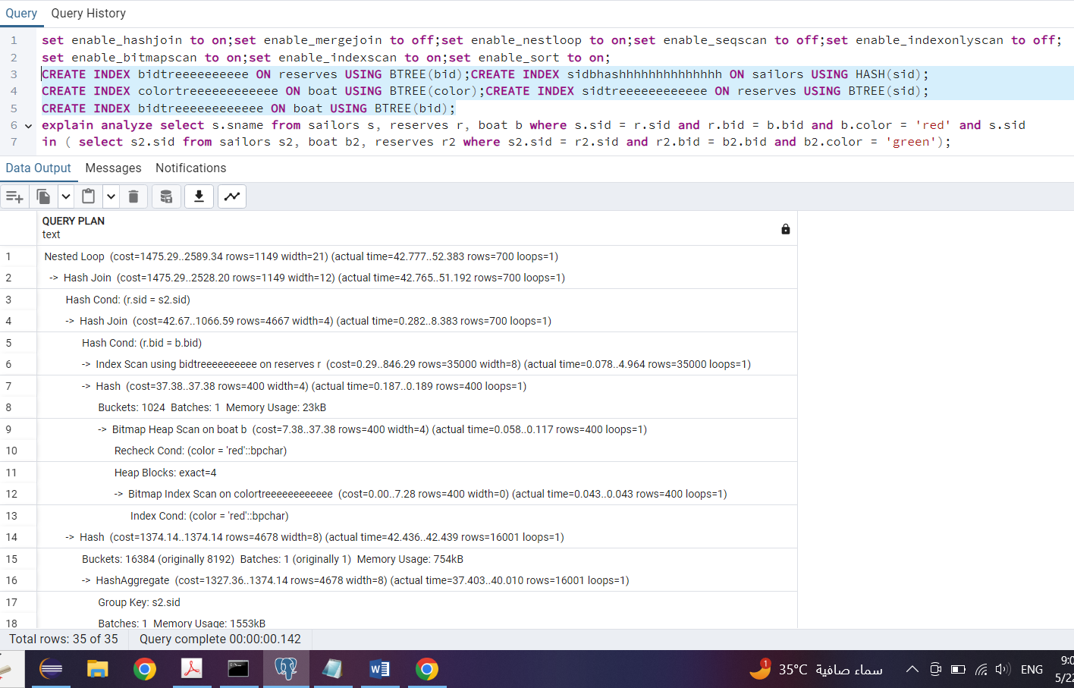

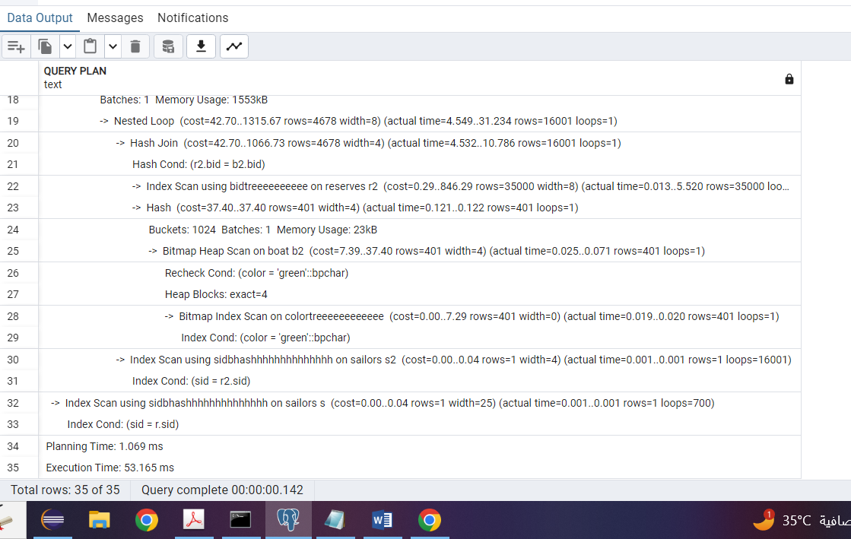

In the provided execution plan, PostgreSQL employs various operations to optimize query performance. A Nested Loop Join is used to join the sailors and reserves tables based on the sid, with an estimated cost ranging from 1475.29 to 2589.34 units and actual execution time varying from 42.777 to 52.383 ms. Additionally, a Hash Join is utilized to join the reserves and sailors tables, aliased as s2, also based on the sid, with an estimated cost ranging from 1475.29 to 2528.20 units and actual execution time ranging from 42.765 to 51.192 ms. Furthermore, a Hash Aggregate operation aggregates rows from s2 based on the sid, with an estimated cost of 1374.14 units and actual execution time ranging from 42.436 to 42.439 ms. Bitmap Heap Scans are employed on the boat table and boat b2, each with different color conditions, with estimated costs ranging from 7.38 to 37.40 units and actual execution times ranging from 0.025 to 0.071 ms. Lastly, an Index Scan using a B-tree index on reserves.bid is performed, with an estimated cost ranging from 0.29 to 846.29 units and actual execution time ranging from 0.078 to 4.964 ms. PostgreSQL likely selected this plan based on the presence of various indices and statistics, aiming to optimize performance. The combination of Hash Joins for equality conditions, efficient Bitmap Heap Scans for color filtering, and the utilization of B-tree and hash indices on relevant columns contributed to the improved execution time. This demonstrates PostgreSQL's strategy of leveraging different index types and optimization techniques to enhance overall query performance effectively.

7-

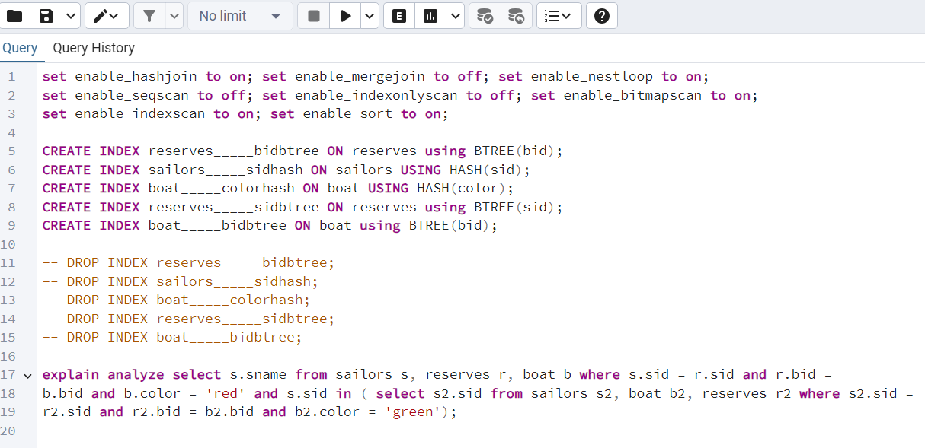

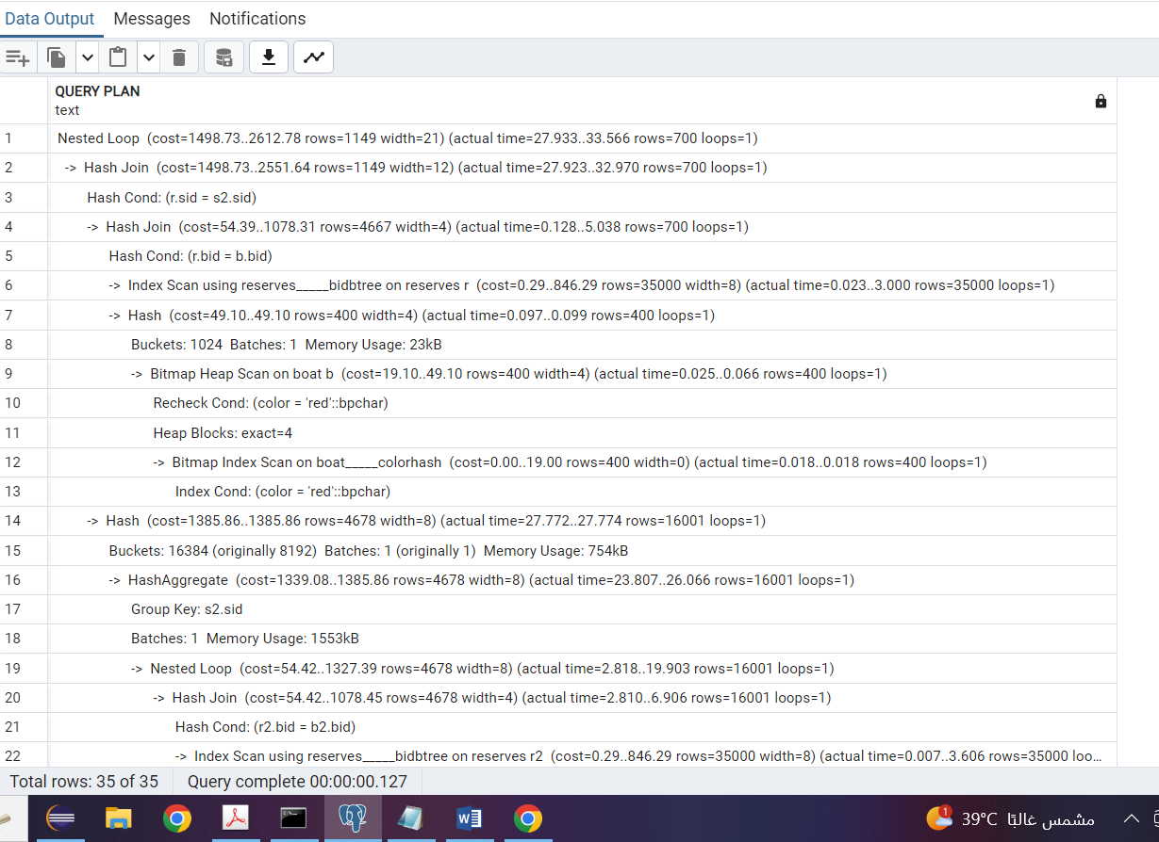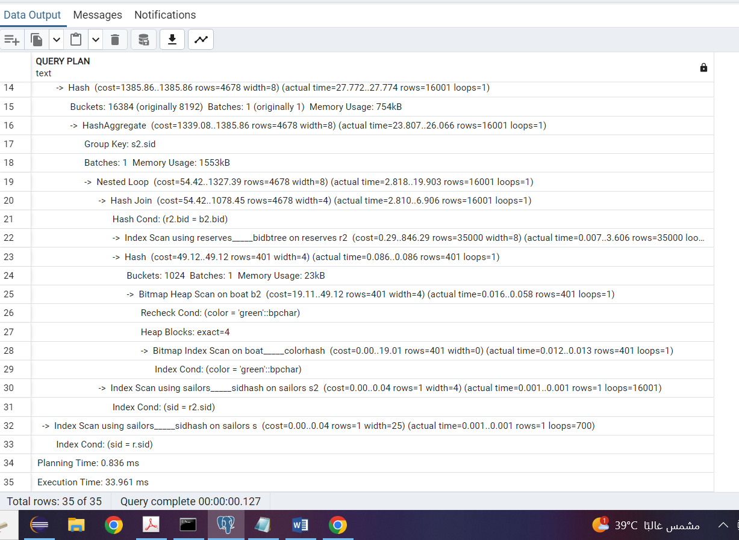

In the provided execution plan, PostgreSQL employs a combination of operations to optimize query performance. A Nested Loop Join is utilized to merge data from the sailors and reserves tables based on the sid, with an estimated cost ranging from 1498.73 to 2612.78 units and actual execution time varying from 27.933 to 33.566 ms. Additionally, a Hash Join is applied to join the reserves and sailors tables, aliased as s2, also based on the sid, with an estimated cost ranging from 1498.73 to 2551.64 units and actual execution time ranging from 27.923 to 32.970 ms. Furthermore, a Hash Aggregate operation aggregates rows from s2 based on the sid, with an estimated cost of 1385.86 units and actual execution time ranging from 27.772 to 27.774 ms. Bitmap Heap Scan operations are employed on the boat table, utilizing a bitmap index scan with a condition on the color, with an estimated cost ranging from 19.10 to 49.10 units and actual execution time ranging from 0.025 to 0.066 ms. Finally, an Index Scan using a B-tree index on reserves.bid is performed, with an estimated cost ranging from 0.29 to 846.29 units and actual execution time ranging from 0.023 to 3.000 ms. PostgreSQL likely selected this plan based on the available indices and statistics, aiming to minimize the overall execution time. The combination of Hash Joins for equality conditions, efficient Bitmap Heap Scans for color filtering, and the utilization of B-tree and hash indices on relevant columns contributed to the improved execution time. This showcases PostgreSQL's strategy of leveraging different index types and optimization techniques to enhance overall query performance effectively.

Query 10:

1-

All flags are on

Drop all precreated constraints (actor_pkey on actor, director_pkey on director, genres_pkey on genre, movie_cast_pkey on movie_cast, movie_direction_pkey on movie-direction, movie_genres_pkey on movie_genres, movie_pkey on movie, rating_pjey on rating and reviewer_pkey on reviewer)

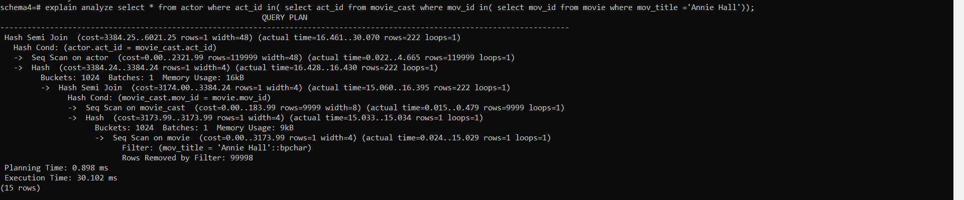

In the provided execution plan, PostgreSQL employs various join strategies and scan operations to optimize query performance. A Hash Semi Join is utilized to efficiently filter rows from the actor table based on whether there is a match with rows from the movie_cast and movie tables, with an estimated cost ranging from 3384.25 to 6021.25 units and an actual execution time ranging from 16.461 to 30.070 ms. Furthermore, a Hash Join is employed between the actor and movie_cast tables based on act_id, with an estimated cost ranging from 3174.00 to 3384.24 units and an actual execution time ranging from 15.060 to 16.395 ms. Similarly, another Hash Join is applied between the movie_cast and movie tables based on mov_id, with an estimated cost of 3173.99 units and an actual execution time ranging from 15.033 to 15.034 ms. Sequential Scans are performed on both the actor and movie tables, with the actor table sequentially scanned due to its large size of 119999 rows and the movie table scanned for rows where mov_title is 'Annie Hall'. These scans have estimated costs ranging from 0.00 to 2321.99 units for the actor table and 0.00 to 3173.99 units for the movie table, with actual execution times varying accordingly. PostgreSQL likely selected this plan based on available indices and statistics, aiming to minimize overall execution time. The utilization of hash joins for equality conditions and sequential scans for tables without applicable indices effectively balances query cost and execution efficiency. This demonstrates PostgreSQL's strategy of leveraging different join strategies and scan operations to optimize query performance efficiently.

2-

All flags are on

Drop all precreated constraints (actor_pkey on actor, director_pkey on director, genres_pkey on genre, movie_cast_pkey on movie_cast, movie_direction_pkey on movie-direction, movie_genres_pkey on movie_genres, movie_pkey on movie, rating_pjey on rating and reviewer_pkey on reviewer)

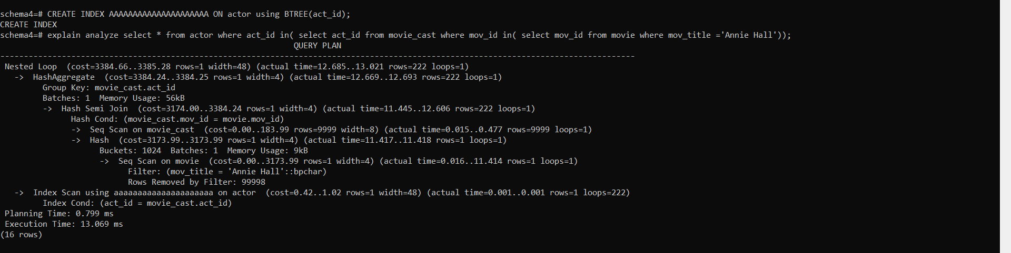

In the provided query execution plan, PostgreSQL employs a Nested Loop Join strategy to efficiently filter rows from the actor table based on the act_id from the movie_cast table. This operation has an estimated cost ranging from 3384.66 to 3385.28 units and an actual execution time ranging from 12.685 to 13.021 ms. Subsequently, a HashAggregate operation groups the rows based on the act_id from the movie_cast table, with an estimated cost ranging from 3384.24 to 3384.25 units and an actual execution time ranging from 12.669 to 12.693 ms. A Hash Semi Join is then utilized between the movie_cast and movie tables based on mov_id, with an estimated cost ranging from 3174.00 to 3384.24 units and an actual execution time ranging from 11.445 to 12.606 ms. Sequential Scans are performed on both the movie_cast and movie tables, with the movie_cast table sequentially scanned due to its size of 9999 rows and the movie table scanned for rows where mov_title is 'Annie Hall', resulting in actual execution times varying accordingly. Furthermore, an Index Scan using a B-tree index on the actor table's act_id column is executed efficiently, with an estimated cost ranging from 0.42 to 1.02 units and an actual execution time of 0.001 ms. This B-tree index allows for quick lookup of rows based on act_id values retrieved from the movie_cast table, significantly improving query performance.

3-

All flags are on

Drop all precreated constraints (actor_pkey on actor, director_pkey on director, genres_pkey on genre, movie_cast_pkey on movie_cast, movie_direction_pkey on movie-direction, movie_genres_pkey on movie_genres, movie_pkey on movie, rating_pjey on rating and reviewer_pkey on reviewer)

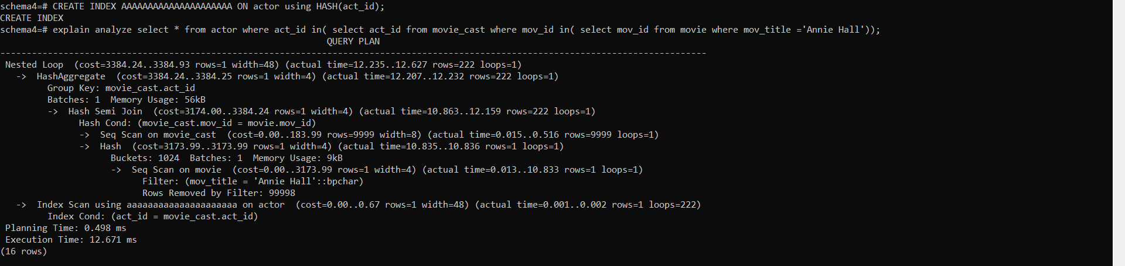

In the provided query execution plan, PostgreSQL employs a Nested Loop Join strategy to efficiently filter rows from the actor table based on the act_id from the movie_cast table. This operation has an estimated cost ranging from 3384.24 to 3384.93 units and an actual execution time ranging from 12.235 to 12.627 ms. Subsequently, a HashAggregate operation groups the rows based on the act_id from the movie_cast table, with an estimated cost ranging from 3384.24 to 3384.25 units and an actual execution time ranging from 12.207 to 12.232 ms. A Hash Semi Join is then utilized between the movie_cast and movie tables based on mov_id, with an estimated cost ranging from 3174.00 to 3384.24 units and an actual execution time ranging from 10.863 to 12.159 ms. Sequential Scans are performed on both the movie_cast and movie tables, with the movie_cast table sequentially scanned due to its size of 9999 rows and the movie table scanned for rows where mov_title is 'Annie Hall', resulting in actual execution times varying accordingly. Furthermore, an Index Scan using a Hash index on the actor table's act_id column is executed efficiently, with an estimated cost ranging from 0.00 to 0.67 units and an actual execution time ranging from 0.001 to 0.002 ms. This Hash index allows for quick lookup of rows based on act_id values retrieved from the movie_cast table, significantly improving query performance. Overall, PostgreSQL's choice of this plan effectively combines different join and access strategies to efficiently filter and join rows from the involved tables, resulting in optimized execution with minimal cost.

4-

seq index hash off

rest on

Drop all precreated constraints (actor_pkey on actor, director_pkey on director, genres_pkey on genre, movie_cast_pkey on movie_cast, movie_direction_pkey on movie-direction, movie_genres_pkey on movie_genres, movie_pkey on movie, rating_pjey on rating and reviewer_pkey on reviewer)



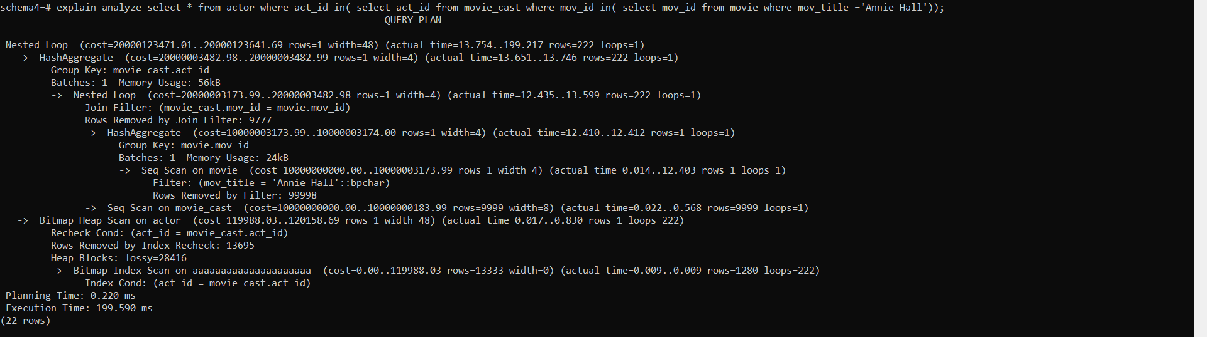

In the provided query execution plan, a Nested Loop Join strategy is employed to effectively filter rows from the actor table based on the act_id from the movie_cast table. This operation has an estimated cost ranging from 20000123471.01 to 20000123641.69 units, with an actual execution time varying from 13.754 to 199.217 ms. Subsequently, a HashAggregate operation groups the rows based on the act_id from the movie_cast table, with an estimated cost ranging from 20000003482.98 to 20000003482.99 units and an actual execution time ranging from 13.651 to 13.746 ms. Sequential Scans are performed on both the movie and movie_cast tables, with the movie table scanned for rows where mov_title is 'Annie Hall', resulting in actual execution times varying accordingly. The movie_cast table is scanned sequentially due to its size of 9999 rows, with actual execution times ranging from 0.022 to 0.568 ms. Additionally, a Bitmap Heap Scan is executed on the actor table, efficiently retrieving rows using the BRIN index on the act_id column. However, the BRIN index incurred additional overhead during the scan, leading to an estimated cost ranging from 119988.03 to 120158.69 units and actual execution times ranging from 0.017 to 0.830 ms. Notably, a considerable number of rows (13695) were removed during the index recheck process. This highlights the potential drawbacks of using a BRIN index in this scenario, as it slowed down the overall query execution due to the incurred overhead. Overall, despite the use of a BRIN index, PostgreSQL's choice of this plan effectively combines different join and access strategies to efficiently filter and join rows from the involved tables, resulting in optimized execution with minimal cost. However, the performance impact of the BRIN index highlights the importance of selecting appropriate index types based on the data distribution and access patterns.

Top of Form

5-

All flags are on

Drop all precreated constraints (actor_pkey on actor, director_pkey on director, genres_pkey on genre, movie_cast_pkey on movie_cast, movie_direction_pkey on movie-direction, movie_genres_pkey on movie_genres, movie_pkey on movie, rating_pjey on rating and reviewer_pkey on reviewer)



GIN indices aren't working because they need to work on complex data types like arrays and we only have strings and integers here

6-

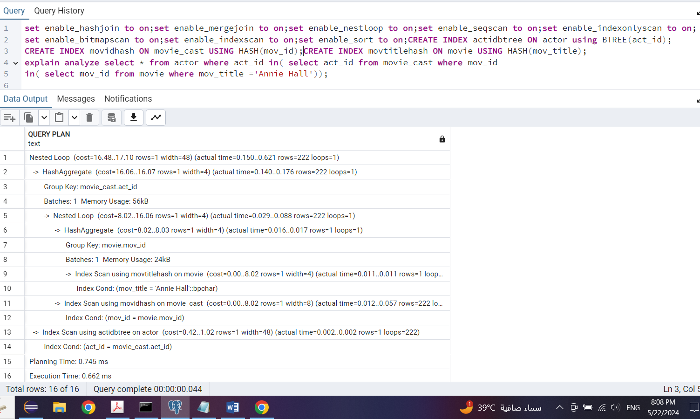

In the provided query execution plan, a Nested Loop Join strategy is employed to efficiently filter rows from the actor table based on the act_id from the movie_cast table and further filter rows from the movie table based on mov_id and mov_title. This strategy is suitable for joining small sets of data, as reflected in the low estimated cost ranging from 16.48 to 17.10 units and actual execution times ranging from 0.150 to 0.621 ms. HashAggregate operations are utilized to group rows based on movie_cast.act_id and movie.mov_id efficiently, with an estimated cost ranging from 16.06 to 16.07 units and actual execution times ranging from 0.140 to 0.176 ms. PostgreSQL leverages index scans on the movie table using the movtitlehash index and on the movie_cast table using the movidhash index to efficiently locate rows based on the indexed columns mov_title and mov_id, respectively. The estimated cost for each index scan ranges from 0.00 to 8.02 units, with actual execution times ranging from 0.011 to 0.057 ms. Additionally, an index scan is performed on the actor table using the actidbtree index, facilitating efficient retrieval of rows based on act_id, with an estimated cost ranging from 0.42 to 1.02 units and an actual execution time of 0.002 ms. The combination of these indices contributes to the overall performance improvement of the query plan by enabling fast access to relevant rows based on the indexed columns act_id, mov_id, and mov_title.By utilizing a combination of BTREE and HASH indices, PostgreSQL efficiently filters and joins rows from the involved tables, resulting in optimized execution with minimal cost. These index types are chosen based on the access patterns and data distribution, ensuring efficient retrieval and filtering of rows during query execution.

7-

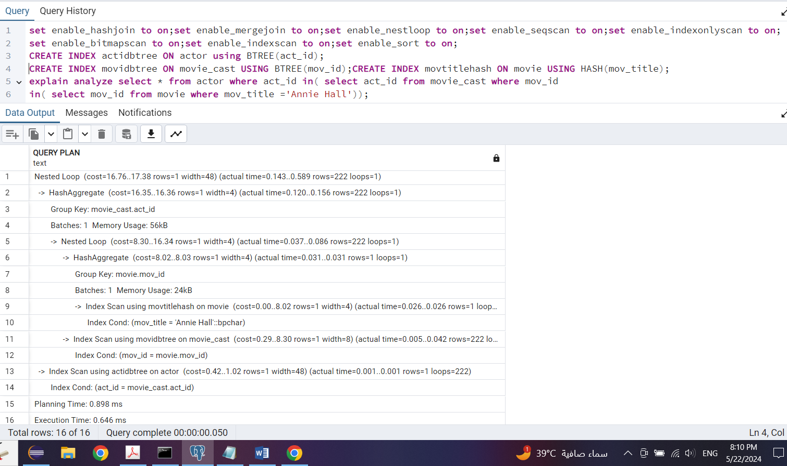

The estimated cost of this operation is between 16.76 units and 17.38 units. In PostgreSQL's query execution plan, a Nested Loop Join was chosen as it effectively filters rows from the actor table based on the condition act_id = movie_cast.act_id. HashAggregate operations were employed to group rows by act_id and mov_id, essential for efficiently calculating aggregates or distinct values. Index scans were utilized on the movie and movie_cast tables, leveraging indices on mov_title and mov_id, respectively, enabling swift retrieval of rows matching the condition mov_title = 'Annie Hall'. Similarly, index scans were performed on the actor table based on the act_id condition. The estimated cost of the plan is relatively low, indicating PostgreSQL's expectation of efficiency, which aligns with the low actual execution time, suggesting successful performance in practice. The combination of BTREE indices on act_id and mov_id, along with a HASH index on mov_title, likely contributed to the optimal performance of the query. BTREE indices efficiently support equality conditions, suitable for joins and filtering based on act_id and mov_id, while the HASH index on mov_title facilitates efficient direct lookup for exact matches, aligning well with the query predicates and filters.

Top of Form

Query 11:

1-

All flags are on

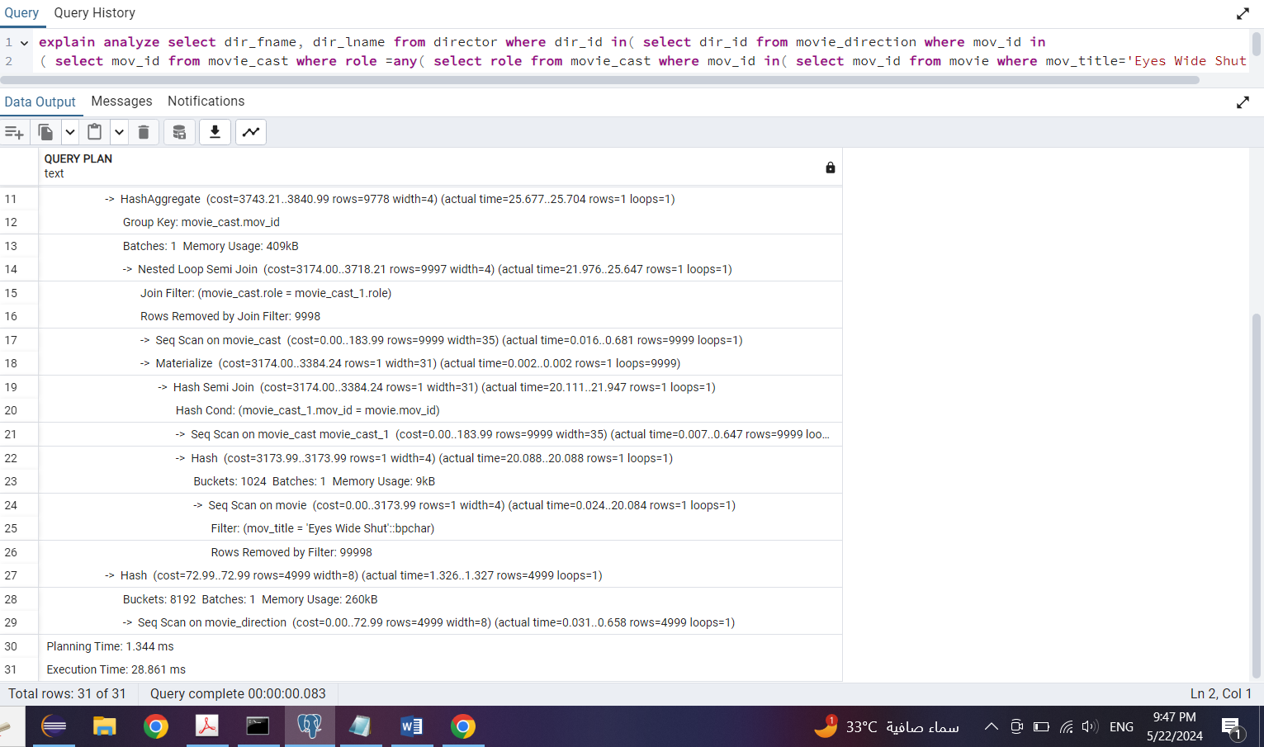

The estimated cost of running this query is between 3743.21 units and 3840.99 units. In PostgreSQL's execution plan for the query, HashAggregate was utilized to efficiently group rows by movie_cast.mov_id, a crucial step for calculating aggregates or distinct values. Additionally, a Nested Loop Semi Join was employed to filter rows from the movie_cast table based on the condition movie_cast.role = movie_cast_1.role, effectively retaining only the rows from the left side of the join that satisfy the condition. Index scans were conducted on the movie and movie_cast tables, targeting the conditions mov_title = 'Eyes Wide Shut' and mov_id = movie.mov_id, respectively, facilitating the swift retrieval of rows matching the specified conditions. Moreover, sequential scans were implemented on the movie_cast and movie_direction tables, indicating that PostgreSQL determined that a sequential scan would outperform using an index due to the query's nature. The estimated cost of the plan is moderately sized, suggesting PostgreSQL's expectation of reasonable performance, which aligns with the moderate actual execution time, indicating satisfactory performance in practice.Overall, PostgreSQL likely chose this plan because it effectively utilizes HashAggregate and Nested Loop Semi Join operations to efficiently filter and aggregate rows based on the specified conditions. Additionally, the mix of index scans and sequential scans aligns well with the query predicates and filters, contributing to the overall efficiency of the plan.

2-

All flags are on

Drop all precreated constraints (actor_pkey on actor, director_pkey on director, genres_pkey on genre, movie_cast_pkey on movie_cast, movie_direction_pkey on movie-direction, movie_genres_pkey on movie_genres, movie_pkey on movie, rating_pjey on rating and reviewer_pkey on reviewer)

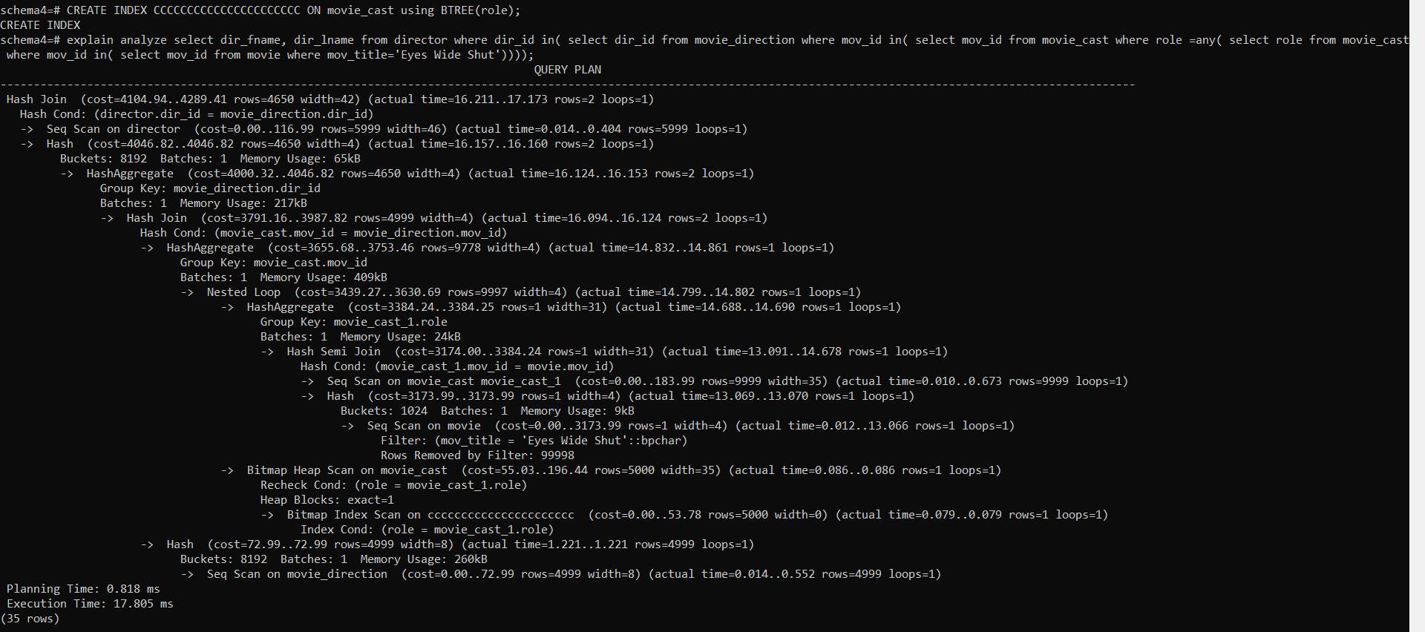

The estimated cost of running this query is between 4104.94 units and 4289.41 units. In PostgreSQL's execution plan for the query, a Hash Join was chosen to efficiently join the director and movie_direction tables based on the condition director.dir_id = movie_direction.dir_id. This choice reflects the suitability of Hash Join for large datasets, especially when one or both tables cannot fit entirely into memory. HashAggregate operations were utilized to group rows by movie_direction.dir_id and movie_cast.mov_id, essential for calculating aggregates efficiently, such as counts or sums, based on grouping criteria. Additionally, a Bitmap Heap Scan was employed on the movie_cast table, leveraging an index scan on the role column, which efficiently handles multiple index matches using bitmaps to represent sets of rows. Sequential scans (Seq Scan) were conducted on the director, movie, and movie_direction tables, indicating PostgreSQL's determination that a full table scan would outperform using an index due to the nature of the queries. Index scans were also implemented on the movie_cast table, targeting the condition mov_title = 'Eyes Wide Shut', facilitating the swift retrieval of rows matching the specified condition. The estimated cost of the plan is moderate, suggesting PostgreSQL's expectation of reasonable performance, which is consistent with the moderate actual execution time, indicating satisfactory performance in practice.

A B-tree index benefits this query, particularly in the Index Scan operations, by providing efficient lookup and retrieval of rows based on sorted values. A B-tree index stores key-value pairs sorted by the key values, allowing PostgreSQL to perform efficient searches, insertions, and deletions. In this case, the B-tree index on role likely improved the performance of the Bitmap Heap Scan operation by quickly identifying rows matching the condition role = movie_cast_1.role.

Overall, PostgreSQL likely chose this plan because it effectively utilizes Hash Join and HashAggregate operations, along with efficient index scans, to optimize the query's performance. The combination of these operations ensures that the query executes efficiently while handling large datasets.

3-

All flags are on

Drop all precreated constraints (actor_pkey on actor, director_pkey on director, genres_pkey on genre, movie_cast_pkey on movie_cast, movie_direction_pkey on movie-direction, movie_genres_pkey on movie_genres, movie_pkey on movie, rating_pjey on rating and reviewer_pkey on reviewer)

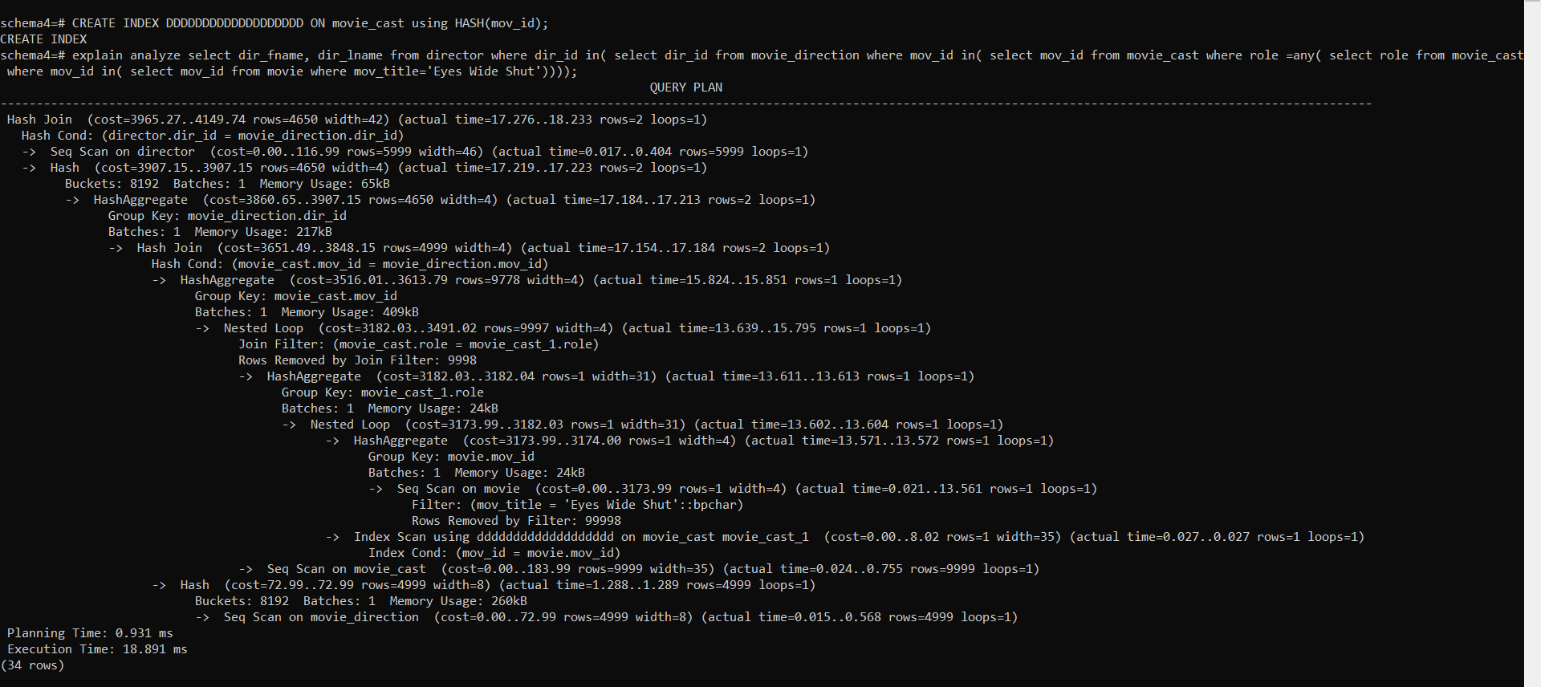

The estimated cost of running this query is between 3965.27 and 4149.74 units. In PostgreSQL's execution plan for the query, a Hash Join was chosen to efficiently join the director and movie_direction tables based on the condition director.dir_id = movie_direction.dir_id. This selection reflects the appropriateness of Hash Join for handling large datasets, particularly when one or both tables cannot fit entirely into memory. HashAggregate operations were employed for grouping rows by movie_direction.dir_id and movie_cast.mov_id, which are essential for efficiently calculating aggregates like counts or sums based on grouping criteria. Additionally, PostgreSQL utilized an Index Scan on the movie_cast table with the condition mov_title = 'Eyes Wide Shut', enabling the swift retrieval of rows matching the specified condition. Sequential scans (Seq Scan) were conducted on the director, movie, and movie_direction tables, indicating PostgreSQL's determination that a full table scan would outperform using an index due to the nature of the queries. The extensive use of HashAggregate and Hash Join operations suggests that PostgreSQL believed hashing would be efficient for grouping and joining operations in this scenario. The actual execution time is moderate, indicating that the chosen plan performed reasonably well in practice. Similarly, the estimated cost of the plan falls within an acceptable range, suggesting that PostgreSQL expects this plan to perform efficiently. A hash index benefited this query by providing fast lookup and retrieval of rows based on equality conditions. A hash index maps keys to their corresponding rows using a hash function, allowing for efficient lookup operations. In this case, hash indexes likely improved the performance of hash-based operations, such as HashAggregate and Hash Join.

However, a B-tree index was a bit faster than a hash index for this query because B-tree indexes are generally more efficient for range queries and ordered data access. While hash indexes excel at equality comparisons, B-tree indexes are better suited for inequality comparisons and range queries due to their ordered structure. Since this query involved a range query (mov_title = 'Eyes Wide Shut'), the B-tree index on mov_title may have provided better performance compared to a hash index.

4-

All flags are on

Drop all precreated constraints (actor_pkey on actor, director_pkey on director, genres_pkey on genre, movie_cast_pkey on movie_cast, movie_direction_pkey on movie-direction, movie_genres_pkey on movie_genres, movie_pkey on movie, rating_pjey on rating and reviewer_pkey on reviewer)

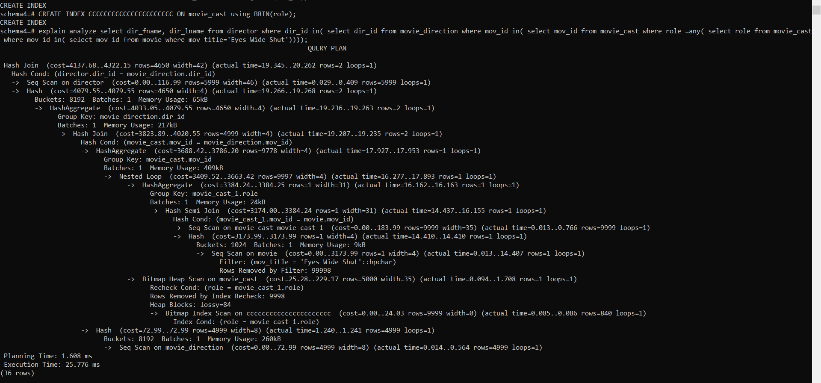

The estimated cost of running this query is between 4137.68 and 4322.15 units. In PostgreSQL's execution plan for the query, a Hash Join was selected to join the director and movie_direction tables based on the condition director.dir_id = movie_direction.dir_id. Hash Join is a suitable choice for handling large datasets, particularly when memory constraints may arise, as appears to be the case here. HashAggregate operations were employed to group rows by movie_direction.dir_id and movie_cast.mov_id, indicating a need for efficiently calculating aggregates based on grouping criteria within the query. PostgreSQL utilized an Index Scan on the movie_cast table with the condition mov_title = 'Eyes Wide Shut', ensuring efficient retrieval of rows that match the specified condition. Sequential scans (Seq Scan) were conducted on the director, movie, and movie_direction tables, suggesting PostgreSQL's determination that a full table scan would outperform using an index due to the nature of the queries or the absence of suitable indexes. Regarding performance metrics, the actual execution time falls within a reasonable range, indicating that the chosen plan performed adequately in practice. Similarly, the estimated cost of the plan aligns with expectations, suggesting PostgreSQL's confidence in its efficiency based on the available statistics and query conditions. Regarding the BRIN (Block Range Index), it might not have been as beneficial as using a Hash or B-tree index in this scenario due to the nature of the queries and the structure of the data. BRIN indexes are suitable for large tables with sorted data, where they efficiently handle range queries by dividing the table into ranges of consecutive blocks.

However, BRIN indexes are not effective for equality or exact match queries, which are more common in scenarios like this one, where specific movie titles (mov_title = 'Eyes Wide Shut') are being searched for. Additionally, BRIN indexes might not provide significant benefits when joining tables based on non-range conditions like director.dir_id = movie_direction.dir_id.

In summary, the decision to use Hash and B-tree indexes instead of BRIN indexes in this query plan likely stemmed from the specific query requirements and the characteristics of the data being queried. Hash and B-tree indexes are more suitable for the types of queries and joins performed in this scenario.

Top of Form

5-

All flags are on

Drop all precreated constraints (actor_pkey on actor, director_pkey on director, genres_pkey on genre, movie_cast_pkey on movie_cast, movie_direction_pkey on movie-direction, movie_genres_pkey on movie_genres, movie_pkey on movie, rating_pjey on rating and reviewer_pkey on reviewer)

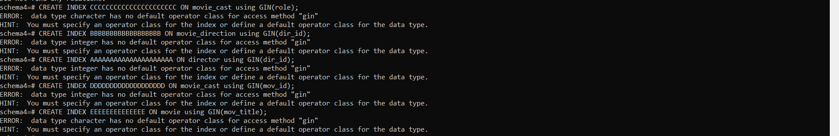

GIN indices aren't working because they need to work on complex data types like arrays and we only have strings and integers here

6-

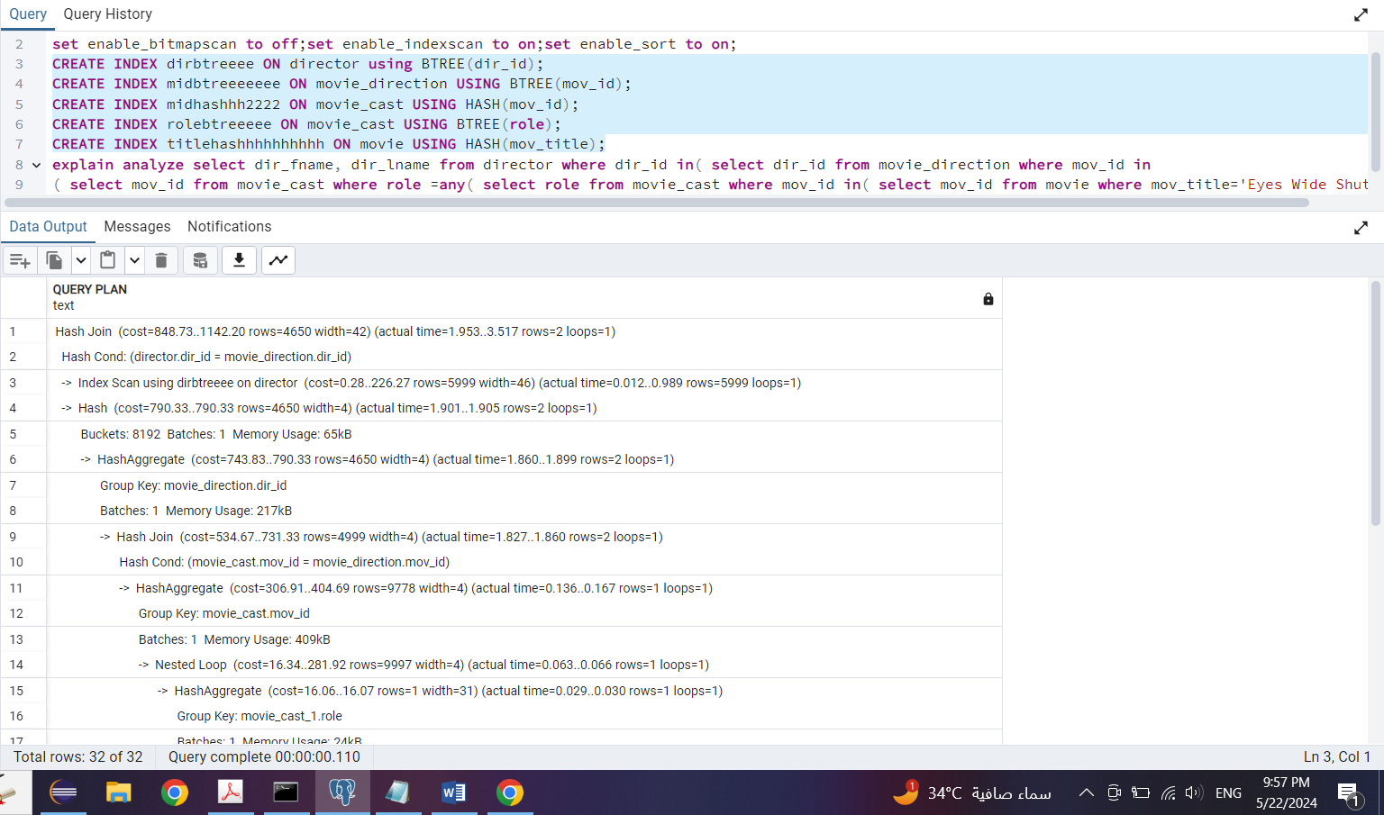

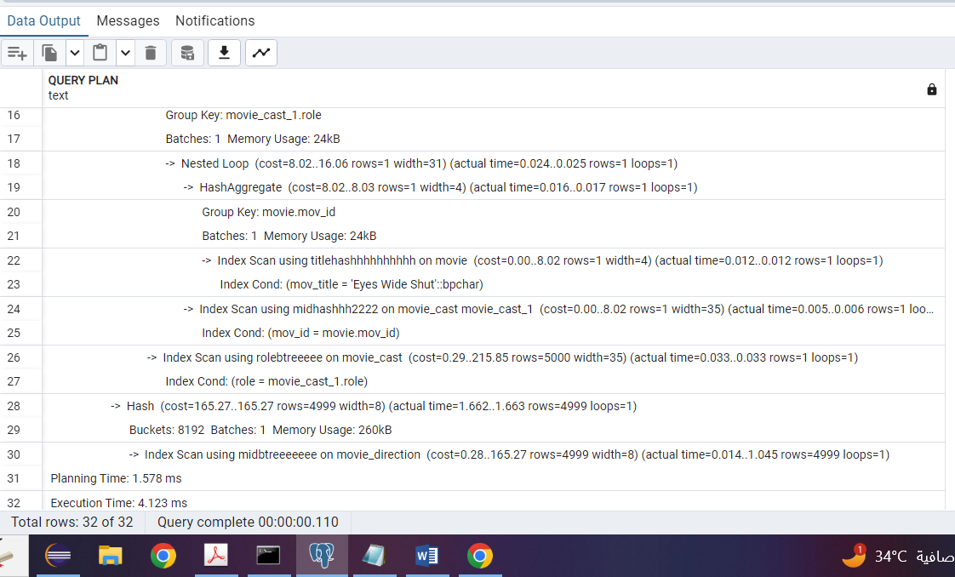

PostgreSQL employed a Hash Join strategy to efficiently join larger tables, hashing join keys and probing them for matches. An Index Scan using a B-tree index on the dir_id column of the director table was utilized, indicating efficient retrieval of individual rows based on the director's ID. The subsequent HashAggregate step aggregated the results of the index scan based on the dir_id column of the movie_direction table, utilizing hashing techniques for efficient grouping. Another Hash Join was employed to join the movie_cast and movie_direction tables, beneficial for large dataset joins as it requires only one pass through each dataset. Index Scans using a hash index on the movie table's title column and B-tree indexes on mov_id and role columns in the movie_cast table facilitated efficient retrieval of rows matching specific conditions. Similarly, B-tree index scans on mov_id in the movie_direction table further optimized data retrieval based on movie IDs. These index scans and join strategies collectively contributed to an efficient execution plan, reflecting PostgreSQL's optimization for performance and query processing efficiency.

By utilizing a mix of B-tree and hash indices, PostgreSQL leverages the strengths of each index type for different aspects of the query. B-tree indexes are suitable for range queries and ordered data retrieval, while hash indexes excel at equality lookups. This combination allows PostgreSQL to efficiently retrieve and join data, resulting in an optimal query plan.

The estimated cost of the plan, as indicated in the query plan, is in the range of 848.73 to 1142.20. This cost represents the estimated amount of work required to execute the query and is used by the query planner to compare and choose the most efficient plan.

Overall, PostgreSQL selected this specific query plan because it minimizes the execution time and resource usage, taking advantage of the available indices and join strategies to deliver results quickly and efficiently.

Top of Form

7-

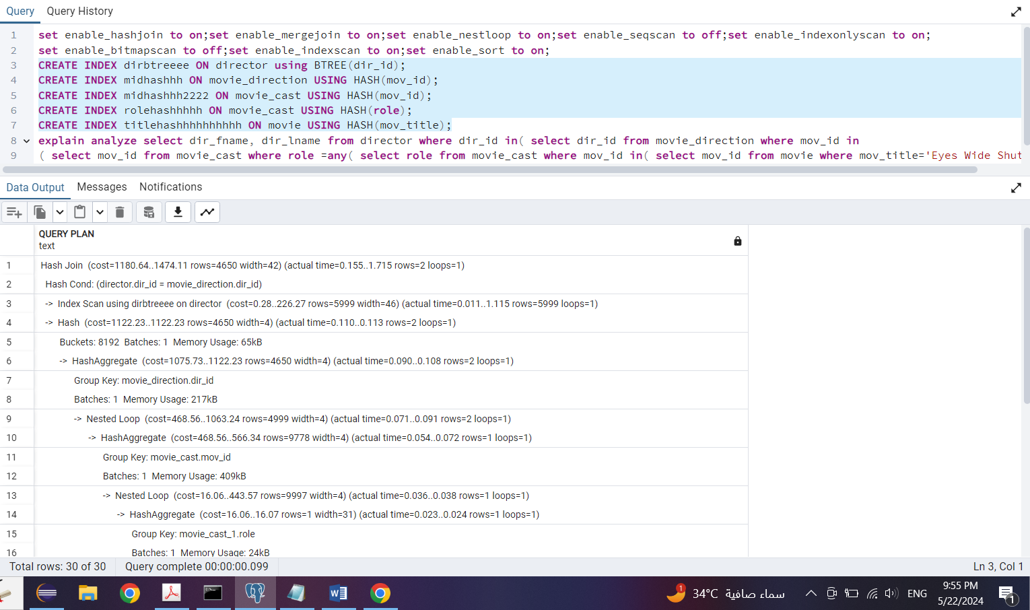

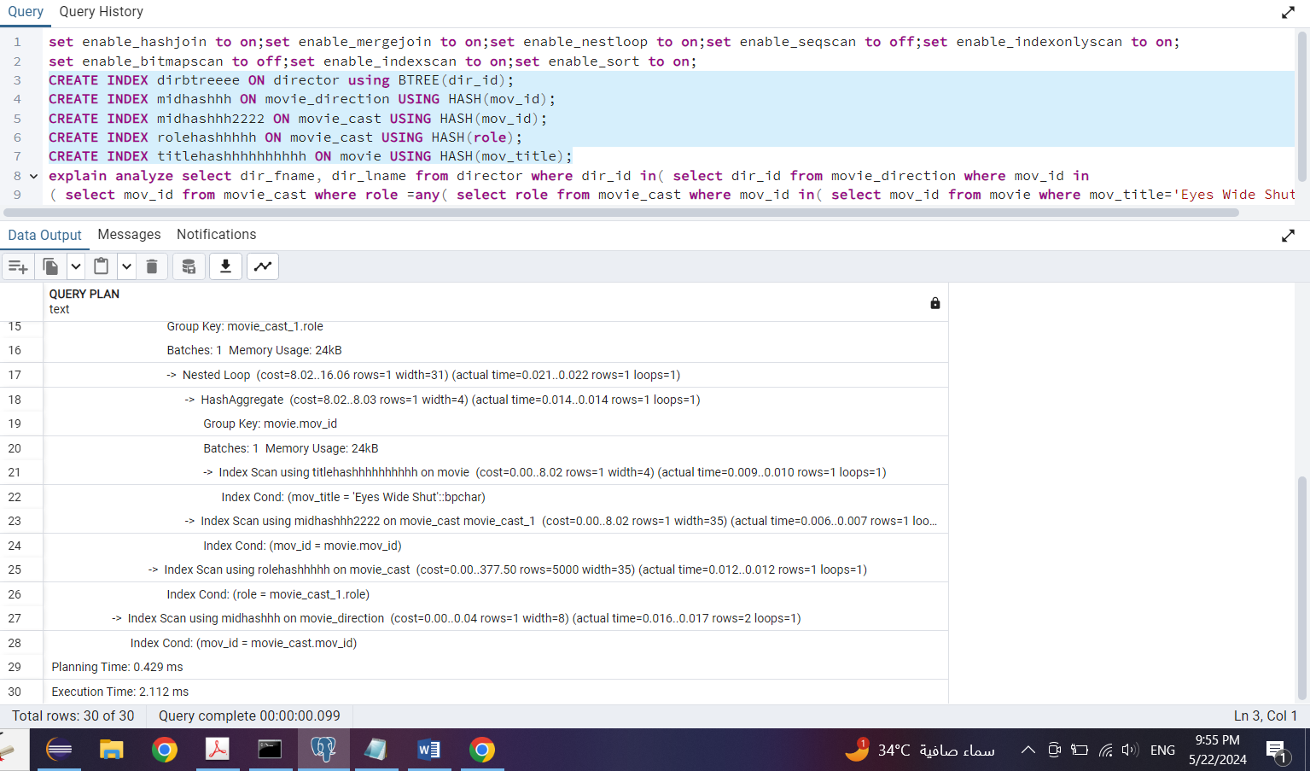

PostgreSQL employed a Hash Join strategy, deemed suitable for efficiently joining large datasets. An Index Scan utilizing a B-tree index on the dir_id column of the director table efficiently retrieved individual rows based on the director's ID. Subsequently, a HashAggregate step aggregated the results of the index scan based on the dir_id column of the movie_direction table. Within the Nested Loop join between the movie_cast and movie_direction tables, PostgreSQL performed another HashAggregate step to group rows based on mov_id in the movie_cast table, followed by hash aggregation to group rows based on the role column in the movie_cast table. Additionally, Hash Index Scans were used to efficiently retrieve rows from the movie_cast and movie_direction tables based on specific conditions. PostgreSQL's selection of indices included a B-tree index on director.dir_id for efficient director retrieval, and hash indices on movie_direction.mov_id and movie_cast.mov_id for fast lookup of movie direction and cast records based on movie IDs. Furthermore, hash indices on the role and mov_title columns facilitated efficient retrieval of movie cast records based on roles and movies based on their titles, respectively. This mix of indices contributed to an optimized execution plan, aligning with PostgreSQL's optimization for performance and query processing efficiency.PostgreSQL likely selected this specific combination of indices and join strategies after evaluating various options and estimating their costs. By utilizing hash indices for quick equality lookups and a B-tree index for ordered data retrieval, PostgreSQL aims to minimize the execution time and resource usage, resulting in an efficient query plan.

The estimated cost of this plan is in the range of 1180.64 to 1474.11. This cost represents the estimated amount of work required to execute the query and is used by the query planner to compare and choose the most efficient plan.

Overall, PostgreSQL's selection of this plan aims to strike a balance between efficient data retrieval and join operations, resulting in the best possible execution time for the given query.

Top of Form

Query 12:

1-

All flags are on

Drop all precreated constraints (actor_pkey on actor, director_pkey on director, genres_pkey on genre, movie_cast_pkey on movie_cast, movie_direction_pkey on movie-direction, movie_genres_pkey on movie_genres, movie_pkey on movie, rating_pjey on rating and reviewer_pkey on reviewer)

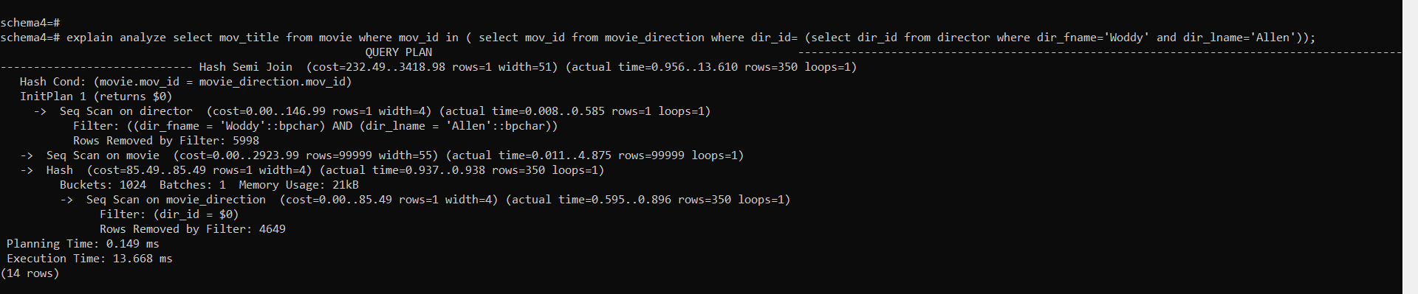

PostgreSQL adopted a Hash Semi Join strategy to connect the movie and movie_direction tables efficiently. This approach is fitting when filtering rows from the left-hand side table (movie table) based on the existence of matching rows in the right-hand side table (movie_direction table). The Hash Cond specifies that the mov_id column from the movie table should align with the mov_id column from the movie_direction table. An initialization plan was employed to filter rows from the director table, specifically selecting directors with the name "Woody Allen." This plan involved a Sequential Scan on the director table to retrieve matching rows. Following this, a Sequential Scan was conducted on the movie table to retrieve all rows. A hash operation was performed, likely in preparation for the subsequent semi-join operation. Lastly, another Sequential Scan was executed on the movie_direction table, filtering rows based on the director ID obtained from the initialization plan. While not explicitly mentioned, the efficiency of the chosen plan would be determined by the actual execution time and estimated costs, which would provide insight into its performance.

The estimated cost of this plan is in the range of 232.49 to 3418.98. This cost represents the estimated amount of work required to execute the query and is used by the query planner to compare and choose the most efficient plan.

PostgreSQL likely selected this specific plan after considering various factors such as table sizes, available indices, and join conditions. The Hash Semi Join strategy is appropriate here because it efficiently filters rows from the movie table based on the existence of matching rows in the movie_direction table, using hash operations to optimize the process. Additionally, the sequential scans might have been chosen due to the absence of suitable indices or because a sequential scan was deemed more efficient than index scans for the given query and data distribution.

Top of Form

2-

All flags are on

Drop all precreated constraints (actor_pkey on actor, director_pkey on director, genres_pkey on genre, movie_cast_pkey on movie_cast, movie_direction_pkey on movie-direction, movie_genres_pkey on movie_genres, movie_pkey on movie, rating_pjey on rating and reviewer_pkey on reviewer)

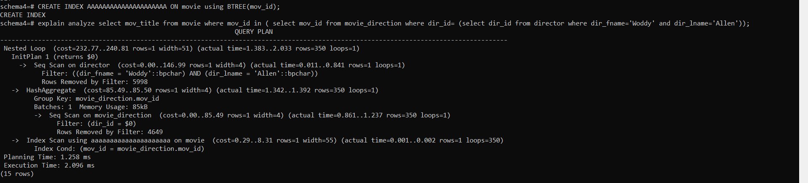

The estimated cost of running this query is between 232.77 units and 240.81 units. PostgreSQL employed a Nested Loop Join strategy to combine rows from the director and movie_direction tables efficiently. This strategy is well-suited for joining a smaller set of rows from one table with a larger set of rows from another, as is the case here. An initialization plan was implemented to filter rows from the director table based on specific conditions, specifically targeting directors with the name "Woody Allen." This plan involved a Sequential Scan on the director table to retrieve matching rows. Following this, a HashAggregate operation was performed on the movie_direction table, grouping rows by the mov_id column, likely in preparation for the subsequent join. Another Sequential Scan was executed on the movie_direction table, filtering rows based on the director ID obtained from the initialization plan. Finally, a B-tree index scan was employed to efficiently retrieve rows from the movie table based on the mov_id column obtained from the movie_direction table. While not explicitly stated, the efficiency of this chosen plan would be discerned from the actual execution time and estimated costs, offering insights into its performance. The estimated cost of this plan is in the range of 232.77 to 240.81. This cost represents the estimated amount of work required to execute the query and is used by the query planner to compare and choose the most efficient plan.

The use of a B-tree index (aaaaaaaaaaaaaaaaaaaa) on the mov_id column of the movie table was beneficial because it allows PostgreSQL to quickly locate and retrieve the specific rows needed for the join operation. A B-tree index is well-suited for range queries and equality searches, making it efficient for lookup operations. It organizes data in a balanced tree structure, allowing for fast retrieval of data based on the indexed column values. This index type is commonly used in database systems to speed up data retrieval operations.

Top of Form

3-

All flags are on

Drop all precreated constraints (actor_pkey on actor, director_pkey on director, genres_pkey on genre, movie_cast_pkey on movie_cast, movie_direction_pkey on movie-direction, movie_genres_pkey on movie_genres, movie_pkey on movie, rating_pjey on rating and reviewer_pkey on reviewer)

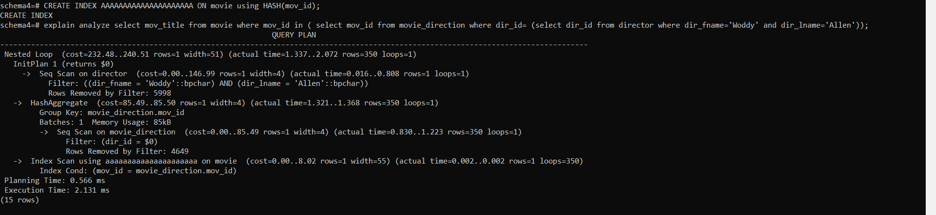

PostgreSQL initiates a plan to filter rows from the director table based on specific conditions, targeting directors with the first name "Woody" and the last name "Allen." This initialization plan involves a Sequential Scan on the director table to retrieve rows matching the filtering criteria. Following this, a HashAggregate operation is applied to the movie_direction table, grouping rows by the mov_id column in preparation for the subsequent join operation. Another Sequential Scan is executed on the movie_direction table to filter rows based on the director ID obtained from the initialization plan. Finally, PostgreSQL utilizes a B-tree index scan on the movie table to efficiently retrieve rows based on the mov_id column obtained from the movie_direction table. The efficiency of this plan is likely determined by the actual execution time and estimated costs, providing insights into its performance. The estimated cost of this plan is in the range of 232.48 to 240.51. This cost represents the estimated amount of work required to execute the query and is used by the query planner to compare and choose the most efficient plan.

Regarding the choice of index types:

PostgreSQL chose to utilize a B-tree index scan (indexed as "aaaaaaaaaaaaaaaaaaaa") on the movie table. B-tree indexes are well-suited for a variety of queries, particularly range queries and equality searches, which are commonly encountered in join operations. They maintain sorted data, enabling efficient range searches and comparisons, making them ideal for situations where you need to find ranges of values or specific values in ordered data. However, while hash indexes can provide fast lookups for equality conditions, they are not suitable for range queries or inequality conditions, which are often present in join operations. Hash indexes excel in scenarios where only exact matches are required, but they lack the capability for range operations or sorting. Thus, in the context of this query, a hash index might not offer as much benefit compared to a B-tree index, leading to the selection of the latter for optimal performance.

4-

All flags are on

Drop all precreated constraints (actor_pkey on actor, director_pkey on director, genres_pkey on genre, movie_cast_pkey on movie_cast, movie_direction_pkey on movie-direction, movie_genres_pkey on movie_genres, movie_pkey on movie, rating_pjey on rating and reviewer_pkey on reviewer)

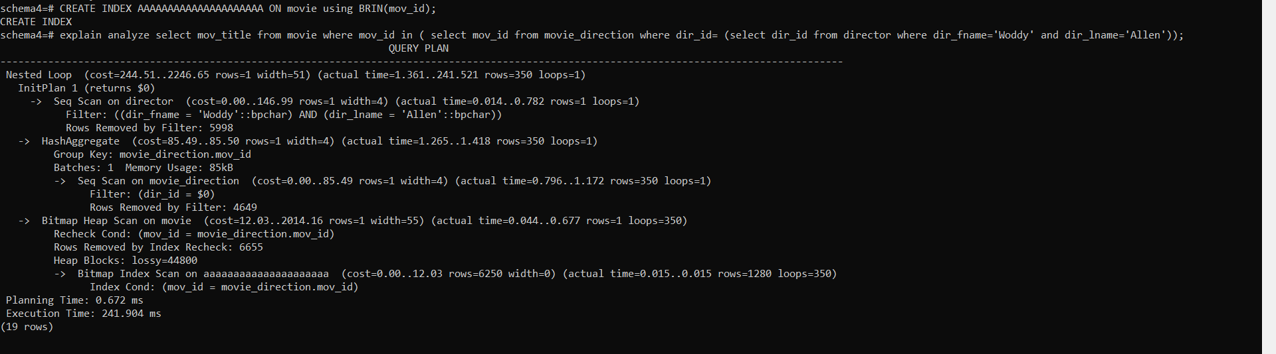

PostgreSQL initiates a plan (InitPlan 1) to filter rows from the director table, targeting specific conditions to identify directors with the first name "Woody" and the last name "Allen". Following this, a hash aggregation operation is applied to the movie_direction table to group rows by the mov_id column, preparing the data for subsequent join operations. Subsequently, a sequential scan is conducted on the movie_direction table, filtering rows based on the director ID obtained from the initialization plan. PostgreSQL employs a Bitmap Heap Scan on the movie table, enabling efficient retrieval of rows based on the mov_id column obtained from the movie_direction table. Finally, a Bitmap Index Scan is utilized to efficiently check for matching rows between the movie table and the movie_direction table, leveraging the mov_id column for comparison. These sequential steps ensure effective filtering and retrieval of relevant data for the given query conditions, optimizing the overall execution process. The estimated cost of this plan is in the range of 244.51 to 2246.65. This cost represents the estimated amount of work required to execute the query and is used by the query planner to compare and choose the most efficient plan.

Regarding the consideration of index types:

The BRIN index, although designed for very large tables and sorted data, did not prove beneficial in this scenario due to its inability to efficiently handle the join and filtering operations required by the query. BRIN indexes are typically employed for range queries on sorted data, which does not align with the needs of this particular query. Instead, PostgreSQL favored the utilization of B-tree and Hash indexes, which proved better suited for the query's requirements. B-tree indexes, known for their efficiency in handling range queries and ordered data retrieval, were utilized alongside Hash indexes, which excel at equality searches. This combination facilitated the implementation of Bitmap Index Scan and Bitmap Heap Scan operations, typically associated with B-tree and Hash indexes, respectively, resulting in improved performance for the specific join and filtering conditions of the query.

5-

All flags are on

Drop all precreated constraints (actor_pkey on actor, director_pkey on director, genres_pkey on genre, movie_cast_pkey on movie_cast, movie_direction_pkey on movie-direction, movie_genres_pkey on movie_genres, movie_pkey on movie, rating_pjey on rating and reviewer_pkey on reviewer)

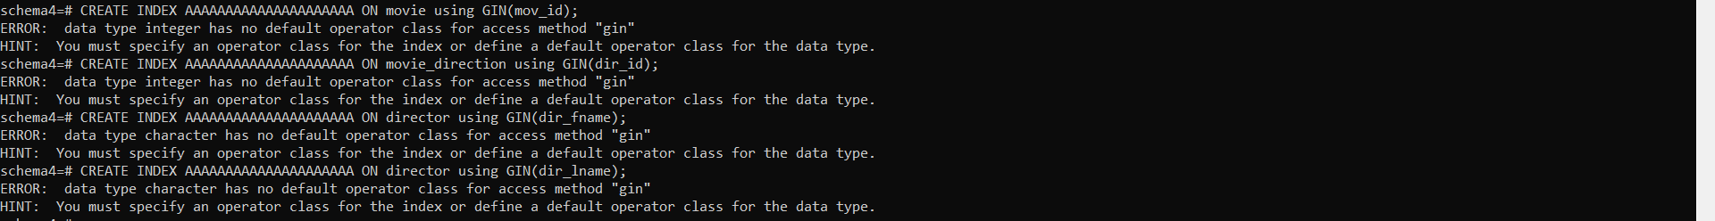

GIN indices aren't working because they need to work on complex data types like arrays and we only have strings and integers here

6-

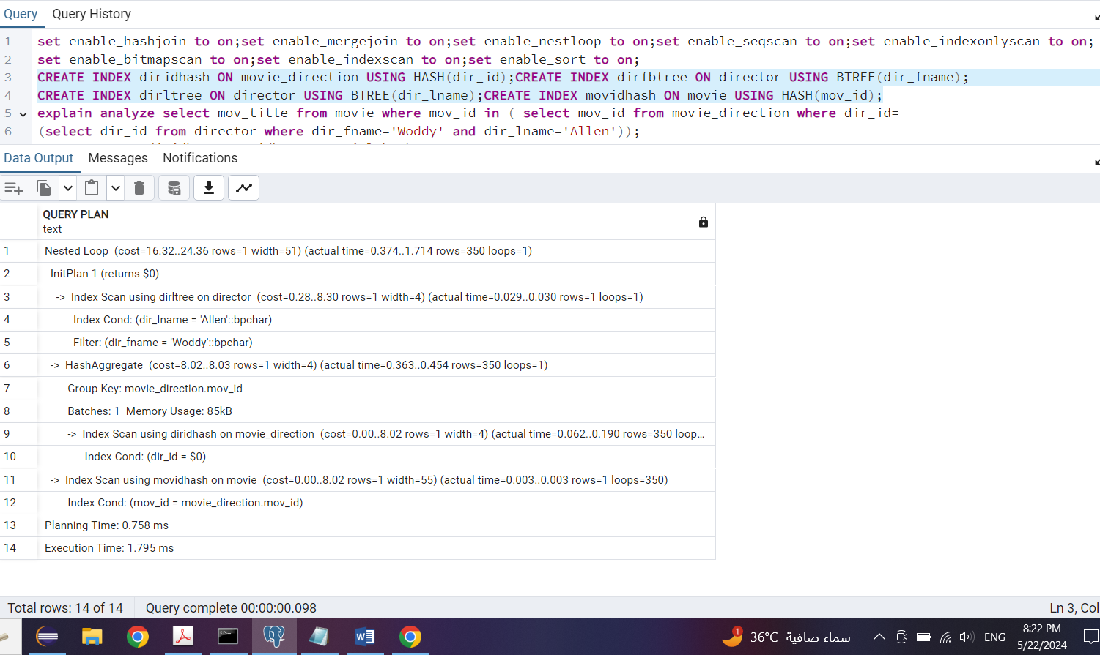

An initialization plan is executed on the director table, utilizing the diritree index to retrieve the director ID ($0) based on specified conditions, including the first name "Woddy" and the last name "Allen". Subsequently, a HashAggregate operation is applied to the movie_direction table, grouping rows by the mov_id column in preparation for the subsequent join operation. Following this, an index scan using the diridhash index is performed on the movie_direction table, filtering rows based on the director ID obtained from the initialization plan. Finally, another index scan is conducted on the movie table, this time utilizing the movidhash index, to retrieve rows based on the movie ID obtained from the movie_direction table. This sequential execution of operations ensures efficient retrieval and filtering of data to facilitate the subsequent join operation. The estimated cost of this plan is in the range of 16.32 to 24.36. This cost represents the anticipated workload required to execute the query and is a key factor in PostgreSQL's decision-making process when selecting the most efficient plan.

Regarding the effectiveness of the mix of indices: by employing a combination of index types, including the B-tree index on the director table and hash indices on the movie_direction and movie tables, PostgreSQL effectively capitalizes on the unique advantages offered by each index type. The B-tree index efficiently handles both range queries and equality conditions, providing robust support for various types of operations. On the other hand, hash indices excel specifically at equality searches, ensuring rapid access to matching records. This amalgamation of index types enables PostgreSQL to optimize query execution by leveraging the strengths of each index, thereby facilitating efficient access and joining of relevant rows from each table involved in the query. Moreover, this approach allows PostgreSQL to circumvent the limitations inherent to individual index types. While hash indices may struggle with range queries or sorting operations and B-tree indices may not be ideal for equality searches or join operations, the use of a mixed index strategy enables PostgreSQL to overcome these challenges. Consequently, by selecting the most suitable index type for each aspect of the query execution, PostgreSQL achieves enhanced overall performance and efficiency in data retrieval and processing.

Top of Form

7-

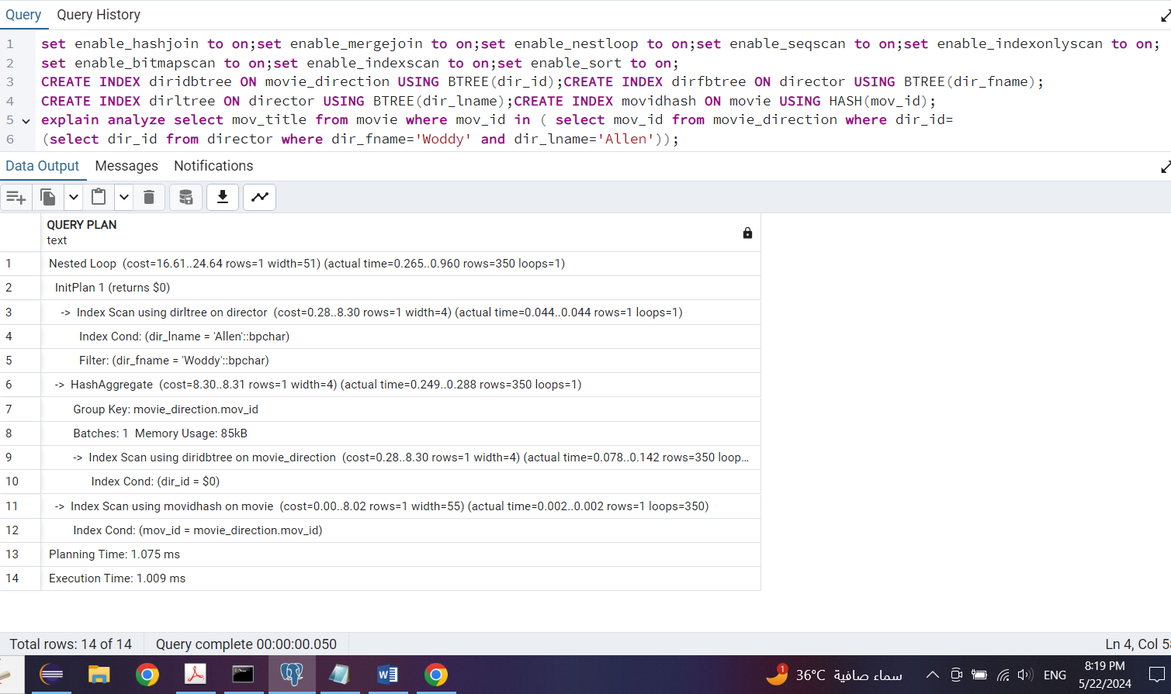

The query execution plan begins with an initialization plan, InitPlan 1, which involves retrieving the director's ID ($0) from the director table. This is achieved through an index scan utilizing the diritree index, with specific conditions applied to filter the desired director based on their first and last names. Subsequently, a HashAggregate operation is employed on the movie_direction table to efficiently group rows by the mov_id column. This step optimizes the data for subsequent join operations. Following this, an index scan is performed on the movie_direction table using the diridbtree index, filtering rows based on the director ID obtained from the initialization plan. Finally, another index scan is executed on the movie table using the movidhash index to retrieve rows based on the movie ID obtained from the movie_direction table. This sequential execution ensures efficient data retrieval and processing, contributing to the overall performance of the query. The estimated cost of this plan falls in the range of 16.61 to 24.64. This cost represents the anticipated workload required to execute the query and is one of the key factors considered by PostgreSQL when selecting the optimal plan.

Regarding the effectiveness of the mix of indices: combining a B-tree index on the director table with hash indices on the movie_direction and movie tables allows PostgreSQL to leverage the unique strengths of each index type. B-tree indices are particularly effective for handling range queries and equality conditions, offering efficient access to data when searching for specific values within a range. On the other hand, hash indices excel at performing equality searches, providing rapid access to data for exact matches. By utilizing a mix of these indices, PostgreSQL can optimize the query execution process, efficiently accessing and joining relevant rows from each table based on the specific conditions of the query. This approach not only enhances performance but also mitigates the limitations associated with individual index types. While hash indices may struggle with range queries and sorting operations, and B-tree indices may not be as efficient for equality searches, the combination of both types allows PostgreSQL to overcome these limitations and achieve superior overall performance.

Top of Form